**Course 17 Process CM - Configuration Management Transforming Business Processes**

#### ****Course Title:****

Configuration Management Transforming Business Processes: A Comprehensive Guide to Business Process Reengineering (BPR), Continuous Process Improvement (CPI), and CM.

#### ****Course Duration:****

Three days (24 hours total)

#### ****Workshop Objectives:****

* Understand the fundamentals of Business Process Reengineering (BPR).
* Understand the principles of continuous process improvement (CPI).
* Understand the Functions and Principles of CM and how they impact BPR and CPI.
* Learn how to identify and analyze core business processes.
* Understand the principles of continuous process improvement (CPI).
* Develop skills to redesign processes for efficiency and effectiveness.
* Apply BPR principles to real-world scenarios.
* Develop a plan for implementing CPI initiatives and fostering a culture of continuous process improvement within organizations.

#### ****Target Audience:****

* Configuration Management professionals
* Business leaders and managers
* Process improvement teams
* Operations managers
* IT professionals
* HR professionals involved in change management
* Consultants
* Team leaders
* Project managers
* Process owners.
* Anyone interested in improving efficiency and effectiveness.

#### ****Pre-Workshop Preparation:****

* Participants are encouraged to identify a specific process within their organization that they believe could benefit from reengineering.

Table of Contents

Introduction 6

About i-infusion 6

i-infusion.com 6

Class Requirements 6

About Exam 7

Copyright Information 7

Structure and Use of this Training 8

Let’s Introduce Ourselves 9

Objectives of this Course 9

Outline of the Course 10

Section 1: Understanding and Analyzing Processes 11

Chapter 1: Introduction to Process Configuration Management (ProCM) 11

Process Configuration Management (ProCM) 12

What is a Service? 15

What is a Process? 16

What are some examples of process? 17

Who Owns Processes? 18

CM’s Role in Process Management 19

Key Points 20

Chapter 2: Processes, and their Management’s Role in Emerging “Best Practice” Success 21

ProCM's Role in the Digital Thread and Digital Twin 22

ProCM and Process Management Play a Vital Role in the Digital Thread Concept 24

Process and their Management Play a Vital Role in the Digital Twin Concept 27

Model-Based Initiatives; ProCM and Process Management Play a Central Role 29

Process and Process Management’s Role in Model-Based Initiatives Integrity 29

Model Types 30

Key Points 32

Chapter 3: Components of a Process/Service 33

Key Components of a Process and/or Service 35

Message to Leadership 38

Key Points 39

Chapter 4. Configuration Management Recap 40

To What Does CM Apply 41

Benefits of Configuration Management 42

Who Benefits From CM 43

What are the elements/Functions of CM 47

Key CM Components of an Enterprise Processes and/or Service 49

Configuration Management Planning and Management (CMPM) 51

Configuration Identification (CId) 53

Configuration Change Management (CCM) 55

Configuration Status Accounting (CSA) 57

Configuration Verification & Audit (CVA) 58

CM and “Best Practice” Initiatives 60

Key Points 62

Chapter 5: Introduction to Business Process Reengineering (BPR) 62

Definition and History of Business Process Reengineering (BPR) 63

BPR Key Principles and Objectives 65

Benefits and Challenges of BPR 67

Best Way to Get Started 71

Key Points 74

Chapter 6: Identifying and Mapping Business Processes 75

Identifying Critical Business and Technical Processes 76

Techniques for mapping processes (e.g., flowcharts, SIPOC diagrams) 77

Tools for process mapping (e.g., Microsoft Visio, Orpheus) 78

Key Points 79

Workshop 80

Chapter 7: Understanding the Fundamentals of Continuous Process Improvement (CPI) 81

What is Continuous Process Improvement (CPI)? 82

Why is Continuous Process Improvement Important 83

What are the Benefits of Continuous Process Improvement 84

Identifying Improvement Opportunities 85

Brainstorming Techniques 85

Process Mapping 86

Data Collection and Analysis 87

Key Points 88

Chapter 8: Practical Tools and Techniques 88

Lean: Value Stream Mapping, 5S, Kaizen Events 89

Six Sigma: DMAIC Methodology, Statistical Process Control 90

Other tools: Pareto Charts, Fishbone Diagrams, Run Charts 91

Key Points 92

Workshop 93

Chapter 9: Analyzing Process Performance 94

Status, Key Performance Indicators (KPIs) and Metrics 95

Monitoring Progress and Measuring Results 96

Analyzing Process Inefficiencies and Bottlenecks 97

Techniques for Process Analysis (e.g., Root Cause Analysis, Pareto Analysis) 98

Key Points 99

Section 2: Redesigning and Implementing Processes 100

Chapter 10: Preparing for Change 101

Change management principles 102

Building a case for BPR within the organization 103

Engaging Stakeholders and Managing Resistance 104

Key Points 105

Chapter 11: Redesigning Processes for Improvement 106

Principles of Effective Process Redesign 107

Customer-Centricity 108

Value Stream Focus 109

Cross-Functional Collaboration 110

Data-Driven Decision Making 111

Continuous Improvement Mindset 112

Technology Enablement 113

Key Points 114

Workshop 114

Chapter12: Implementing the Redesigned Process 115

Developing an Implementation Plan 116

Communicating Changes to the Organization 117

Training and Development for New Processes 118

Key Points 119

Chapter 13: Monitoring and Continuous Improvement 120

Establishing a Monitoring and Feedback System 121

Techniques for Continuous Process Improvement (e.g., Kaizen, Six Sigma) 122

Sustaining BPR Initiatives Over the Long Term 123

Key Points 124

Chapter 14: Real-World Applications and Case Studies 125

Case Studies of Successful BPR Implementations 126

Lessons Learned and Best Practices in Business Process Reengineering 127

Interactive Q&A with a BPR Expert (Guest Speaker) 128

Key Points 128

Chapter 15: Training Recap 129

Recap of key learnings 130

Post-workshop resources and support 131

Key Points 131

# Introduction

* About i-infusion
* i-infusion.com
* Class Requirements
* About the Exam
* Copyright Information
* Let’s Introduce Ourselves
* Outline of the Course

## About i-infusion

Since its inception, i-infusion has been helping clients achieve their enterprise operational and financial goals by assisting them with institutionalizing Process Lifecycle Management best practices and principals.

i-infusion’s award-winning consulting resources help your organization understand, prioritize, orchestrate, improve, implement, and command enterprise-wide process-based initiatives. We help our clients confidently achieve their goals by delivering the value expected.

## i-infusion.com

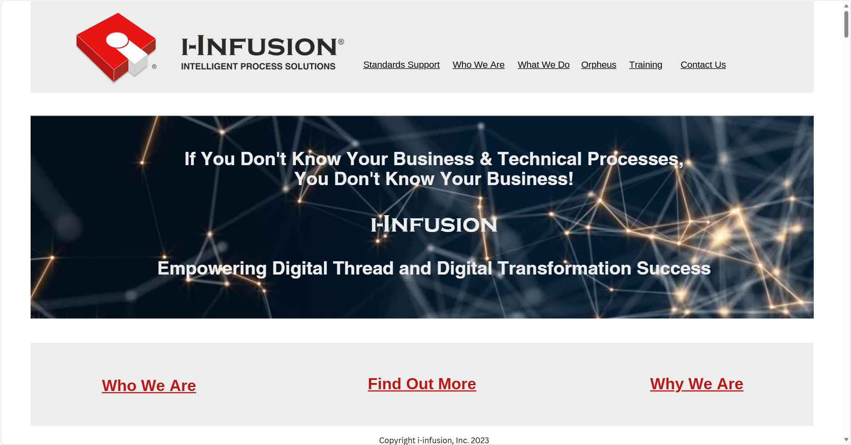

# Class Requirements

* Class starts at the published time. Please be on time.
* Absences beyond two hours throughout the courses may necessitate retaking the missed portions.
* There will be short breaks throughout the day after each chapter as time permits.
* We encourage you to participate in class and workshops.

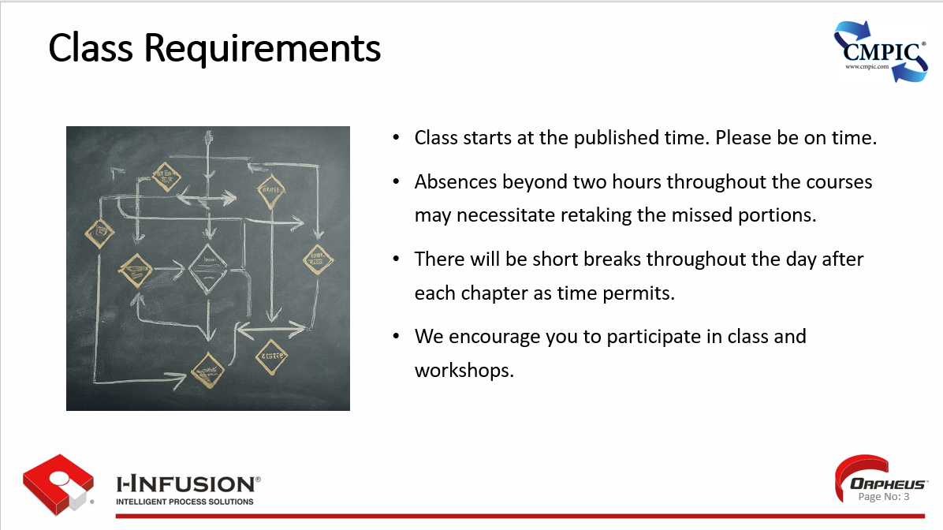

# About Exam

* An exam will be given at the end of this course.
* The exam is 50 questions.
* All questions will come from the course material.
* The exam is open-book.
* A score of 70% or above is required to obtain certification.

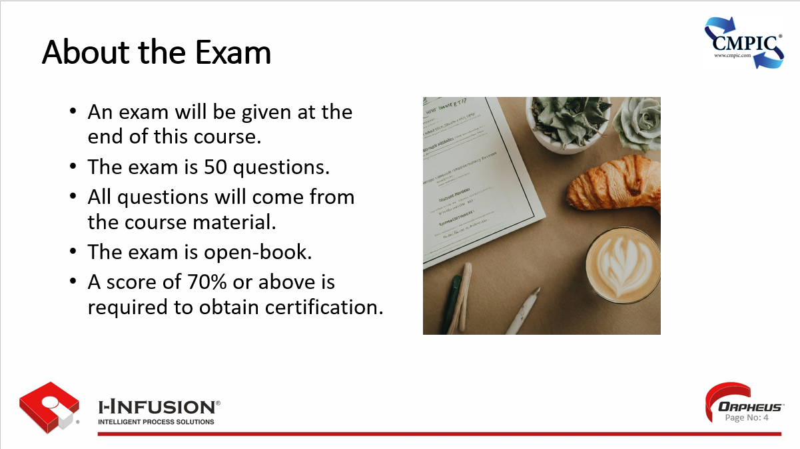

# Copyright Information

* I-infusion, Inc. copyrights this training course material may not be copied, transferred, sold, posted on any Internet or intranet, or used to teach classes by anyone else.
* Photographs were purchased for use in this course from Adobe Stock Photo and are subject to copyright and may not be copied, transferred, sold, or used in any fashion outside this text.

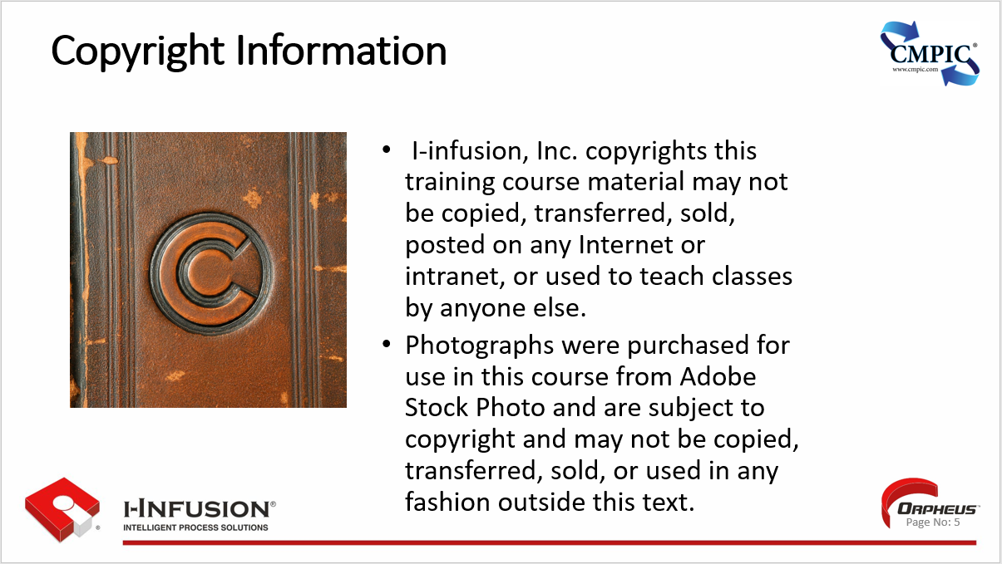

# Structure and Use of this Training

Continuous Process Improvement (CPI) provides organizations with a method for analyzing how work is currently being done and how processes can be improved to do the job more efficiently and effectively on an ongoing basis. CPI has evolved as an overall approach from separate performance improvement schools of thought originating in the private and public sectors.

* **Lean**, which evolved with the increased voice of the customer value-added focus from Just-in-Time – initially in manufacturing industries;
* **Six Sigma**, which evolved from Shewhart, Deming, and Juran’s statistical quality control and total quality management focus on satisfying customer expectations across multiple sectors;
* **Theory of Constraints** has evolved through continual refinement by Eli Goldratt to a present stage of advanced planning capability through Critical Chain functionality utilized in both the public and private sectors.

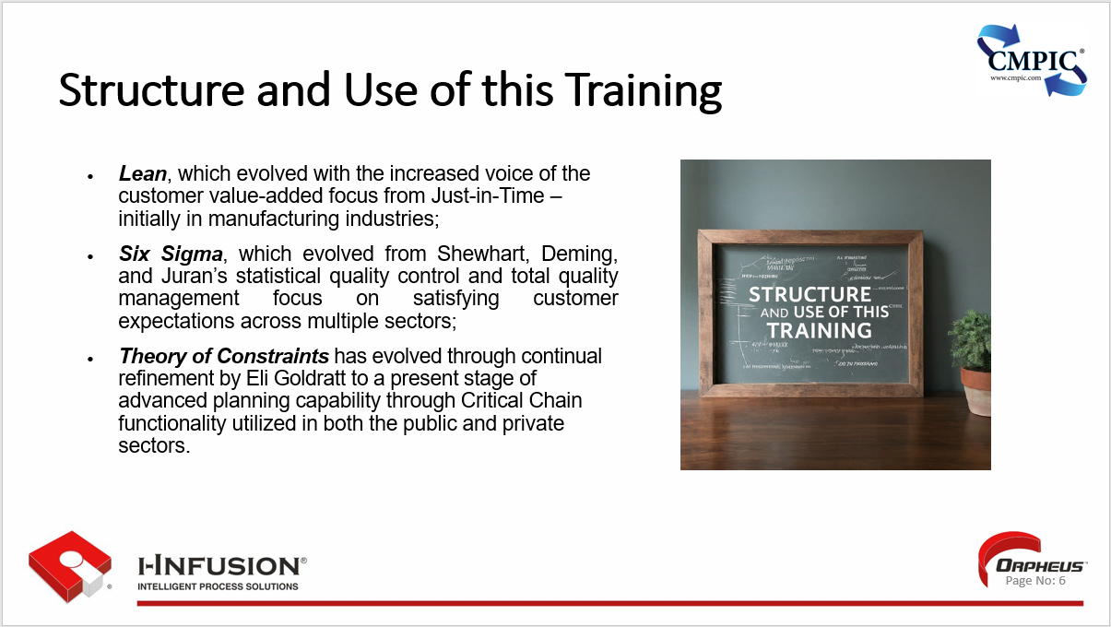

# Let’s Introduce Ourselves

* Student introductions
  + Background & experience
  + Organization
  + Responsibilities
  + Types of “products” goals, etc.
* Instructor introduction
  + Background & experience

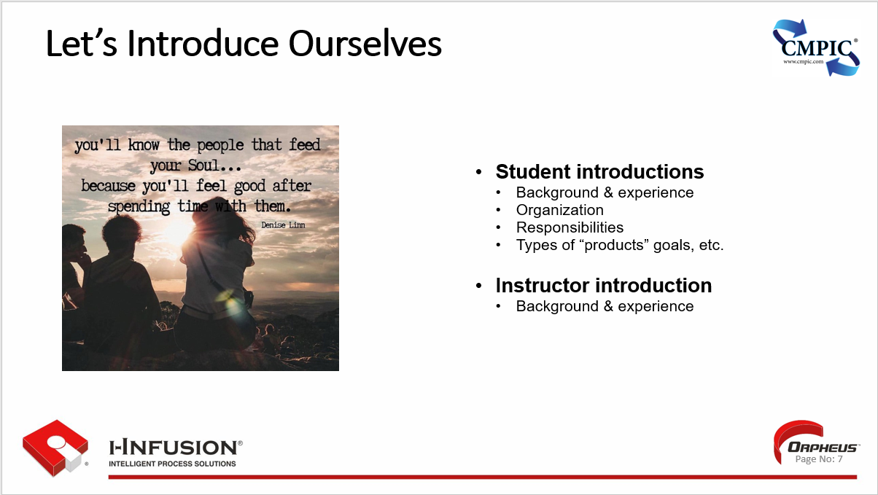

# Objectives of this Course

* Understand the fundamentals of Business Process Reengineering (BPR).
* Understand the fundamentals of Continuous Process Improvement (CPI).
* Understand how CM’s Functions and Principles impact BPR and CPI.
* Learn how to identify and analyze core business processes.
* Understand the principles of continuous process improvement (CPI).
* Develop skills to redesign processes for efficiency and effectiveness.
* Apply BPR principles to real-world scenarios.
* Develop a plan for implementing CPI initiatives and fostering a culture of continuous process improvement within organizations.

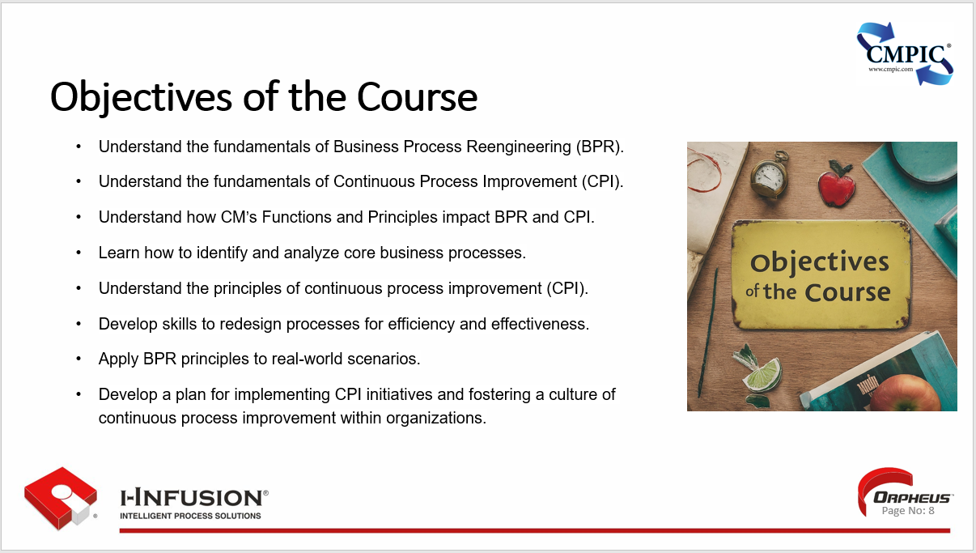

# Outline of the Course

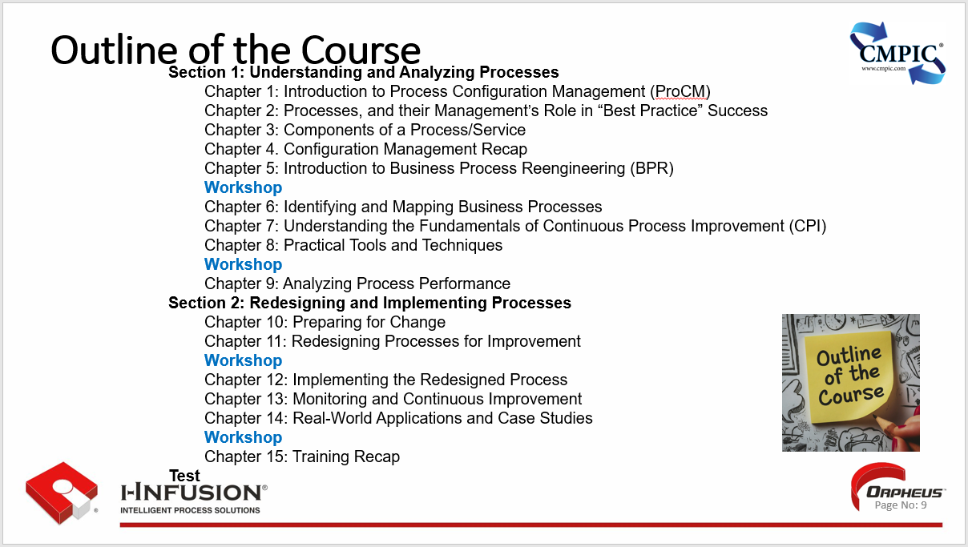

# Section 1: Understanding and Analyzing Processes

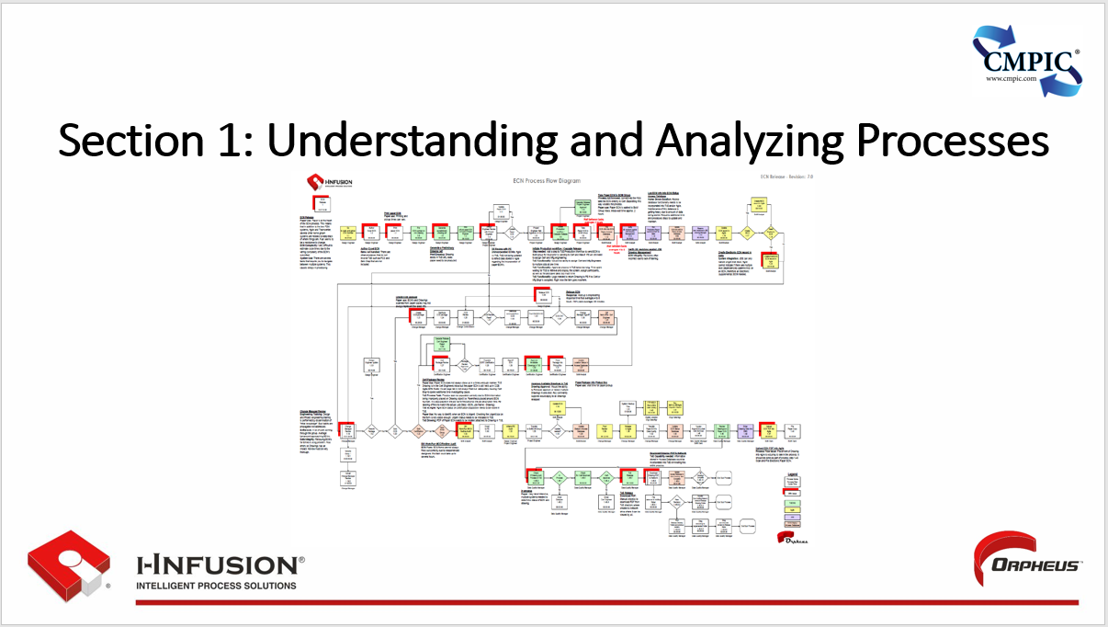

## Chapter 1: Introduction to Process Configuration Management (ProCM)

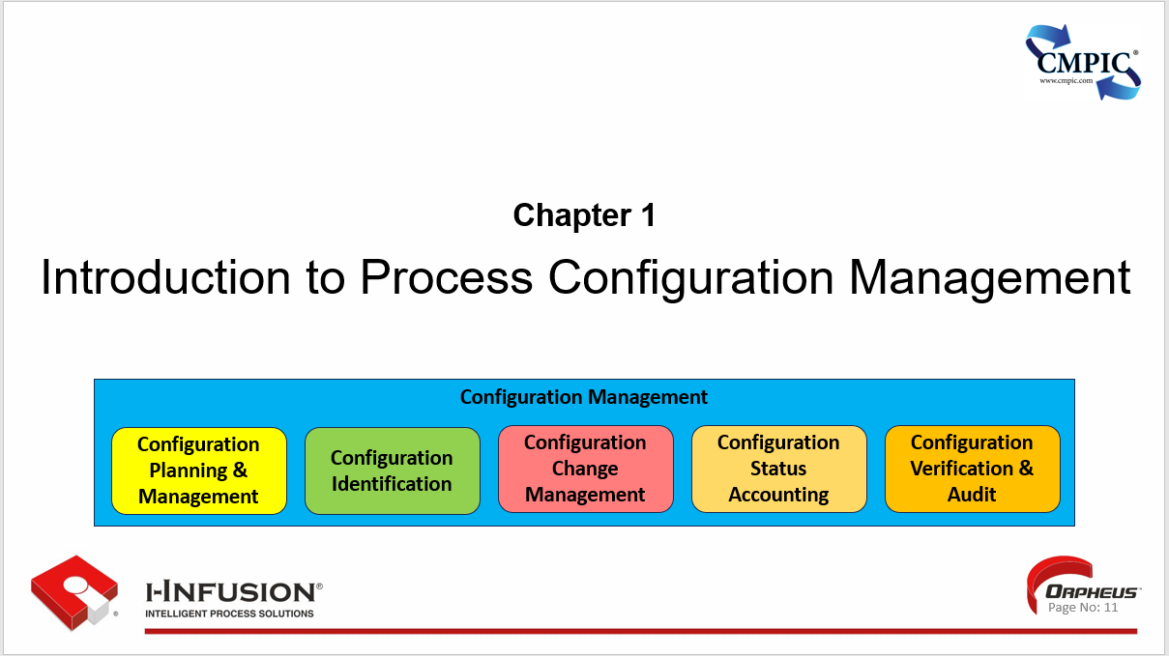

Process Configuration Management (ProCM) and by extension activities, capabilities, and services are products whose configurations need to be managed using appropriate SAE EIA649 CM functions and principles. In this chapter we will take a look at what ProCM is, how it interrelates to services and processes, its role in digital thread/digital twin paradigms, its central role in Model-based initiatives, and the key components of a process and/or service that require the application of appropriate CM.

**Chapter 1. Outline**

* Process Configuration Management (ProCM)
* What is a Service?
* What is a Process?
* Who Owns Processes?
* CM’s Role in Process Management
* Key Points

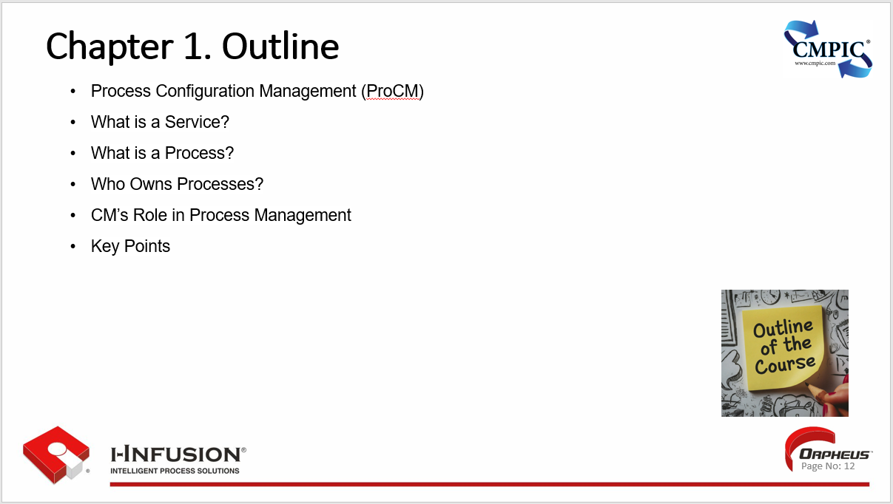

### Process Configuration Management (ProCM)

Getting Started with ProCM: The first step in implementing ProCM is to identify and prioritize the processes that are critical to the organization's success. Once these processes are defined, they can be documented, analyzed, and optimized using ProCM tools and techniques.

* **What is ProCM?** PCM is a systematic approach (i.e., a set of inter-related processes, management techniques and CM supporting tools) to managing and controlling business and technical processes within an organization to ensure:
* That they are what they should be;
* That changes to them are properly evaluated, authorized, implemented, as well as tracked and documented;
* That all information necessary to define and manage our configurations and data are kept:

(a) current and accurate,

(b) structured for user’s needs, and

(c) readily available to all who need to know.

* ProCM ensures processes are well-defined, documented, and consistently executed to achieve desired outcomes.
* ProCM enhances work-place **harmony**.

The workplace becomes a place where the employees feel valued and fairness is present.

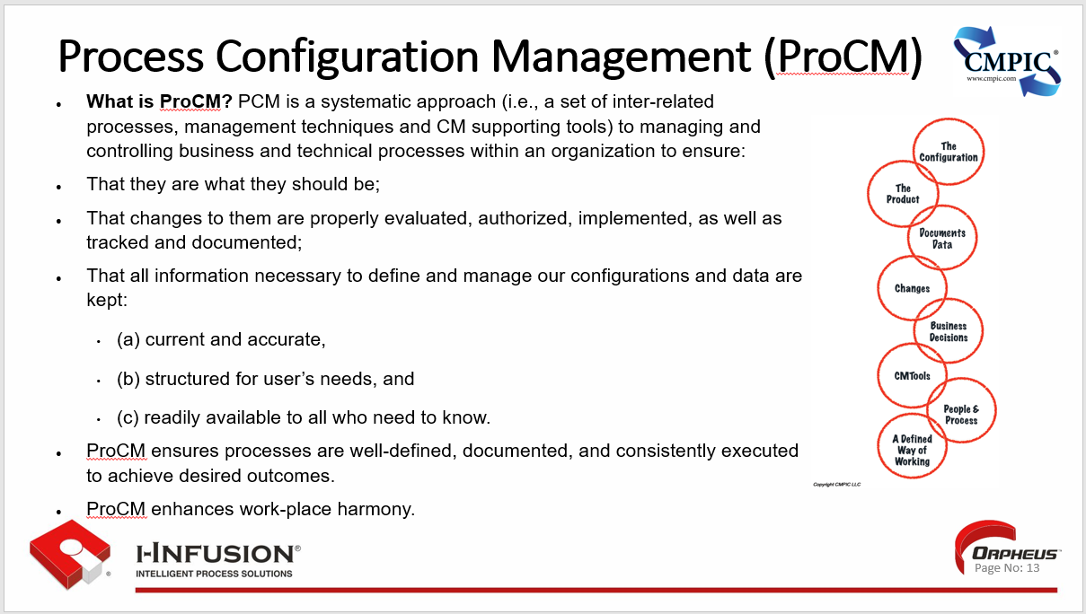

* **Why ProCM is Important**: ProCM is crucial for maintaining operational efficiency, ensuring regulatory compliance, real-time communication, and facilitating continuous improvement initiatives. It helps organizations reduce errors, minimize risks, and improve overall performance. Processes are an enterprises most valuable IP.
* **Key Component(s) of ProCM**: Communication; ProCM encompasses various elements, including process modeling (e.g., flow, inputs, outputs, controls, resources), documentation, version control, change management, and verification all real-time if appropriate. These components work together to create a structured framework for managing and communicating process(es) insight, oversight, knowledge throughout their lifecycle.
* **Benefits of ProCM**: Implementing ProCM can lead to improved process efficiency, enhanced quality control, increased transparency, improved communications, better decision-making, and reduced costs. It can also help organizations adapt more effectively to changing business needs and regulatory/governance requirements.

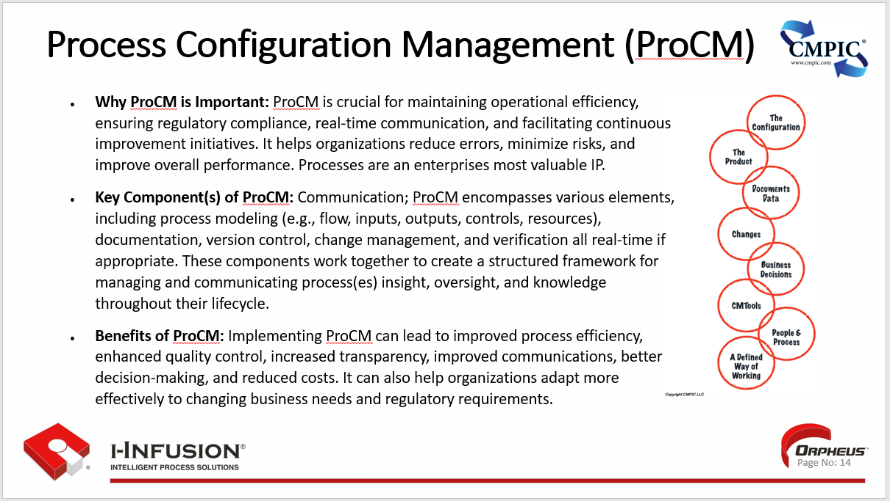By providing the appropriate discipline/rigor to the processes our organization executes, Configuration Management enables the organization to appropriately understand, quantify, and manage the **services, capabilities, and activities** offered by and/or engaged with by our organization. (Click)

Why is this important? (Click)

Services, capabilities, and activities account for approximately 77% of the United States GDP (i.e., over $21 billion USD) (Click) and 65% globally (i.e., over $75 billion USD). Providing “service” is the goal of the functional areas of an organization (e.g., Engineering, Manufacturing, Quality Assurance, Human Resources, Information Technology, finance, etc.).

(Click) Quantifying services down to the processes and constitute components (i.e., steps and decisions, as well as the life cycle product information) level provides an integrated single source of truth framework for our enterprises most valuable Intellectual Property assets; **the services and processes utilized and provided**, constituting **the recipes for enterprise operation**.

The desired outcomes we aspire to reach each day per our role.

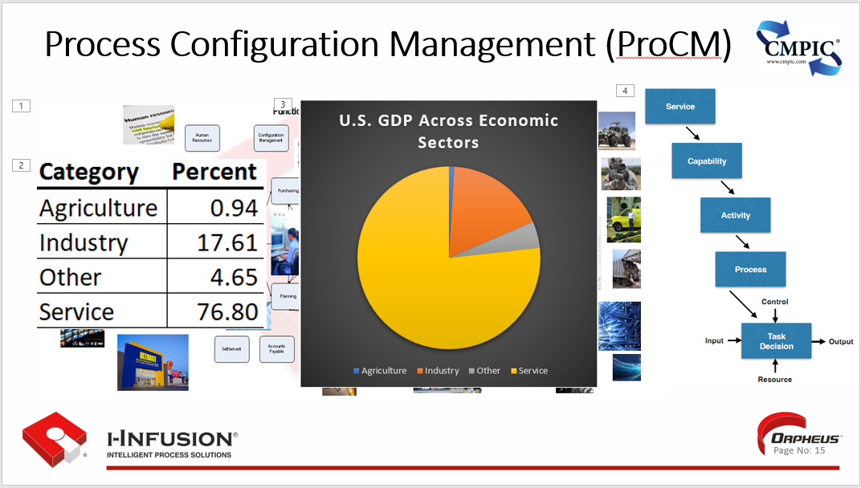

### What is a Service?

In the context of Business Process Engineering/Reengineering (BPR), a service refers to any value-adding activity, process, or task performed by an organization to meet the needs and expectations of its customers.

During BPR initiatives (which many of you have, or have had going on within your organizations), services are often scrutinized to identify areas for improvement or redesign. This may involve eliminating unnecessary steps, automating manual tasks, or rethinking the entire service delivery model to achieve greater efficiency, cost-effectiveness, and customer satisfaction.

The focus on services in BPR is driven by the recognition that they play a crucial role in creating value for customers and differentiating an organization from its competitors.

By optimizing its services, a company can enhance the customer experience, improve its operational efficiency, and ultimately achieve a competitive advantage.

Services can be tangible or intangible and can encompass a wide range of offerings, such as:

* **Customer service:** Providing assistance, support, and information to customers.
* **Product or service delivery:** Fulfilling customer orders, providing installations, or delivering ongoing support.
* **Information processing:** Handling and analyzing customer data, generating reports, or managing information systems.
* **Decision-making:** Approving requests, resolving issues, or making strategic choices that impact the customer experience.

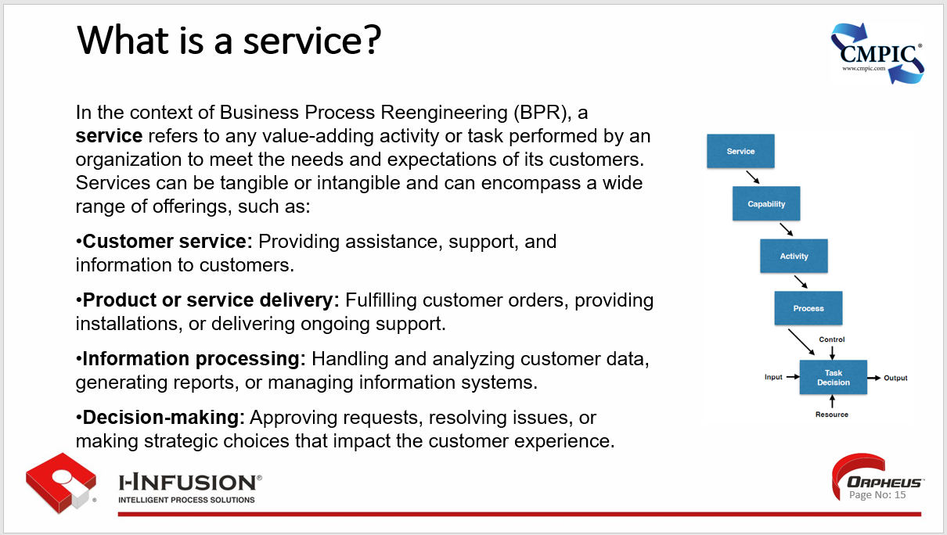

Services can be decomposed in a number of ways. We at i-infusion/CMPIC decompose services into capabilities, into activities, into processes. Truth be said, below a service it’s all a process, task, or decision.

### What is a Process?

A process is nothing more than the subprocess(es), step(s), and decision(s) involved in accomplishing work with the goal of achieving a desired outcome.

Everything we do in our lives where a desired outcome is the goal involves processes, and there are lots of them.

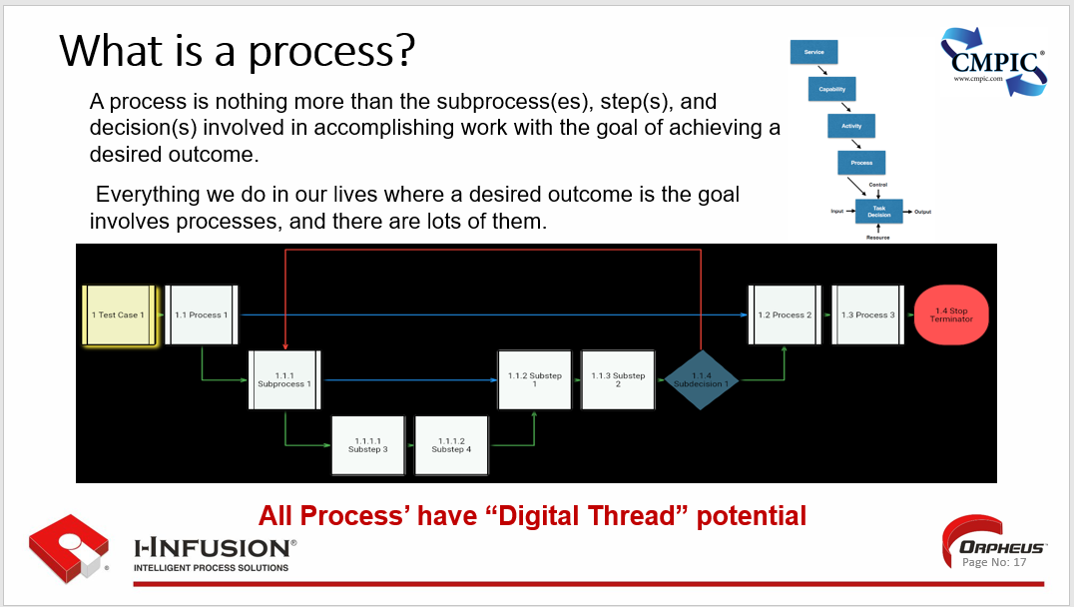

### What are some examples of process?

Here are some examples:

Product Development Sales and Marketing Procurement

Customer Service/Support Client Onboarding

Finance Operations Production

Accounting Management Human Resources

Quality Writing a work order Repairing a valve

Preparing a message Mooring a ship Shooting a weapon

Ordering a part Allocating a budget Conducting a drill

Getting out of bed Forming a test Loading a missile

Conducting an inspection Fueling an aircraft Directions part of a recipe

**All Process’ have “Digital Thread” potential**

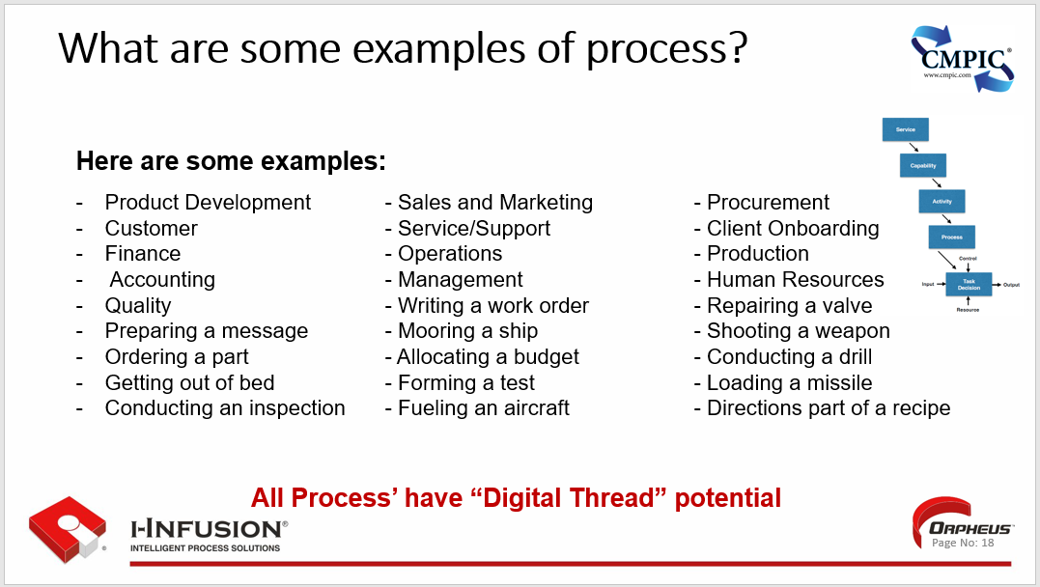

Some processes, such as conducting an inspection or mooring a ship, are very important.

If such a process performs very poorly-if it is not doing what it is supposed to do, the command might be unable to complete its mission.

Other processes-for example, ordering a part, or developing a budget-are less significant in terms of the management mission.

But, while they are less important to the organization’s overall operation, such routine processes are still vital to the smooth functioning of an office or work center.

Besides differing in importance, processes can be either simple or complicated.

Some processes may be comparatively simple. Repairing a valve, for example, may be a relatively simple task involving only a few people and straightforward procedures.

On the other hand, some processes, such as conducting a main space fire drill, are very complicated. Many people are involved and numerous process steps and contributing processes are required.

### Who Owns Processes?

* Stakeholders and those who have a process role and responsibilities. Everyone has a stake in one or more processes. Groups of individuals usually share in and "own“ the activities that make up a process.
* But the one individual who is ultimately responsible and accountable for the proper working of the process is known as the "process owner." The process owner is the immediate supervisor or leader who controls the entire process from beginning to end.
* A process owner may choose to be a team leader and participate directly in the actions of a process improvement team.
* The process owner may decide to delegate the team leadership role to someone knowledgeable about the process.
* Whatever the case, it is very important for the process owner to stay informed about the team's actions and decisions affecting the process.

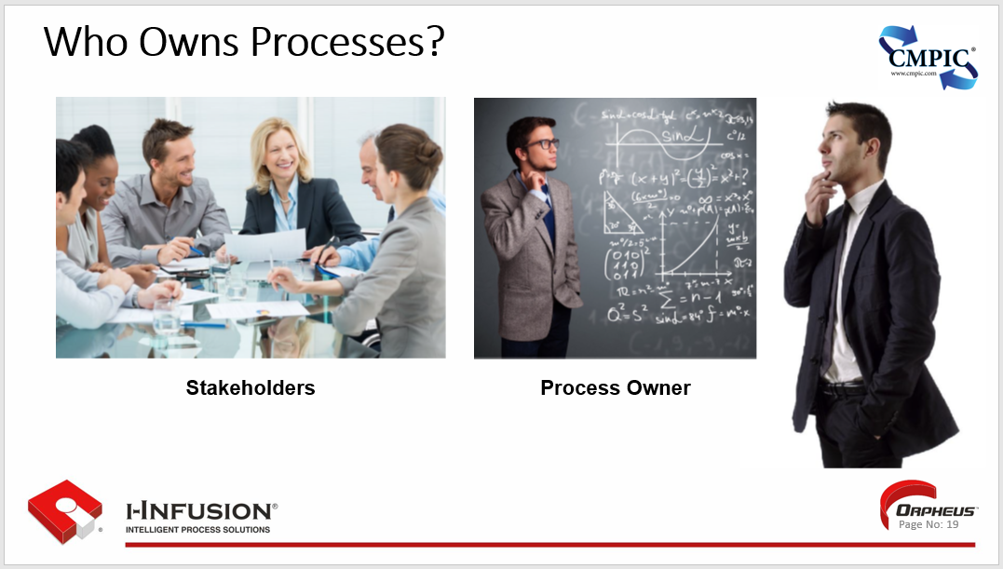

Mapping the flow of and controlling the framework for enterprise execution is a great role for CM professionals. By becoming stewards of the process, they will be privileged to executive level insight, oversight, and knowledge of enterprise activities

### CM’s Role in Process Management

* CM professionals need to become **stewards** of our enterprises Business and Technical Processes.
  + **Steward**: A person who looks after and/or has responsibility for something.
* Processes are an enterprise's most valuable IP. They’re the “music” enterprises play to, to get a” desired” result.
* Process execution provides the contextual boundary to appropriately scope CM planning.
* CM is a discipline that is most effective when all five functions and all 40 principles are applied as tasks are performed.
* This is accomplished by integrating CM activities into the enterprise’s business and technical processes.
* CM activities and logs of CM events can be used to provide real-time insight, oversight, and knowledge information, interface managed, securely communicated information in the users desired format.
* Using ProCM guidance, planning and executing more and better enterprise CM Orchestration has a significant, quantifiable ROI including more effective, efficient, lean, resilient, financially responsible and profitable enterprise operations.
* CM where it makes a difference, and is making a difference.
* The minimum bar for providing enduring truth, trust, and traceability incontrovertibly.

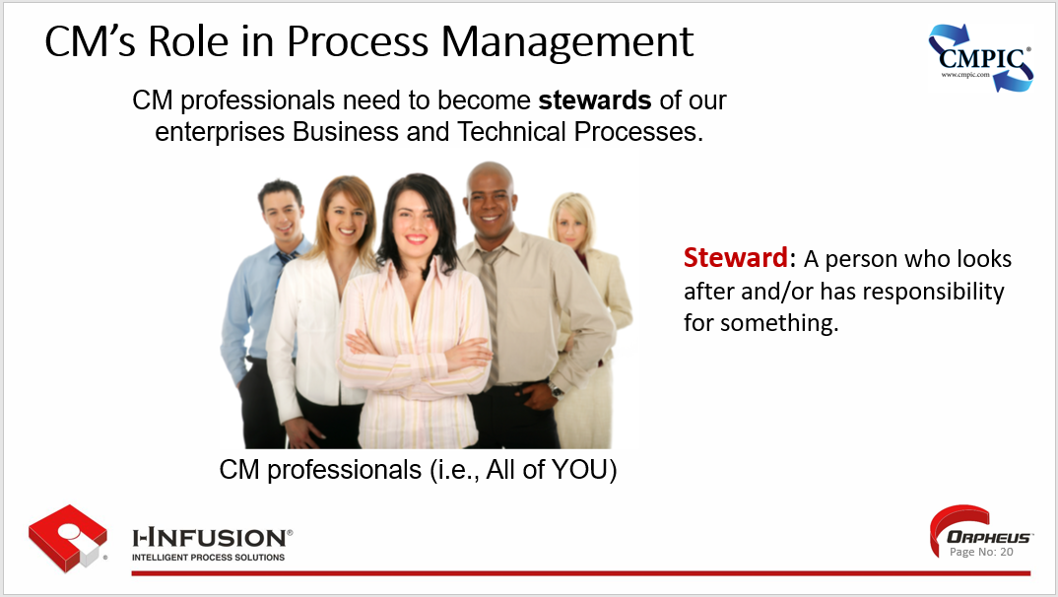

### Key Points

Key Points for this chapter are:

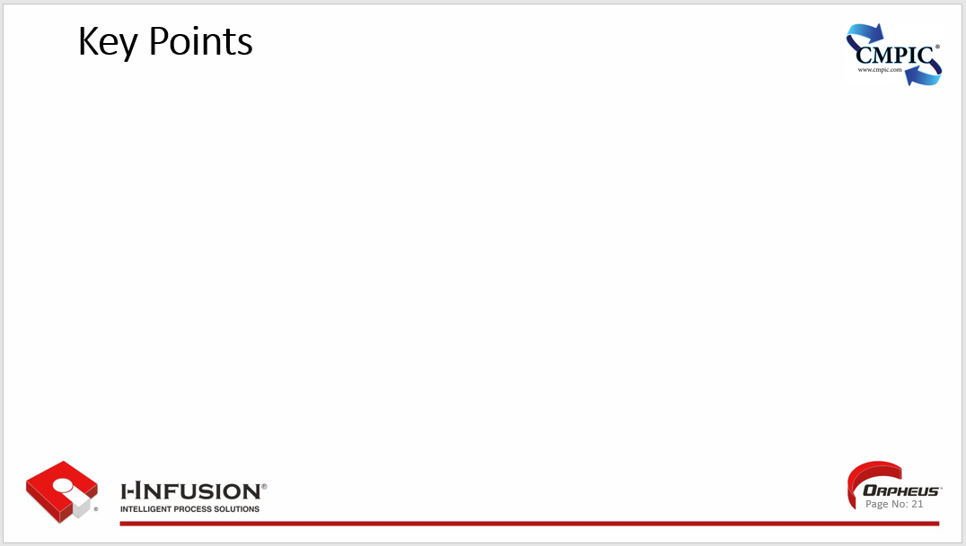

## Chapter 2: Processes, and their Management’s Role in Emerging “Best Practice” Success

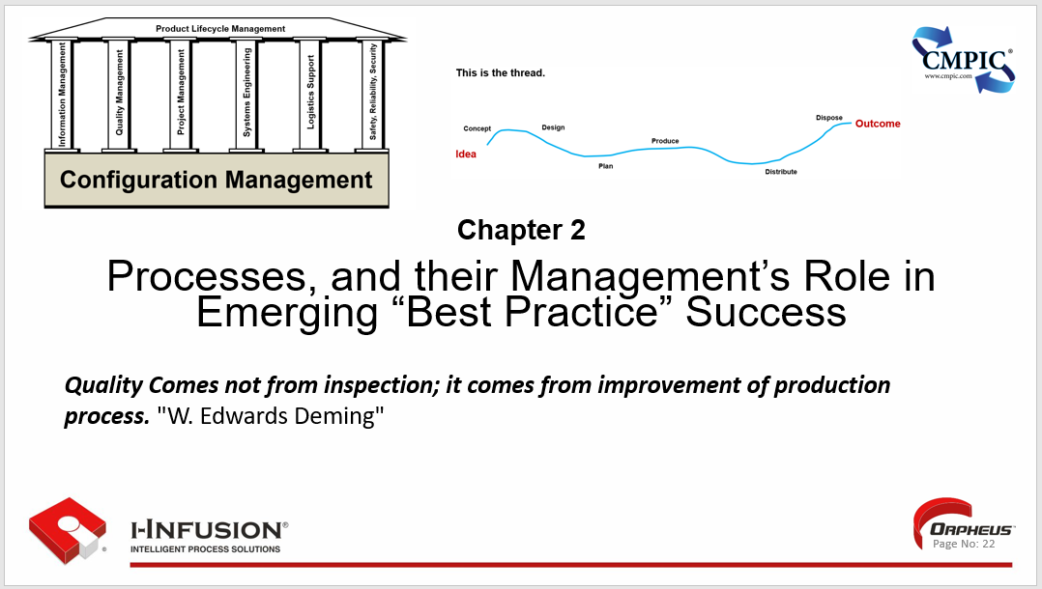

Process Configuration Management (ProCM) and by extension activities, capabilities, and services are products whose configurations need to be managed using appropriate SAE EIA649 CM functions and principles.

**Chapter 2. Outline**

* Process and Their Management's Role in the Digital Thread and Digital Twin
* Process and Process Management's Role in the Digital Thread
* Process and their Management Play a Vital Role in the Digital Twin Concept
* Process and Process Management Play a Central Role in Model-Based Initiatives
* Key Points

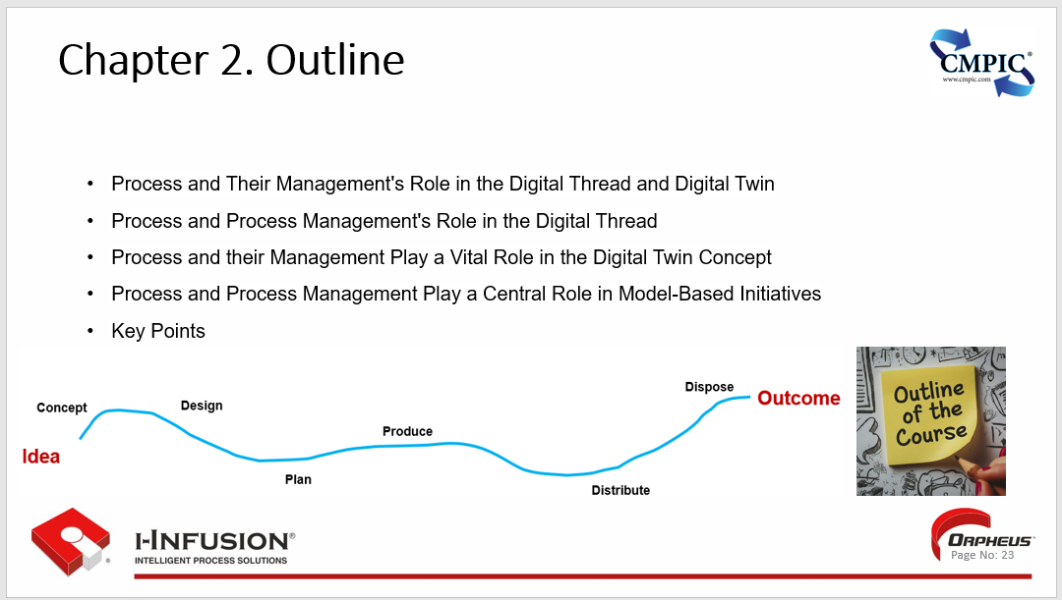 In this chapter we will take a look at what ProCM is, how it interrelates to services and processes, its role in digital thread/digital twin paradigms, and its central role in Model-based initiatives.

### ProCM's Role in the Digital Thread and Digital Twin

**CM’s 5 functions and 40 Principles play a critical role in digital transformation activities and frameworks.**

**Their role is characterized by achievable outcomes such as:**

* **Process Definition & Standardization: CM integrated into business and technical process(es) management creates a structured framework for data and information flow by defining and standardizing processes, which is essential for establishing a solid Digital Thread.**
* **Data Integration & Management: CM integrated into business and technical process(es) ensures seamless data integration and management throughout the product lifecycle, making the Digital Thread a reliable source of information.**
* **Process Simulation & Optimization: By using the Digital Twin for simulation, CM integrated into business and technical process management helps identify and address issues before physical implementation, improving efficiency.**
* **Real-time Monitoring & Control: CM integrated into business and technical the Digital Twin enables real-time process monitoring, quickly detecting deviations and timely corrective actions.**
* **Cross-functional Collaboration: CM integrated into business and technical process management facilitates collaboration and information sharing across different teams, enhancing decision-making and overall product lifecycle management.**

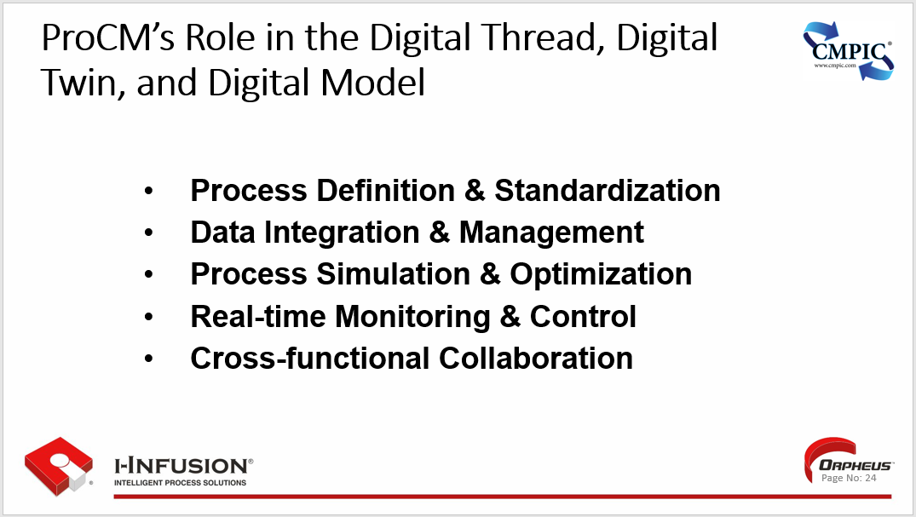

If your thread is appropriately technologically enabled, we call this a “digital thread”. (Click)

The **Digital Thread** refers to the **process** and **tools** used for communicating information through a **connected flow** (Click) of a product’s data sets throughout a product’s life cycle connecting information from various organizational processes, utilizing a complete digital information structure (i.e., process flow to the task and decision level, including variants, **from concept to disposal**) and **a closed loop, branching enabled, change process to manage its evolution over time.**

Most “threads” today, regardless of industry are “hybrid”, meaning that they contain both analog (paper) and digital(eDocs) artifacts requiring interoperability and exchange.

(Click)

Process, and the management of process empowered with appropriately integrated, and enabled CM, play a crucial role in the digital thread concept, ensuring seamless integration and data flow throughout the product lifecycle. It helps to establish clear and consistent processes for managing product data, ensuring that all stakeholders have access to the latest and most accurate information.CM enabled effective processes and process management enable organizations to identify and eliminate inefficiencies, streamline (lean)workflows, and improve overall productivity and quality.

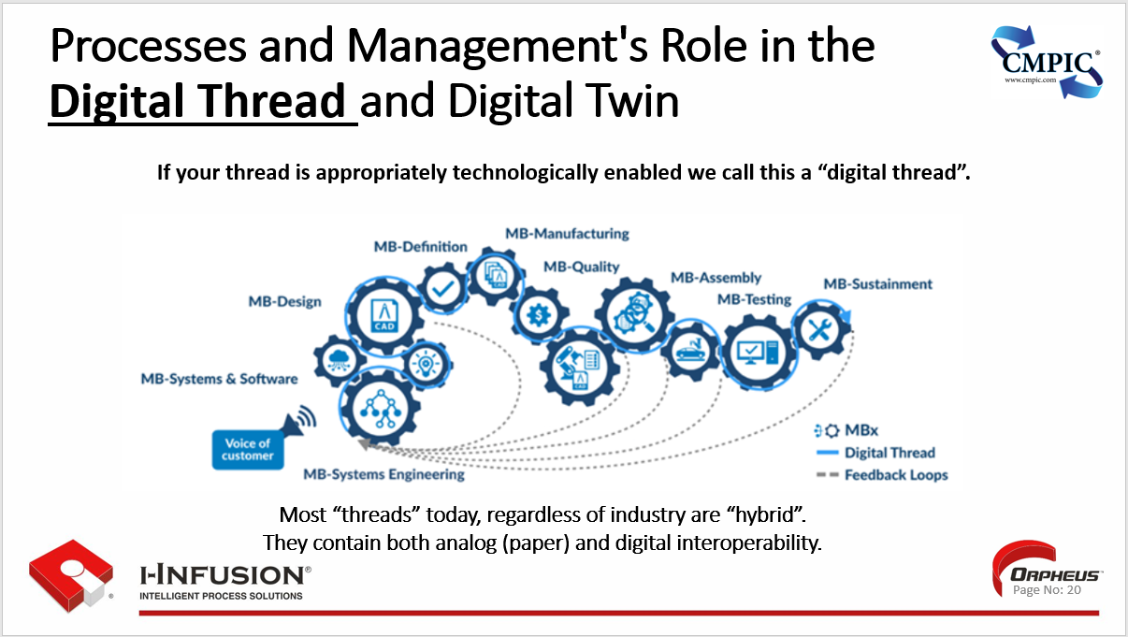

### ProCM and Process Management Play a Vital Role in the Digital Thread Concept

**Here are some specific ways in which ProCM and process management are used in the digital thread concept:**

**Data Collection and Management:** ProCM in combination with process management establishes procedures for collecting, organizing, and storing product data throughout the product lifecycle. This includes data from the design, manufacturing, testing, and maintenance phases.

**Process Integration:** ProCM in combination with process management integrate various processes and systems involved in the product lifecycle, ensuring that data flows seamlessly between them. This eliminates silos and facilitates collaborative decision-making.

**Change Management:** ProCM in combination with process management provide a framework for managing changes to product design, manufacturing processes, or other aspects of the product lifecycle. This ensures that changes are implemented in a controlled and coordinated manner, minimizing disruptions and ensuring product quality.

**Risk Management:** ProCM in combination with process management incorporates risk management practices to identify and mitigate potential risks throughout the product lifecycle. This helps to prevent costly delays, defects, or recalls.

**Performance Monitoring:** ProCM in combination with process management establishes metrics and KPIs to monitor the performance of product development and manufacturing processes. This enables organizations to identify areas for improvement and make data-driven decisions to optimize performance.

**Continuous Improvement** ProCM in combination with process management promotes a culture of continuous improvement, encouraging employees to identify and suggest process enhancements. This leads to ongoing optimization of the digital thread and overall product lifecycle management.

Because “Digital Threads” execution can be guided using appropriate enabling technology, **event captured information** can be used in and for simulation and analysis (e.g., Generative AI) enabling value stream mapping, demand flow planning, business process reengineering, lean execution, and continuous process improvement.

Processes and their management **(including appropriate CM)** are an essential element of the digital thread concept, enabling organizations to achieve greater efficiency, effectiveness, and innovation in product development, manufacturing, and sustainment. By implementing effective processes and process management practices, **again including CM**, organizations can streamline operations, reduce costs, and ensure the development, manufacture, delivery and maintainability of high-quality products that meet customer expectations.

This value has been recognized by many including NATO. NATO has recently initiated a project to study and document CM activities in the Digital Thread and Digital Twin(s) environment.

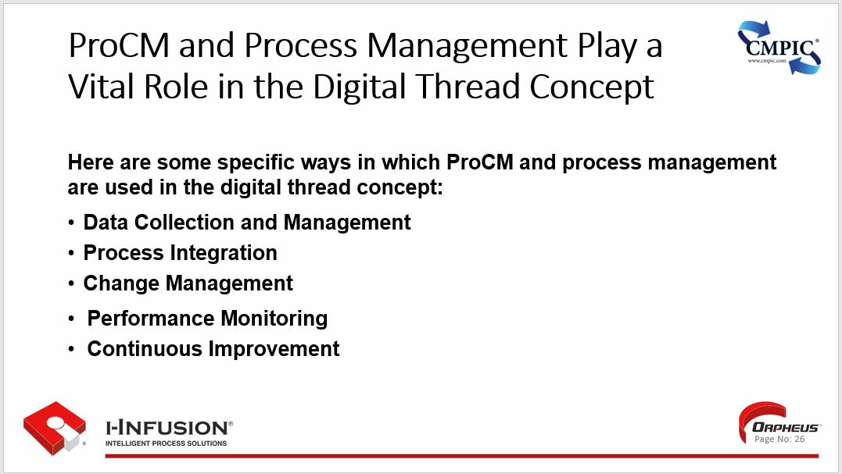

(Click)

NATO’s study concluded that appropriate CM activities integrated effectively have an overwhelmingly positive benefits to overall operations and sustainment activities.

Benefits specifically in the areas of:

* **Data Backbone: Processes (the “Digital Thread”) generate the data that feeds and updates the Digital Twin. CM integrated Digital Threads ensure data accuracy, consistency, and timeliness, enabling the Digital Twin to be a reliable virtual representation of the product counterpart.**
* **Simulation & Optimization: By capturing the sequence and interdependencies of processes, the Digital Twin can simulate various scenarios. Process management ensures these simulations accurately reflect real-world process execution, allowing for effective optimization and decision-making.**
* **Real-Time Monitoring & Control**: As the Digital Twin mirrors the product’s operations in real-time, process management provides the structure to interpret this data. It enables prompt detection of anomalies or deviations from expected process behavior, facilitating timely interventions.
* **Continuous Improvement:** The Digital Twin provides a platform for testing and refining processes in a virtual environment. Effective process management allows these improvements to be seamlessly translated into the physical operations, driving continuous enhancement.
* **Lifecycle Management:** Process management plays a vital role throughout the entire lifecycle of the Digital Twin, from its creation and validation to its ongoing maintenance and updates. This ensures the Digital Twin remains relevant and accurately reflects the physical system it represents.

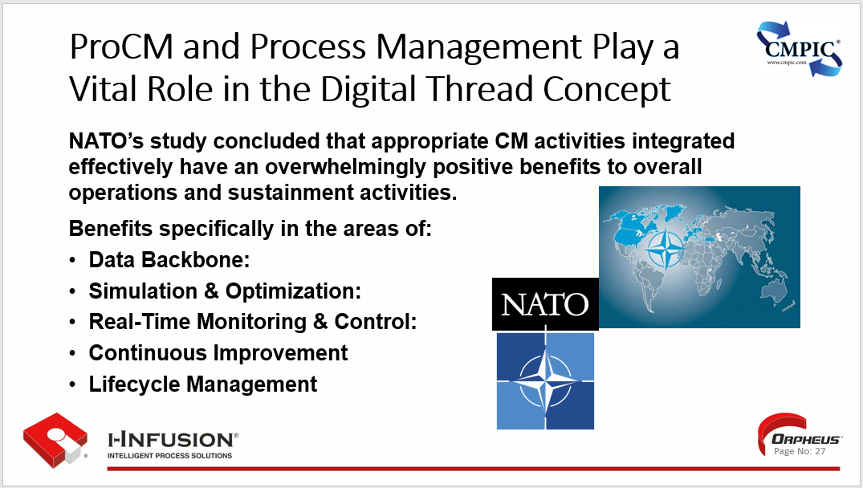

### Process and their Management Play a Vital Role in the Digital Twin Concept

We can quantify and preserve our threads down to the task level. At the task level and every level up from there (i.e., service, activity, capability) we can capture and quantify what is required (down to the attribute level, including security) for inputs to the task; what is/are the desired outputs; what controls apply, and what resources are required for appropriate execution of the task, and the task itself.

We can repeat them providing temporal feedback.

We can guide their execution through technologically enabled workflows.

We can measure their performance, provide status, and continually improve them.

We call this a Digital Twin.

(Click)

The **Digital Twin** is the data and intelligence that represents the structure and interrelated conditions (digital thread) of a physical item or process of any type, at any point in its life cycle.

Its purpose is to understand the previous and current datasets that provide the information to understand past and present operations, and make predictions about the future state of an item.

(Click)

Digital Twins are very powerful digital datasets that can be used to optimize the physical item or process, significantly improving operational performance and enterprise business and technical processes.

Processes and their management, **including appropriate CM**, play a vital role in the digital twin concept, facilitating the translation of real-time data from physical assets into actionable insights that drive process optimization and decision-making.

By connecting the physical world with its digital counterpart, process management bridges the gap between data collection and process improvement.

Here are some specific ways in which processes and process management are used in the **digital twin** concept: (Click)

**Real-time Data Monitoring**: Process management integrates real-time data from sensors and other monitoring devices into the digital twin, providing a comprehensive view of the physical asset's performance and behavior.

**Process Analysis and Simulation:** Process management utilizes the digital twin to analyze and simulate process flows, enabling organizations to identify bottlenecks, inefficiencies, and potential areas for improvement.

**Predictive Analytics and Scenario Planning:** Process management employs predictive analytics to anticipate potential issues or disruptions in the physical process, allowing for proactive intervention and contingency planning.

**Process Improvement and Optimization:** Process management uses insights gained from the digital twin to identify and implement process improvements, such as workflow modifications, resource allocation optimization, and parameter adjustments.

**Decision Support and Root Cause Analysis:** Process management provides decision support tools that leverage the digital twin to analyze historical data and identify root causes of process deviations or anomalies, enabling informed decision-making.

**Training and Education**: Process management utilizes the digital twin for training purposes, allowing employees to visualize and simulate process flows, enhancing their understanding and operational efficiency.

**Collaboration and Knowledge Sharing:** Process management facilitates collaboration and knowledge sharing between different departments or teams involved in the process, ensuring a holistic approach to process optimization.

In essence, processes and process management, **including appropriate CM**, serves as the bridge between the digital twin and real-world process improvement. By effectively managing and utilizing the data generated by the digital twin, organizations can gain valuable insights, identify areas for optimization, and implement process improvements that lead to enhanced efficiency, productivity, and cost savings.

In order for digital threads and Digital Twins to realize their possible benefits they need an **authoritative source of truth** to manage product information through.

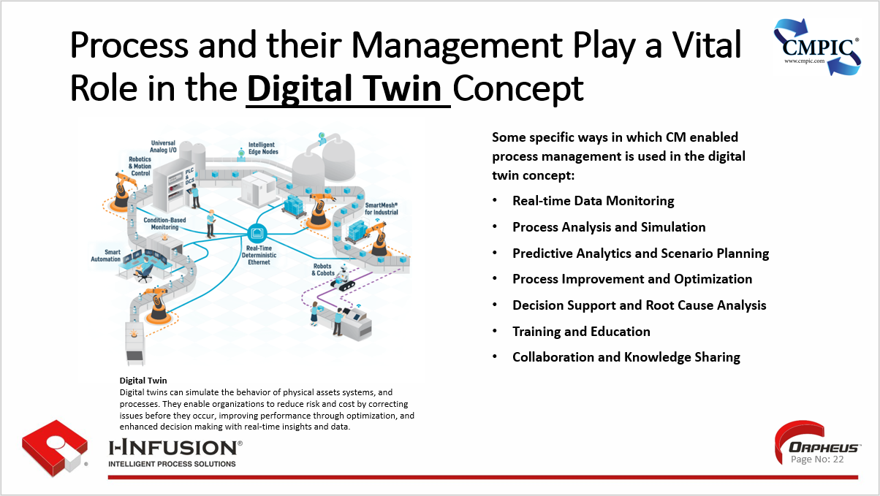

(Click)

### Model-Based Initiatives; ProCM and Process Management Play a Central Role

**A Process as the Core:**

* **Model-Based Definition (MBD):** The heart of model-based initiatives is capturing and conveying product information through a digital model. The processes that create, modify, and use this model need to be well-defined and managed to ensure data integrity and consistency.
* **Model-Based Enterprise (MBE):** Beyond just design, MBE extends the use of the model across the entire product lifecycle. This requires seamless process integration and management from concept to disposal to ensure the model remains the single source of truth.

**Process Management's Role:**

* **Standardization and Optimization:** Process management helps to establish clear, repeatable processes for creating, updating, and validating the digital model. This reduces errors, improves efficiency, and facilitates collaboration.

**Configuration Management's Role:**

* **Change Management:** With the digital model as a central asset, any changes need to be carefully managed. Process management provides a structured approach to evaluating, approving, and implementing changes, minimizing disruptions and ensuring traceability.

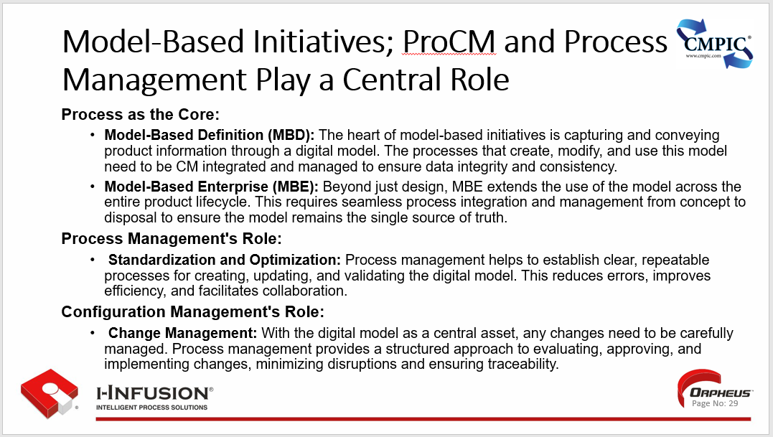

### Process and Process Management’s Role in Model-Based Initiatives Integrity

Here are three critical areas where process management impact model integrity:

* **Data Flow and Integration:** Process management ensures data flows seamlessly between different functions and systems, keeping the digital model up-to-date and accurate. This is crucial for making informed decisions and avoiding costly mistakes.
* **Collaboration and Communication:** A model-based approach requires collaboration across various disciplines. Process management facilitates communication and knowledge sharing, breaking down silos and enabling teams to work together effectively.
* **Continuous Improvement:** Process management fosters a culture of continuous improvement, encouraging teams to identify and implement optimizations to both the model and the processes that support it.

**In summary:** Without well-defined and managed processes, the digital model risks becoming fragmented, inaccurate, or difficult to use.

Process management provides the necessary structure and control to unlock the full potential of model-based initiatives, enabling organizations to achieve significant benefits in terms of cost reduction, quality improvement, and faster time-to-market.

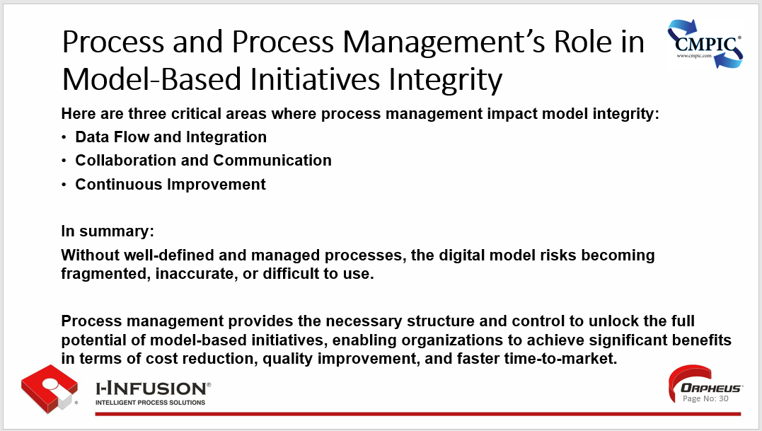

### Model Types

Let’s take a look at various model types and their use in enabling a model-based enterprise. (Click)

Model-Based Definition (MBD) is the practice of using a 3D CAD model and associated data instead of relying solely on engineering drawings. (Click)

Model-Based Systems Engineering (MBSE) is an engineering discipline in its own right that, simply put, attempts to describe how things interrelate in a predictable and controllable manner. Tools like: Cameo, MagicDraw.

Problem is, there are no current connections between MBSE and MBD. This is where the MBP plays as vital and critical role.

 This is where and why Process modeling is (Click) critical.

Model-Based Process (MBP) is the practice of using a process flow model and associated product definition and execution information creating the opportunity for operational “digital twin” business and technical processes.

Process not only provides context, but also scope for our MBSE modeling. It facilitates the tying together (i.e., digital thread) requirements, the product info, and testing (verification) across the full lifecycle of the product.

(Click)

A Model-Based Enterprise (MBE) is simply an enterprise, an organization, that has based its processes on using a Model-Based Definition.

Per the National Institute of Standards and Technology (NIST), a Model-Based Enterprise (MBE) is “an organization that applies modeling and simulation technologies to integrate and manage its technical and business processes related to production and product lifecycle support.”

By leveraging data-rich models, MBE realizes an end-to-end digital vision throughout the Operational, Design, Buy, Build, and Sustain value chains.

Transition to a Model-Based Enterprise enables real-time data sharing amongst Enterprises and their Supply Chain, enabling accelerated design, reduced total cycle time, and improved quality.

A Model-Based Enterprise will accelerate an enterprises transformation capability, driving their industry competitiveness including improved Supplier collaboration.

We must remember that MBE will be evolving over time.

For now, it means 3D models are the new norm and suppliers will start receiving a 3D model’s instead of a 2D drawing.

In other areas, it is still evolving - for instance, collaboration on Model- Based Systems Engineering (MBSE) design work, the use of Process Models (MBP) to support BPR and CPI. As a result, any guidance regarding MBE must be a living document that changes as overall MBE maturity evolves.

(Click)

By effectively using CM to guide us we can provide repeatability, sustainability, and temporal management of the product information, and the product; the C in CM. 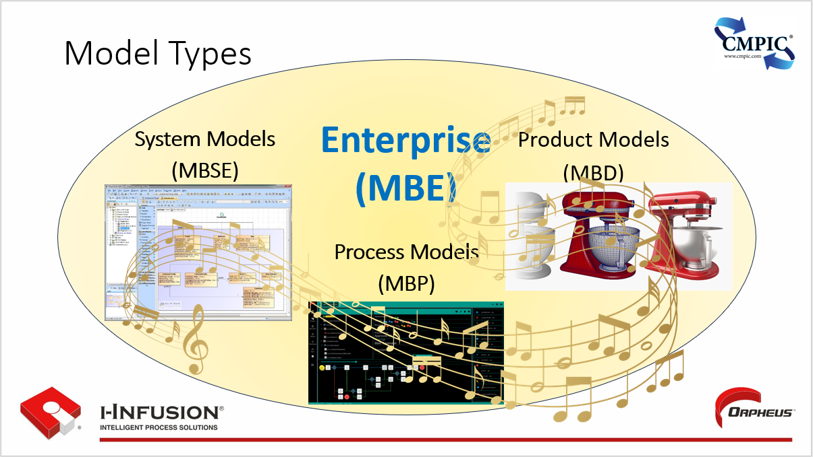

(Click)

### Key Points

Key Points for this chapter are:

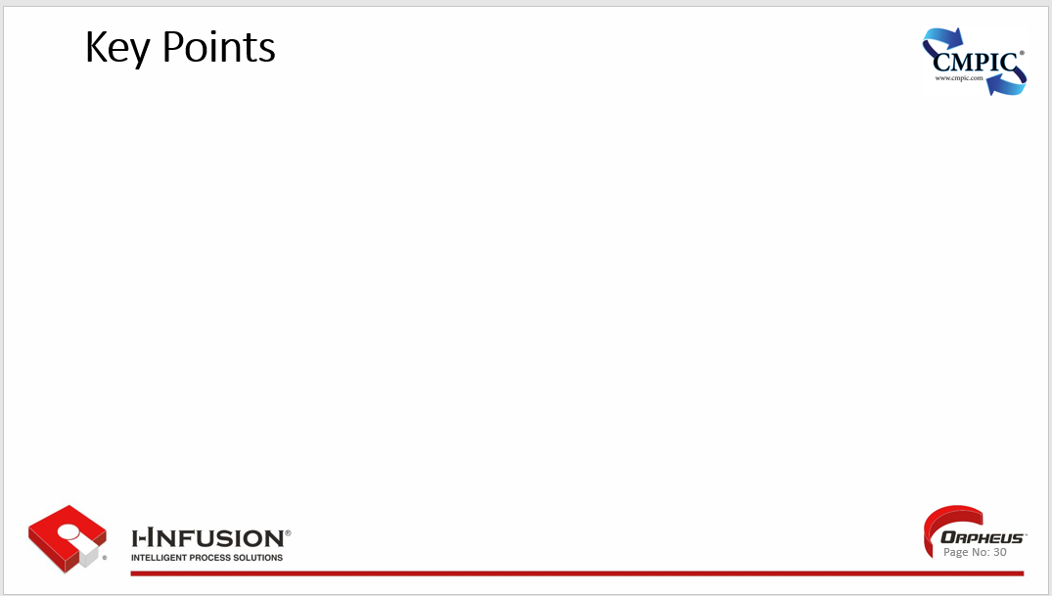

## Chapter 3: Components of a Process/Service

Process Configuration Management (ProCM) and by extension activities, capabilities, and services are products whose configurations need to be managed using appropriate SAE EIA649 CM functions and principles. In this chapter we will take a look at what ProCM is, how it interrelates to services and processes, its role in digital thread/digital twin paradigms, its central role in Model-based initiatives, and the key components of a process and/or service that require the application of appropriate CM.

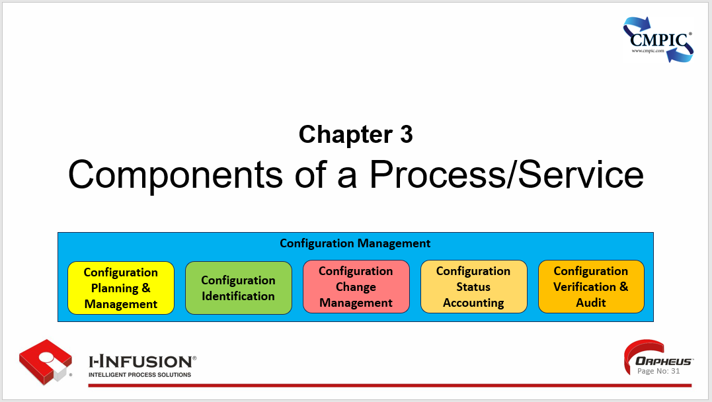

Chapter 3. Outline

* Key Components of a Process and/or Service
* Message to Leadership
* Key Points

In this chapter we will take a look at ProCM and how it interrelates to, and with understanding, quantifying, and managing the key components of a process and/or service that require the application of appropriate CM.

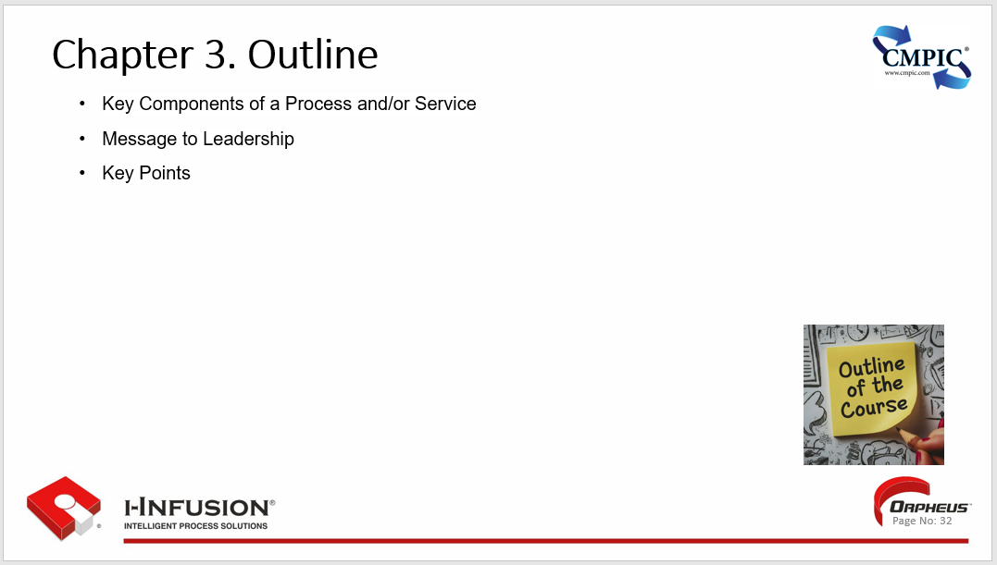

### Key Components of a Process and/or Service

To effectively define, manage, and improve a process or service, it is crucial to understand its fundamental components:

**1. Inputs:**

These are the **resources, information, or materials** that are required to initiate the process or service. They act as the raw ingredients or starting point for the transformation that will take place.

Examples include customer orders, raw materials, data, or client requests.

**2. Outputs:**

The **desired results or deliverables** produced by the process or service. These are the tangible or intangible outcomes that create value for the customer or organization.

Examples include finished products, completed tasks, satisfied customers, or improved efficiency.

**3. Activities or Tasks:**

The **sequence of steps or actions** that are performed to convert the inputs into the desired outputs. These activities should be well-defined, organized, and optimized for efficiency.

Examples include assembling a product, processing an order, providing customer support, or analyzing data.

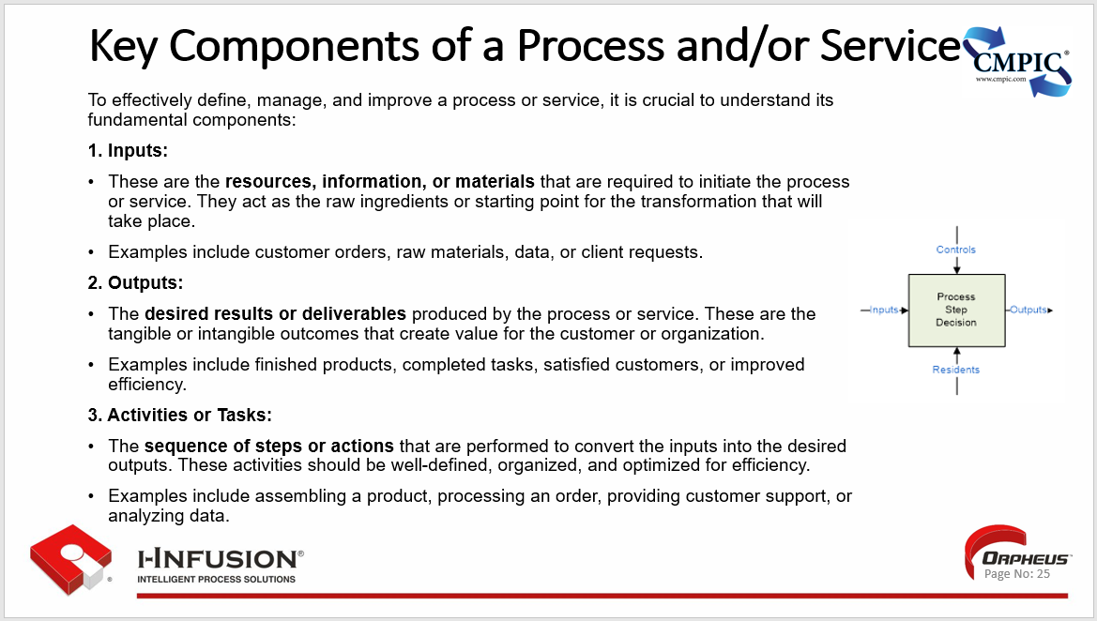

**4. Roles and Responsibilities:**

The **individuals or teams** responsible for executing each activity or task within the process or service. Clear assignment of roles ensures accountability and smooth collaboration.

It is crucial to identify who is responsible for what, and what level of authority they have in decision-making or problem-solving within the process.

**5. Decision Points:**

These are the **critical junctures** within the process or service where choices need to be made to determine the next course of action. Decisions can be based on predefined rules, data analysis, or human judgment.

Well-defined decision points help ensure consistent and predictable outcomes and enable effective management of exceptions or variations in the process.

**6. Metrics and KPIs:**

The **key performance indicators (KPIs)** used to track and measure the effectiveness, efficiency, and quality of the process or service. These metrics provide valuable data for analysis and continuous improvement.

Examples include cycle time, customer satisfaction ratings, error rates, or cost per transaction.

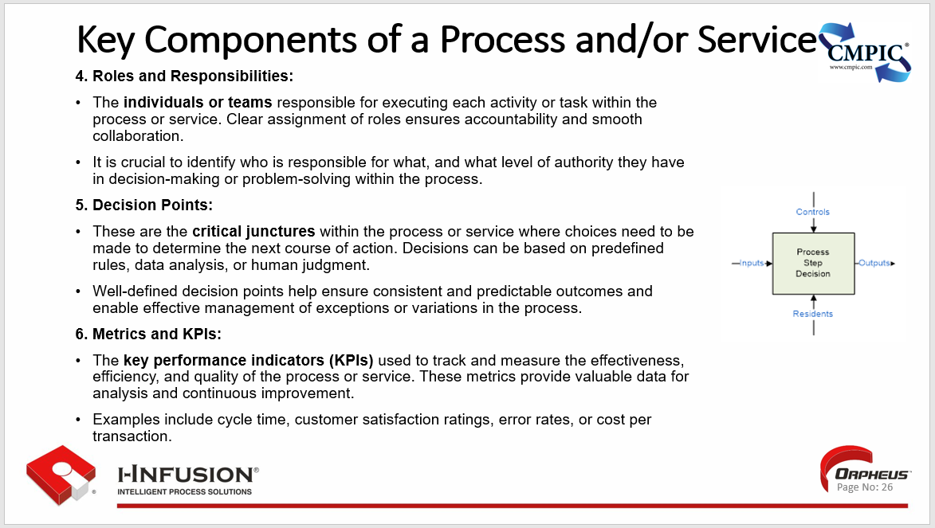

**7. Resources, Technology and Tools:**

The **systems, software, or equipment** used to support and enable the execution of the process or service. Technology can play a crucial role in automating tasks, streamlining workflows, and facilitating data management.

Choosing the right technology and tools can enhance productivity, reduce errors, and improve overall performance.

**8. Controls:**

Conditions required to produce the correct output. Name item and identify classification type from Knowledge, Business, Requirements, Life Cycle, Measurements types.

**9. Feedback Loops:**

Mechanisms for **gathering feedback** from customers, employees, or other stakeholders to gain valuable insights into the strengths and weaknesses of the process or service.

Feedback is critical for identifying areas for improvement and ensuring continuous alignment with customer expectations.

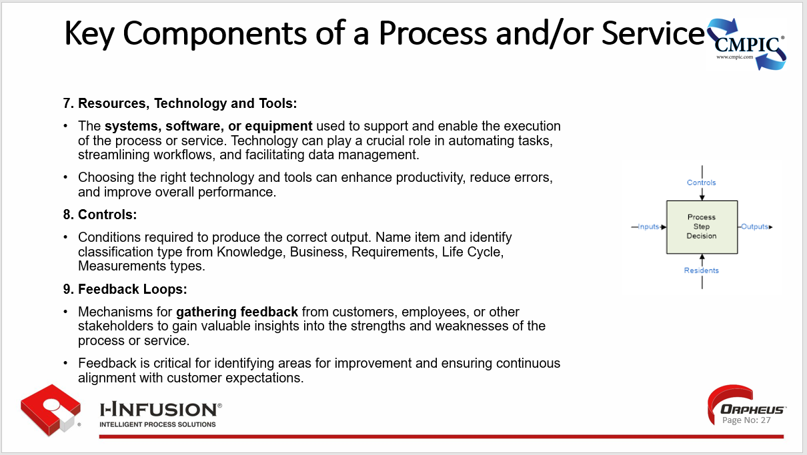

**Additional Considerations for Services:**

* **Customer Interaction:**
  + Services often involve direct **interaction with customers**, making customer satisfaction and experience paramount.
* **Intangibility:**
  + Services are often intangible, making it challenging to measure and manage their quality compared to physical products.
* **Heterogeneity:**
  + The quality of a service can **vary depending on the provider and the specific circumstances**, making standardization and consistency important goals.

By carefully considering and managing these key components, organizations can design, implement, and continuously improve their processes and services, ensuring optimal performance and customer satisfaction.

### Message to Leadership

“Brilliant process management is our strategy.

We get brilliant results from average people managing brilliant processes.

We observe that our competitors often get average (or worse) results from brilliant people managing broken processes. ”  ~ Mr. Cho – CEO Toyota Motor Corporation (TMC) 1999-2005, COB TMC 2006-2013, Honorary Chairman of TMC 2013–present

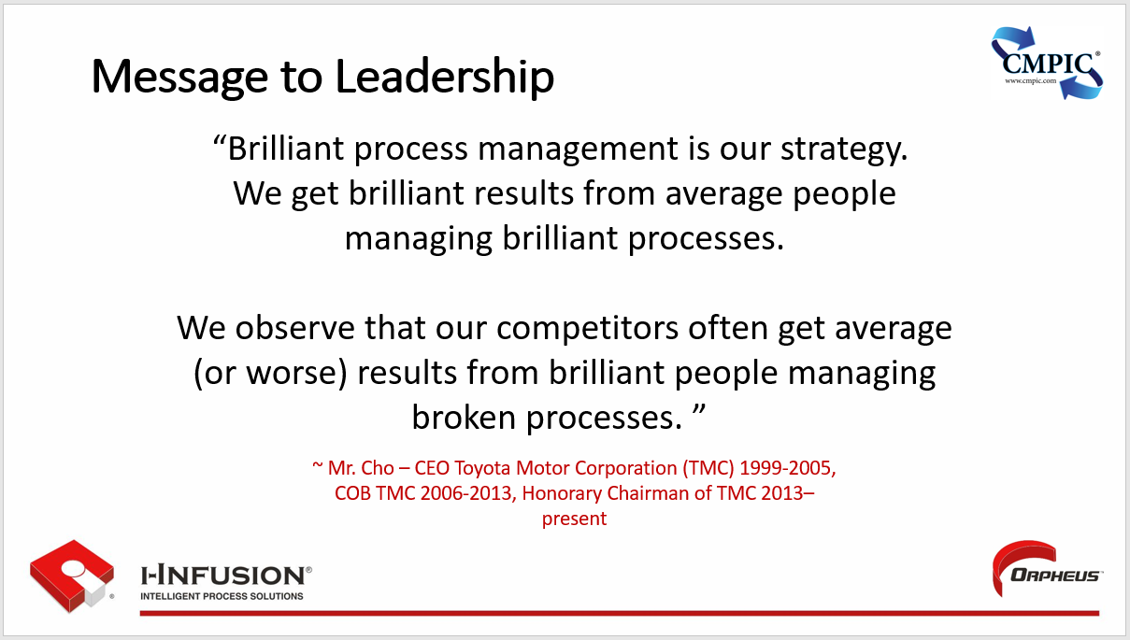

### Key Points

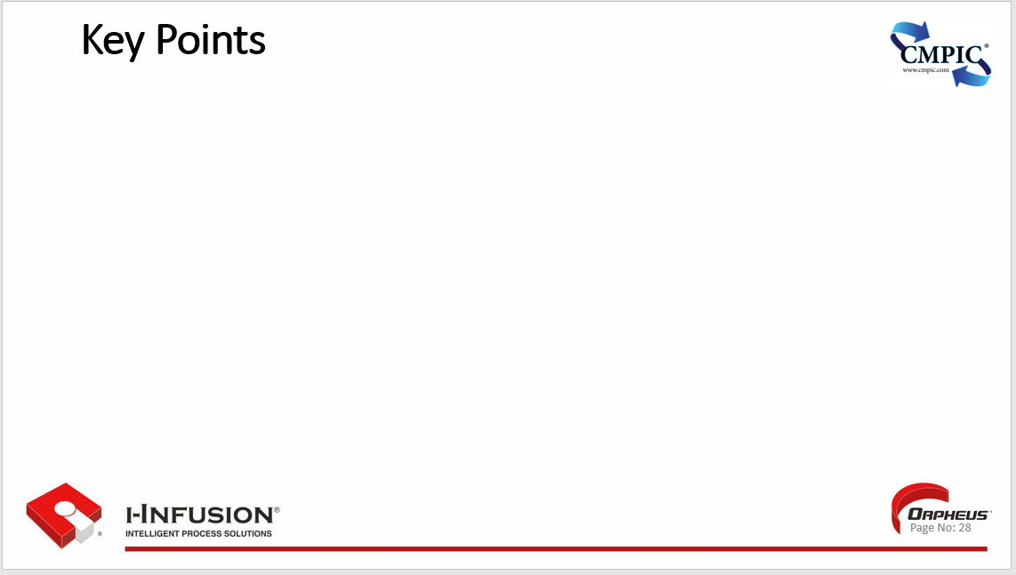

## Chapter 4. Configuration Management Recap

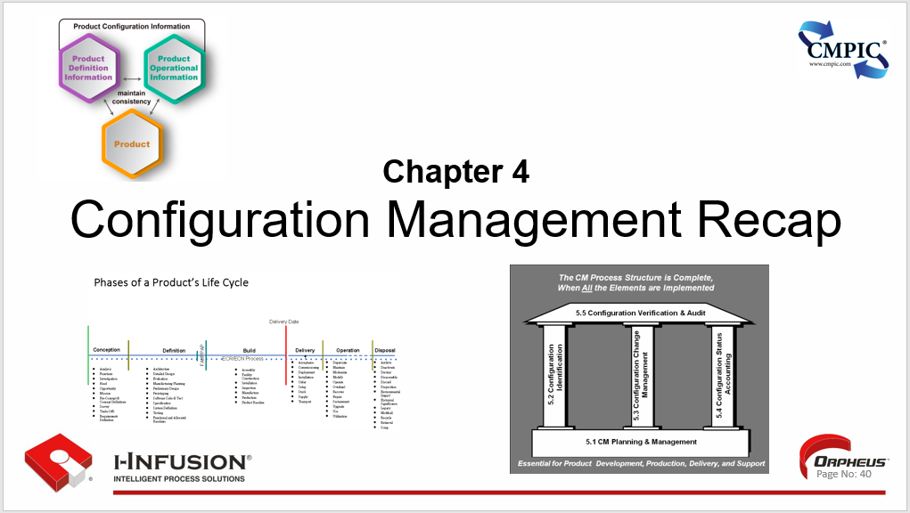

Now that we know a little more about ProCM and Business Process Reengineering, let’s recap our 5 functions and their collective 40 principles. But first, let’s remember what CM is. “Configuration Management (CM) is a technical and management process applying appropriate processes, resources, and controls, to establish and maintain consistency between product configuration information, and the product.”

“The term “product” in the 649 standard should be interpreted as applicable to all product categories; e.g., documents, facilities, firmware, hardware, software, tools, materials, processes, services, systems, assets.”

We must continually remember the definition of **Product** per 649C: “Anything used in or resulting from the execution of a process including the process itself.”

**Chapter 4. Outline**

* To What Does CM Apply
* Benefits of CM
* Who Benefits From CM
* What are the elements/Functions of CM
* Configuration Management Planning and Management
* Configuration Identification
* Configuration Change Management
* Configuration Status Accounting
* Configuration Verification & Audit
* CM and “Best Practice” Initiatives

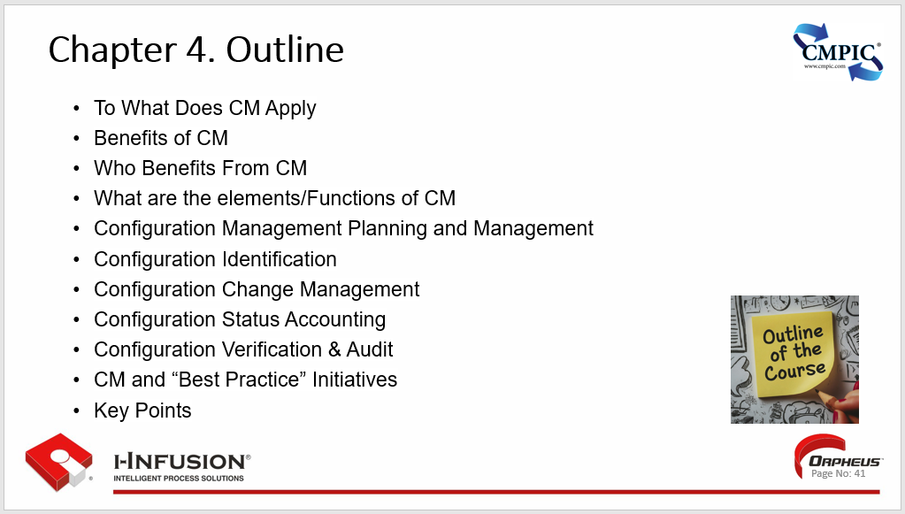

### To What Does CM Apply

* IT Infrastructure & Systems:
* Software Development and DevOps
* Hardware Development and Manufacturing
* Business / Technical Process(es)
* Assets
* Security
* Compliance
* Disaster Recovery / Incident Management

Anything that needs to be planned for.

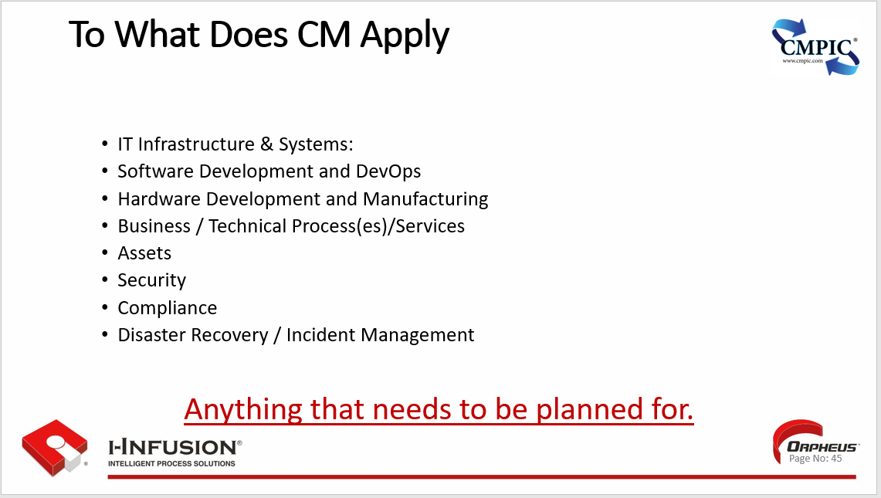

### Benefits of Configuration Management

Benefits towards “Best Practice” goals:

* Establishment and sustainment of an authoritative source of information and truth,
* Collaboration and assurance across capability roles, functions, and systems
* Improving efficiencies,
* Improving information flow,
* Improving process effectiveness,
* Eliminating waste,
* Improving product control,
* A leaner, more reliable, resilient, financially responsible, and mature enterprise.

Without CM, enduring truth, trust, and traceability are an impossibility.

Without truth, we cannot agree on what road to go down.

Without trust, we cannot go down that road together.

Traceability, through the transparency and desired precision it provides, gives us confidence in our decisions and a framework for knowledge capture.

Without truth, trust, and traceability, and making them endure, enterprises cannot sustain a healthy, mature digital, model based, or otherwise realized and/or sustained: product, system, project, program, supply base, and/or enterprise, now, or in whatever future we evolve to.

CM provides truth, trust, and traceability to Model Based Everything (MBX) Framework(s) through appropriate adaption of its functions and principals allowing speed and agility to be achieved without sacrificing leadership’s ability to not only control, but to command.

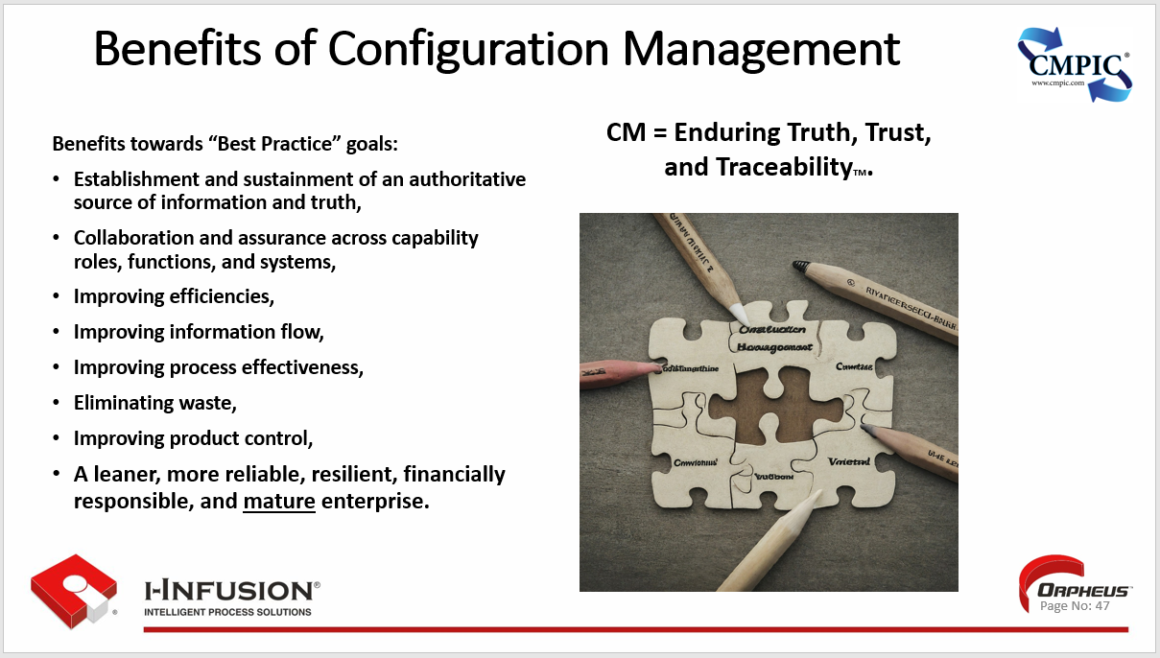

### Who Benefits From CM

Configuration management benefits a wide range of stakeholders within an organization, including:

* IT and Operations Teams:
* Reduced Downtime and Incidents
* Consistent Environments:
* Version Control and Rollbacks
* Collaboration and Visibility
* Version Control and Rollbacks.

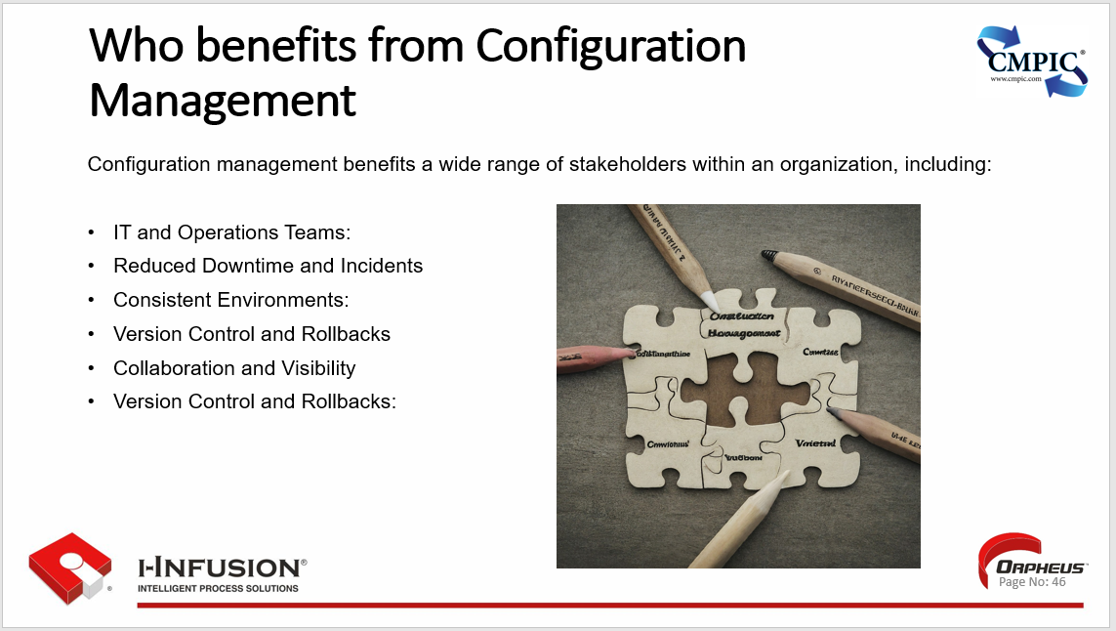

Configuration management benefits a wide range of stakeholders within an organization, including:

#### 1. IT and Operations Teams:

* **Reduced Downtime and Incidents:** CM helps prevent configuration errors and inconsistencies that can lead to system outages and service disruptions.   [1. How to Standardize Configuration Management - IT Glue](https://www.itglue.com/blog/how-to-standardize-configuration-management/)
* [www.itglue.com](https://www.itglue.com/blog/how-to-standardize-configuration-management/)
* **Improved Efficiency:** Automation of routine tasks and standardized configurations free up IT staff to focus on strategic initiatives.   [1. IT Infrastructure Automation: Transforming IT Operations for the Future - Scale Computing](https://www.scalecomputing.com/resources/it-infrastructure-automation-transforming-it-operations-for-the-future)
* [www.scalecomputing.com](https://www.scalecomputing.com/resources/it-infrastructure-automation-transforming-it-operations-for-the-future)
* **Faster Troubleshooting:** Having a clear understanding of system configurations helps identify and resolve issues quickly.
* **Easier Change Management:** CM provides a structured approach for managing changes, minimizing the risk of unexpected side effects.   [1. Configuration and Change Management Best Practices for SMBs - OSIbeyond](https://www.osibeyond.com/blog/configuration-change-management-best-practices-for-smbs/)
* [www.osibeyond.com](https://www.osibeyond.com/blog/configuration-change-management-best-practices-for-smbs/)

#### 2. Development Teams:

* **Consistent Environments:** CM ensures that development, testing, and production environments are consistent, reducing the risk of deployment issues.   [1. What is Configuration Management? - VMware](https://www.vmware.com/topics/configuration-management)
* [www.vmware.com](https://www.vmware.com/topics/configuration-management)
* **Version Control and Rollbacks:** CM enables easy tracking and management of code and configuration changes, allowing for quick rollbacks in case of problems.   [1. Configuration management: definition and benefits - Atlassian](https://www.atlassian.com/microservices/microservices-architecture/configuration-management)
* [www.atlassian.com](https://www.atlassian.com/microservices/microservices-architecture/configuration-management)
* **Collaboration and Visibility:** CM provides a central repository for configuration information, promoting transparency and collaboration among development teams.   [1. Configuration Management - Definition & Best Practices - OTRS](https://otrs.com/otrsmag/configuration-management/)
* [otrs.com](https://otrs.com/otrsmag/configuration-management/)

#### 3. Business Stakeholders:

* **Improved Service Reliability:** Reliable systems and processes translate to better service quality and customer satisfaction.
* **Reduced Costs:** CM helps optimize resource utilization and prevent costly errors and downtime.   [1. What Is Configuration Management and Why Is It Important? - UpGuard](https://www.upguard.com/blog/5-configuration-management-boss)
* [www.upguard.com](https://www.upguard.com/blog/5-configuration-management-boss)
* **Enhanced Agility:** The ability to adapt to change and deploy new features or updates quickly provides a competitive advantage.
* **Compliance and Auditing:** CM helps ensure adherence to regulatory requirements and industry standards, reducing the risk of penalties and fines.   [1. What is Configuration Management? - VMware](https://www.vmware.com/topics/configuration-management)
* [www.vmware.com](https://www.vmware.com/topics/configuration-management)

#### 4. End-Users:

* **Consistent and Reliable Services:** CM contributes to a more stable and predictable user experience, minimizing disruptions and frustration.
* **Faster Access to New Features and Updates:** Efficient change management and deployment processes enable organizations to deliver new features and improvements to users more quickly.

**In summary, configuration management benefits virtually everyone within an organization by improving efficiency, reducing costs, enhancing quality, and promoting collaboration. It enables organizations to deliver better services, adapt to change more effectively, and achieve their business goals.**

CM’s benefit’s also serves effective communication and our future focused initiatives as well.

As stated in 649C, “CM Processes are critical for establishing and maintaining consistent execution and incontrovertible information used to communicate...”

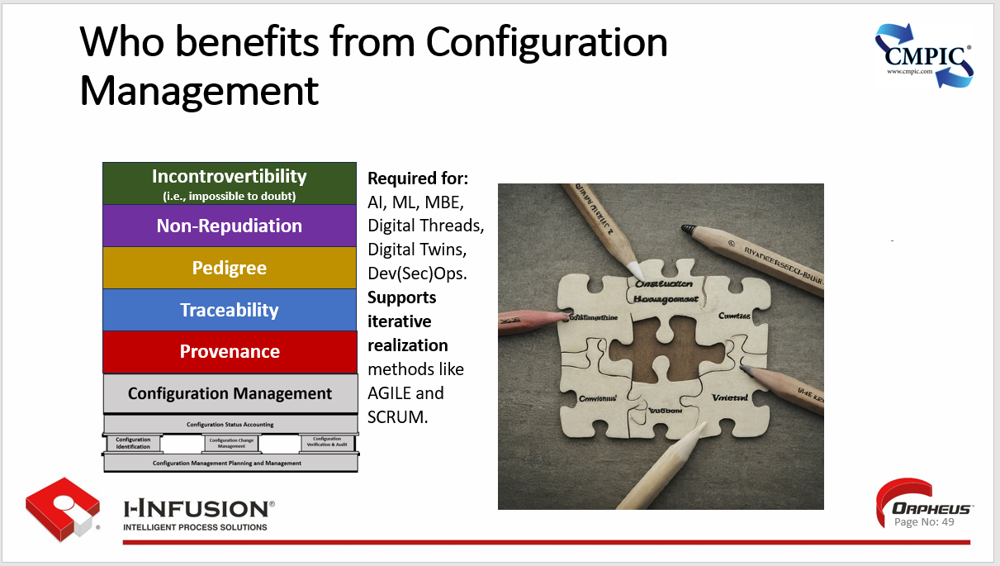

Incontrovertibility (i.e., impossible to doubt) does not happen by happenstance, it starts with provenance.

Provenance is the ability to capture, contain, refer to precisely, sustain, and provide demonstrable evidence of an item’s chronology from origin, through changes, to current status.

Provenance is an impossibility to achieve without CM as its foundation. Provenance is the guaranteed output of having appropriate CM in place for the configuration.

The process of Provenance is traceability.

The validation of the composition and traceability of technologies, products and services establishes the Pedigree.

This enables non-repudiation: the assurance that someone cannot deny the validity of the product or refute responsibility.

With provenance, traceability, pedigree, and non-repudiation, Incontrovertibility can be established in support of initiatives like AI, ML, MBE, Digital Threads, Digital Twins, Dev(Sec)Ops, as well as support iterative realization methods like AGILE and SCRUM.

### What are the elements/Functions of CM

The core elements, or functions, of Configuration Management (CM) are:

* **Configuration** Management Planning and Management
* **Configuration** Identification
* **Configuration** Change Management
* **Configuration** Status Accounting
* **Configuration** Verification and Audit

**Configuration** = The product, and all product configuration information needed to support the product as they evolve across the product’s entire life cycle.

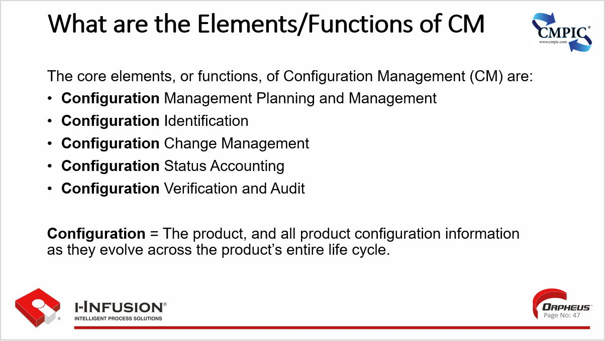

The core objectives of Configuration Management (CM) typically include:

* Each product and its constituent components, as well as their versions, are labelled unambiguously and uniquely so that they can be referenced and retrieved precisely, establishing a basis for configuration control and reference.
* Each product and its constituent components, as well as their versions, are structured to assure they are planned for, there is a place to house them once they are realized, and that a “where used” can be queried for change impact analysis throughout the product’s lifecycle.
* Each product and its constituent components, as well as their versions, are validated and released to establish their integrity throughout the product’s lifecycle.
* Baselines and current approved configurations are defined to allow reference of, control of, and traceability between the evolving product.
* Each product and its constituent components, as well as their versions, interfaces are managed throughout the product’s lifecycle.
* Problem reporting is established to record issues identified throughout the product’s lifecycle and ensure their resolution.
* Change management is established to record, evaluate, approve, and resolve changes throughout the product’s lifecycle.
* Change impact analysis and review is established to ensure that all problems and changes are assessed, approved or disapproved, approved changes are implemented and verified, and feedback is provided to affected processes and their stakeholders, as defined in the product’s planning process.
* Status and performance accounting is established for reporting on the product and its components as events occur for activities like, but not limited to, baseline identification, problem report status, change history, release status and process/task performance.
* Each product and its constituent components, as well as their versions are verified as tasks are performed to mitigate risk propagation throughout the product’s lifecycle.
* Configuration Management is applied to the entire product’s lifecycle process, including to learning assurance, and associated lifecycle information.
* Archival, retrieval and release ensure that product lifecycle artifact(s) (e.g., data for compliance demonstration) can be retrieved for duplication, regeneration, retesting or modification and only authorized data is used.
* The product’s lifecycle environment configuration management ensures that the tools and environment used in the product’s lifecycle are identified, controlled and retrievable.
* CM training is provided to individuals involved in the CM process to ensure they understand their responsibility, authority, accountability, and procedures.
* Configuration Management is conducted in accordance with the functions and principles established in SAE EIA649.

**Additional Functions:**

* **Configuration Planning:** Developing a configuration management plan that outlines the processes, procedures, and tools to be used for CM activities.
* **Release Management:** Managing the packaging, deployment, and tracking of software releases and updates.
* **Baseline Management:** Establishing and maintaining baselines (approved configurations) at various points in the lifecycle.
* **Version Control:** Tracking and managing different versions of CIs and their associated documentation.
* **Change Control Board (CCB):** Establishing a formal body responsible for reviewing, evaluating, and approving or rejecting proposed changes.

**Benefits of Implementing These Functions**

* **Improved Quality:** By ensuring that configurations are consistent and accurate, CM helps reduce errors, defects, and rework.
* **Increased Efficiency:** Streamlined change management processes and automation can save time and resources.
* **Enhanced Collaboration:** A central repository for configuration information promotes transparency and collaboration among teams.
* **Reduced Risk:** CM helps minimize the risk of unauthorized changes, configuration drift, and system outages.
* **Compliance and Auditability:** CM ensures adherence to standards and regulations, making audits easier and more efficient.

Overall, the elements and functions of configuration management work together to provide a structured framework for managing and controlling changes throughout the lifecycle of a system or product, leading to improved quality, efficiency, and risk reduction.

### Key CM Components of an Enterprise Processes and/or Service

Let’s have a quick look at what we will be applying CM’s functions and principles too.

The key components of enterprise processes and/or services are:

**Service Definition —** The application of a specialized competency (skill & knowledge), through deeds, processes, and performance for the benefit of another entity or the entity itself (self-performance).

**Capability Definition —** The power or ability to do something.

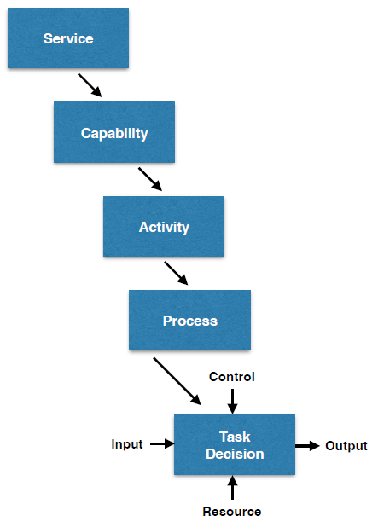**Activity Definition —** The condition in which things are happening or being done; a thing that a person or group does or has done.

**Process Definition —** A series of actions or steps taken in order to achieve a particular end and/or achieve a desired managed outcome.

**Step/Task Definition —** A piece of work to be done or undertaken.

**Decision Definition —** A conclusion or resolution reached after consideration.

**Input Definition —** The data, material, object(s), or part(s) used in/or that are transformed by the function into output. e.g., document, information, material, object, part, etc.

**Output Definition —** The data, material, object(s), or part(s) produced by the function. e.g., document, information, material, object, part, etc.

**Control(s) Definition —** Conditions required to produce the correct output.

**Resource(s) Definition —** The means used to perform a function.

**Flow Definition —** To move along, as in a current, stream, a thread, etc.

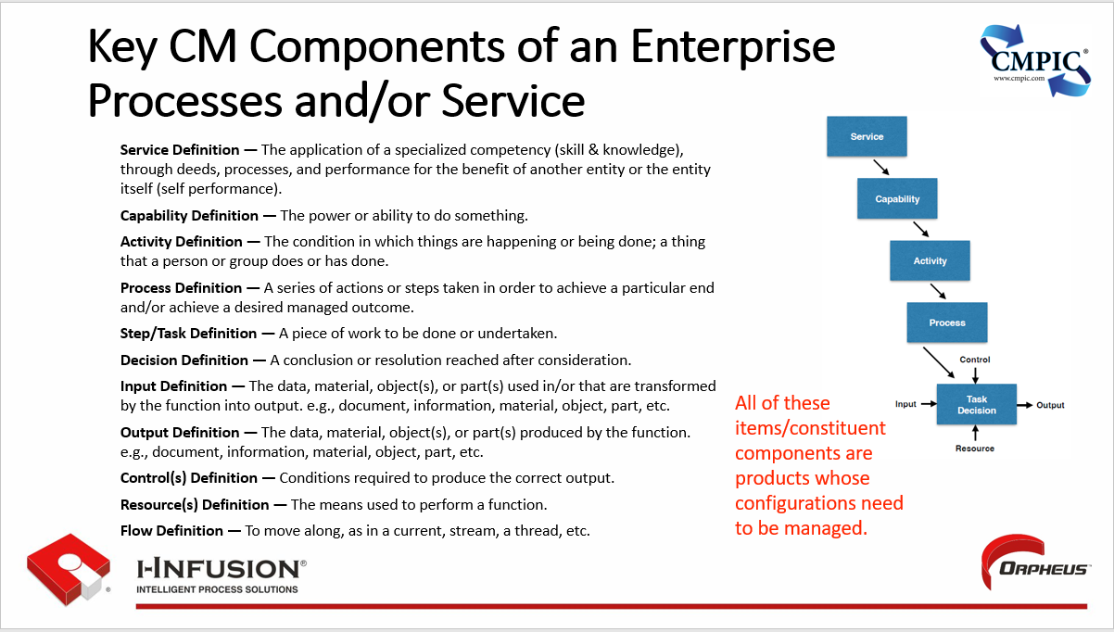

All of these items/constituent components are products whose configurations need to be managed.

This includes everything used-in and resulting from process/task/decision execution as well.

### Configuration Management Planning and Management (CMPM)

The foundation of CM and all CM activities is CM Planning and Management.

**“CM planning and management** over the life cycle of a product are essential to achieve an effective, predictable, and repeatable CM processes. CM processes shape the application of solid, practical procedures that result in cost avoidance and enhanced configuration quality and stability.” *Source: SAE/EIA-649C*

**Example of what needs to be planned for and manage, as well as codified in a CM Plan or CM Operating Standard**

* Identifying Context and Environment
* Documenting the Outcome of CM Planning, the CM Plan
* Applying Adequate Resources and Assigning Organizational Responsibilities
* Establishment of Performance and Status Measurements
* Establishing, Implementing, and Maintaining Procedures
* CM Training
* Configuration Identification, Change Management, Configuration Status Accounting, Verification & Audit
* Interface management
* Assessing Compliance and Effectiveness
* Supplier CM
* Contract/PO Requirements
* Product Configuration Information Processes
* Information Control
* Enabling Technology & Information Exchange
* Information Security and Preservation
* Configuration management phasing and milestones

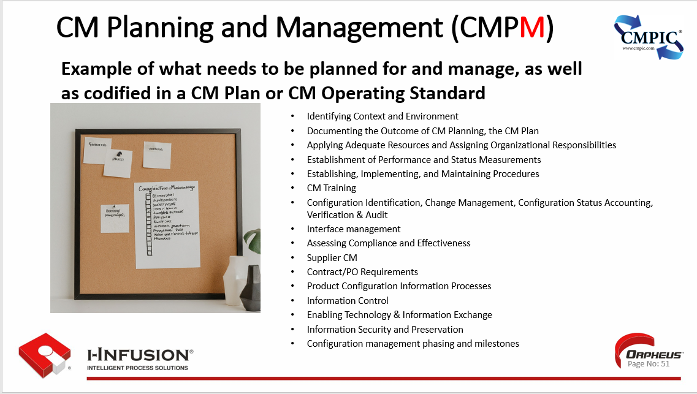

In order for appropriate CM to be established and maintained, it must be planned for which means that our planning must be planned for as well.

We start our planning for CM Planning by:

1. **Define CM Scope and Objectives:**

* Clearly identify the items that will be managed.
* Define the goals and objectives of CM for the project or system.
* Specify the level of control and formality required.

1. **Establish CM Processes and Procedures:**

* Detail the processes for identification, control, status accounting, and audit/verification.
* Define procedures for change requests, reviews, and approvals.
* Outline how configuration information will be documented and stored.

1. **Identify Roles and Responsibilities:**

* Clearly assign roles and responsibilities for CM activities to individuals or teams.
* Establish a Configuration Control Board (CCB) or similar entity for change management oversight.

1. **Select CM Tools and Technologies:**

* Choose appropriate tools for version control, configuration management databases, and other CM activities.
* Ensure tools are compatible with existing systems and workflows.

1. **Develop a CM Schedule:**

* Integrate CM activities into the overall project or system lifecycle.
* Define milestones and timelines for CM tasks.
* Allocate resources for CM activities.

1. **Establish Communication and Reporting Mechanisms:**

* Define how CM information will be communicated to stakeholders.
* Establish reporting mechanisms for tracking CM progress and performance.
* Ensure open communication channels for addressing any CM-related issues.

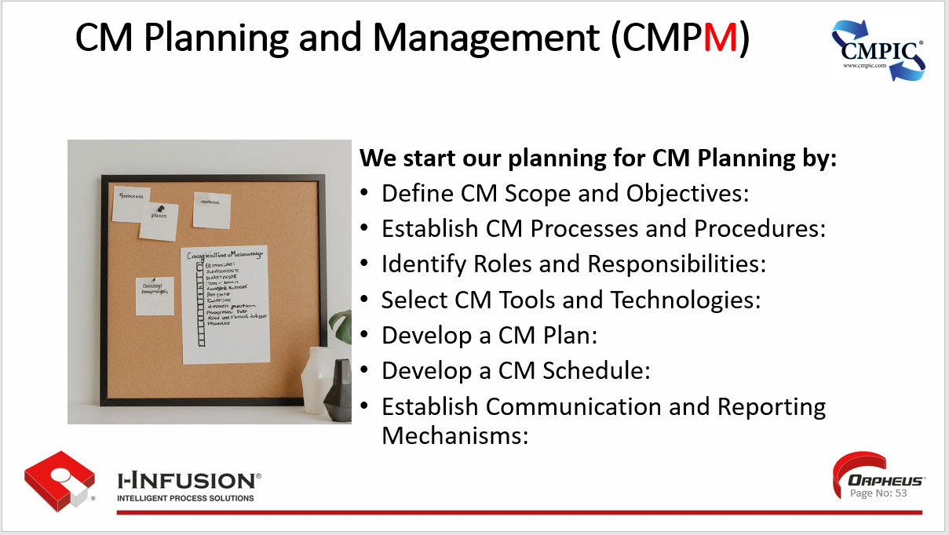

### Configuration Identification (CId)

Configuration Identification is comprised of six activities: Assigning Identifiers, Identifying product and information structure, Identifying product and information validation and release, Identifying baselines/current approved configurations, Identify interface management/control, Identify Configuration Items (CIs).

Here is where the “bar” on what is appropriate for Configuration Identification has been raised. Configuration Identification is more than just identifiers, and baselines, all six of the 649C defined activities for this function are necessary for both provenance and security. Configuration Identification are critical to risk mitigation.

**Risk Statement****:** “**Failure to implement proper identification techniques puts the enterprise** and its relationships with suppliers **at risk** and may result in traceability and security issues, significant errors, additional costs, and schedule delays both in the production and sustainment that will follow the product throughout its lifecycle.

**The time and money expended to restore proper identification of the product configuration is likely to far exceed that which would have been expended to manage the information correctly from the outset**.” SAE EIA649C

**Let’s take a look at the six activities and their intent:**

1. **Assign Unique Identifiers :**

* Provide each constituent component of a product and the product with a unique identifier so it can be referred to precisely, and retrieved accurately to enable easy tracking and reference.
* This identifier should be consistent throughout the item's lifecycle.

1. **Identify Product and Information Structure**

* Structuring makes sure that things get planned for.
* Structuring makes sure you have a place to put the things that got planned for.
* Structuring provides the “where used” capability required for appropriate impact analysis.

1. **Identify Product and Information Validation and Release:**

* “Before any product/product configuration information is considered part of an approved configuration, it must be reviewed to ensure that the artifact is complete, valid and suitable for use.
* A release process is employed to validate the artifact’s integrity.” SAE EIA-649C

1. **Identify Baseline(s)/Current Approved Configuration(s):**

* A mutually agreed upon departure point those results in the establishment of a platform of stability.
* Once established, a platform of stability can only be advanced (i.e. changed) by using a systematic, measurable change process.
* This enables easy retrieval of previous versions and facilitates rollback in case of issues.
* Stability is the key word here; stability means others are counting on it not changing and if it ever does, prior to it being advanced, they will have the opportunity to provide their input as impact analysis information to be considered by the dispositioning authority.

1. **Identify Interface Management/Control:**

* If we have interfacing items created by two or more organizations, we need to assure consistency is maintained between the requirements, documentation and those items at all times.
* The types of “product interfaces” will then determine the need for various agreements defining “interface management” arrangements between organizations.

1. **Identify Configuration Items (CIs):**

* “Configuration Items (CI) are designated for special (additional) CM activity distinct from that which is appropriately applied to every product.
* These can include hardware, software, documentation, network configurations, etc.
* CI’s can be any product, allocated components of a product, or both, that satisfies an end use function, has distinct requirements, functionality and/ or product relationships, and is designated for distinct control by an acquirer.
* CI designation is always accompanied with/by governance.

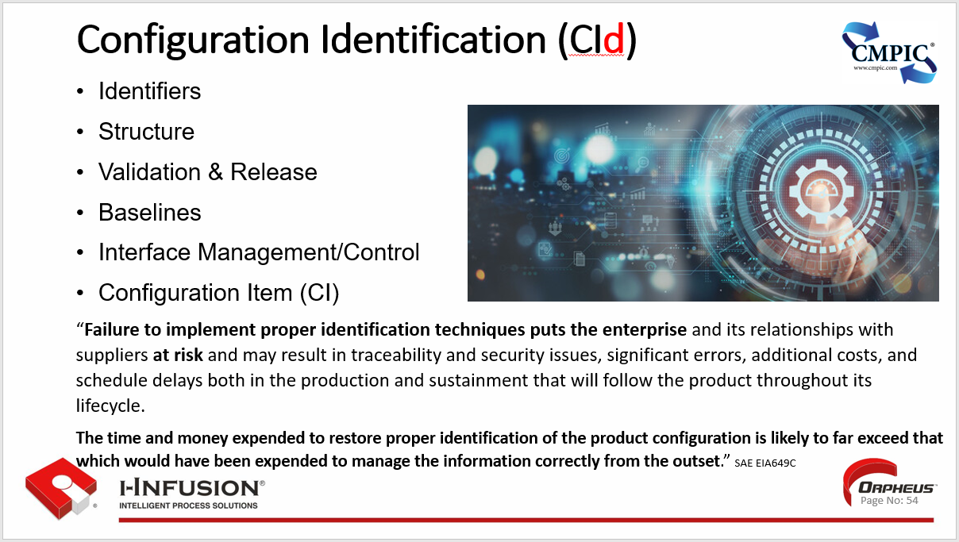

### Configuration Change Management (CCM)

***“Principle CCM-1. Changes to an approved configuration are accomplished using a systematic, measurable change process.***

The configuration change management function includes managing both changes to and variances from the approved product configuration information, using a systematic, measurable process. The configuration change management function applies to all types of products and all program phases.” SAE EIA649C

**Risk Statement**: “If changes to a product or its current, approved configuration information are done in an uncontrolled manner, the product and its product configuration information can easily become un-synchronized jeopardizing product integrity, delivery reproducibility, safety, security, reliability, and resilience, as well as putting at risk operation, maintenance and sustainability.

Changes must be documented, coordinated, evaluated, dispositioned and approved.

The only changes that should be incorporated into a product and its product configuration information are those that have been coordinated with impacted areas of responsibility and approved for incorporation by the appropriate change approval authority.

**The threshold for making a change is that there is significant value** in doing so, whether correcting a defect, adding a capability or seizing an opportunity for improvement.” SAE EIA649C

An effective configuration change management process provides:

**Systematic, Measurable Control:** CM Change Management provides a structured and systematic approach for evaluating, approving, and implementing changes to configuration items (CIs) within a system or product.

**Risk Mitigation:** It helps assess the impact and risks associated with proposed changes, minimizing the potential for disruptions, errors, or unintended consequences.

**Traceability and Accountability:** Change Management ensures that all changes are properly documented, tracked, and authorized, providing a clear audit trail and accountability for modifications made.

**Collaboration and Communication:** It fosters collaboration among different stakeholders involved in the change process, ensuring clear communication and coordination throughout the implementation.

**Version Control:** Change Management integrates with version control systems to manage and track different versions of CIs and associated documentation, enabling easy rollback if necessary.

**Continuous Improvement:** It enables organizations to learn from the outcomes of changes, fostering a culture of continuous improvement and adaptation.

* Define the boundaries of your configuration management system.
* Determine which components, systems, or processes will be subject to configuration management.

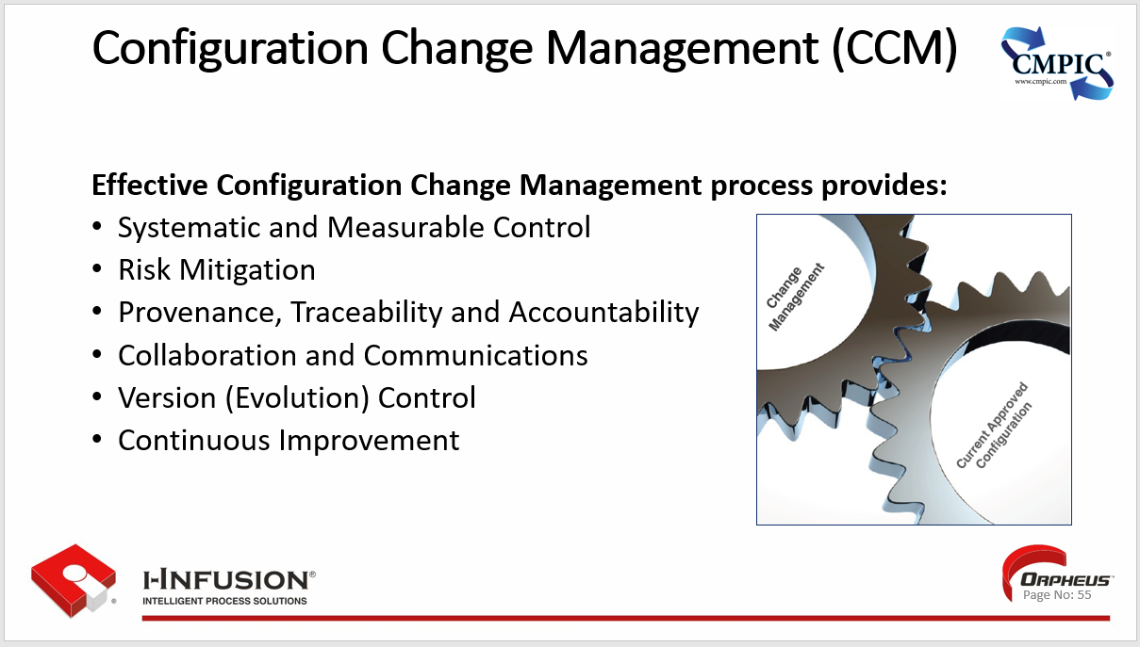

### Configuration Status Accounting (CSA)

As stated in the 649C standard: “Configuration Status Accounting (CSA) consists of the recording and reporting of information needed to trace and manage a configuration effectively by providing information and process status, as well as CM process performance and resource integrity data.

The purpose of CSA is to capture, record, retrieve and report status, performance, and integrity information about the product under configuration management and make the information accessible to support program/project activities as needed.

Measurement of CM activities give insight into their effectiveness and efficiency.

Metrics and key performance indicators derived from CSA information can be used to evaluate and improve CM process effectiveness and efficiency for the benefit of the Enterprise.

**Risk Statement**: **A failure to put appropriate status and performance measurements in place will result in inconsistent CM process execution, which places both the product and the enterprise at risk.”** SAE EIA649C

The configuration status accounting function results in:

* **Accurate Record Keeping:** CM Status Accounting involves maintaining precise and up-to-date records of all configuration items (CIs) throughout their lifecycle. This includes information like versions, revisions, locations, and any changes made.
* **Traceability:** It enables traceability by providing a historical record of CI modifications, making it easy to identify when and why changes were implemented.
* **Reporting:** Status Accounting generates reports on the status of CIs, including their current configurations, pending changes, and implementation status.
* **Decision Support:** It provides valuable information for decision-making, such as impact analysis of proposed changes and assessment of the current system state.
* **Auditing and Compliance:** Accurate status accounting facilitates audits and ensures compliance with regulatory requirements and internal policies by maintaining a verifiable record of configurations.
* **Communication and Collaboration:** It promotes communication and collaboration by providing stakeholders with visibility into the current state of the system and the status of any changes.

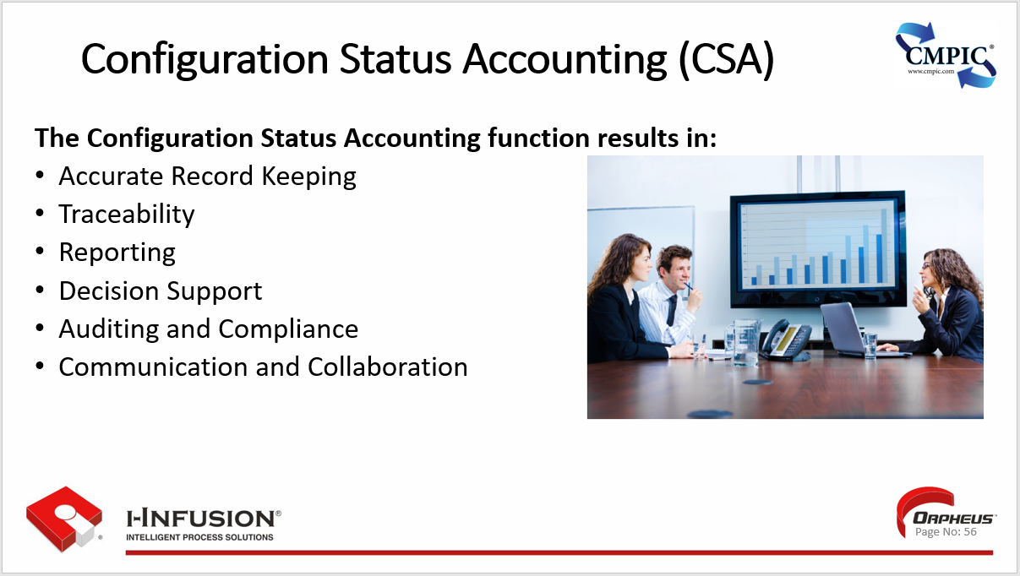

### Configuration Verification & Audit (CVA)

“The Configuration verification and audit function establishes that:

* Appropriate CM processes are in place and that they are effectively operating to maintain consistency between the product and its product configuration information throughout the product life cycle.
* The approved product configuration information is complete, accurate and current to produce the product, and applicable operation and maintenance instructions, training, and spare and repair parts.
* The physical, functional, and interface requirements, defined in the approved product definition information, are achieved by the product.” SAE EIA649C

Verification is our focus from an enterprise perspective.

Verification is the day-to-day due diligence put in place to keep from “burning the toast” as Deming said.

Audits, on the other hand, are acquirer/supplier in nature; they are a validation by the acquirer that appropriate verification and demonstrable evidence of it, is in place and readily accessible in a usable form and format.

“Activities within Configuration verification and audit include:

* Continuous CM process verification.
* Verification of the initial product configuration to assure that it meets its documented configuration requirements.
* Verification of the incorporation of approved changes.
* Functional and Physical Configuration Audits or their equivalent.”

**CM Verification & Audit activities provide demonstrable evidence for:**

1. **Ensuring Compliance and Integrity:** CM Verification & Audit confirms that the actual configuration of a system or product aligns with the approved and documented baseline, ensuring compliance with standards, policies, and requirements, as well as ensuring the products integrity.
2. **Detecting and Correcting Deviations:** This process actively identifies any discrepancies or unauthorized changes, allowing for prompt corrective action to maintain configuration integrity.
3. **Independent Assessment:** Verification & Audit provides an objective and independent assessment of the configuration management process and its effectiveness in controlling and managing changes.
4. **Risk Mitigation:** By uncovering potential risks and vulnerabilities associated with configuration changes, it allows for proactive measures to be taken, reducing the likelihood of system failures or security breaches.
5. **Continuous Improvement:** Audits provide valuable feedback on the CM process, highlighting areas for improvement and enabling organizations to refine their practices for better configuration control.
6. **Traceability and Accountability:** The process establishes clear traceability and accountability for all changes made to the configuration, ensuring that every modification is authorized, documented, and validated.

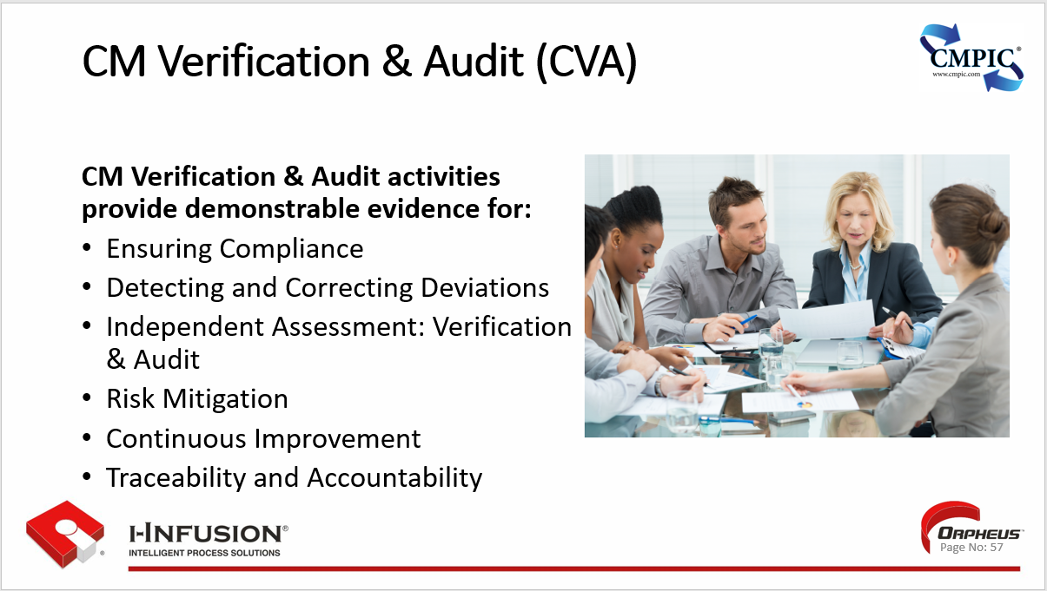

### CM and “Best Practice” Initiatives

**The goals of every “Best Practice” on the planet are an impossibility to achieve with out a foundation** of appropriate CM being in place and this needs to be planned for.

With CM Providing the Foundation for the management of our business and technical processes we can protect from risk and scale our process to serve the ever-changing needs of the acquirer.

**CM Setting the Bar:**

**Establish a Robust CM Framework:** Implement a well-defined CM framework that aligns with industry best practices, covering all phases of the system or product lifecycle. This provides a solid foundation for managing configurations effectively.

**Technologically Enable CM Processes:** Utilize enabling technology to streamline and standardize CM tasks such as providing unique identification, structuring, validation and release, version control, establishing baselines/current approved configurations, change management, verification, and reporting. Technologically enabling our processes and services reduces manual effort, minimizes errors, and improves efficiency.

**Implement Version Control:** Employ a robust version control system to track and manage changes to processes, tasks, and decisions, as well as inputs, outputs, resources, controls, and associated information. This ensures traceability and enables easy rollback to previous versions of the item (i.e., processes, tasks, and decisions) if necessary.

**Foster Collaboration and Communication:** Establish clear communication channels and promote collaboration among teams involved in the CM process. Encourage knowledge sharing and provide access to relevant configuration information as real-time as possible.

**Continuous Monitoring and Auditing:** Regularly monitor and audit the configuration management system to ensure compliance with policies, procedures, and best practices. Identify areas for improvement and implement corrective actions as needed.

**Training and Awareness:** Provide comprehensive training to all relevant personnel on CM processes, tools, and best practices. Promote awareness of the importance of CM and its role in maintaining process/service integrity and stability.

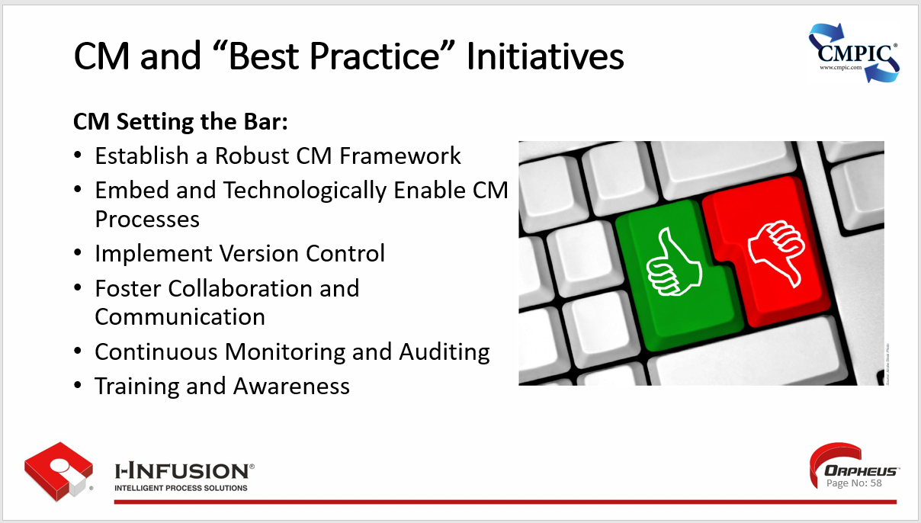

### Key Points

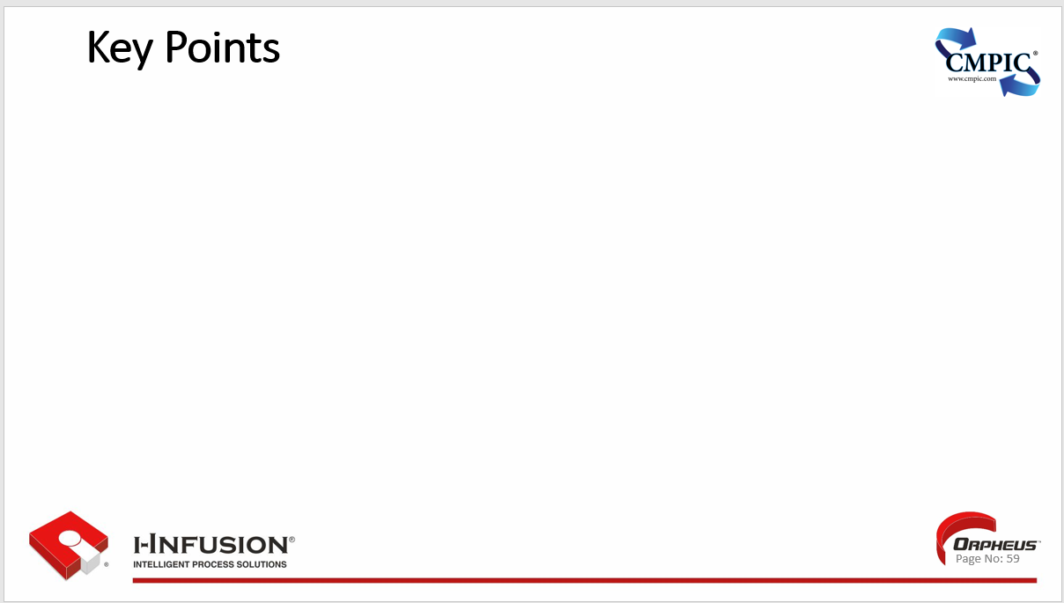

## Chapter 5: Introduction to Business Process Reengineering (BPR)

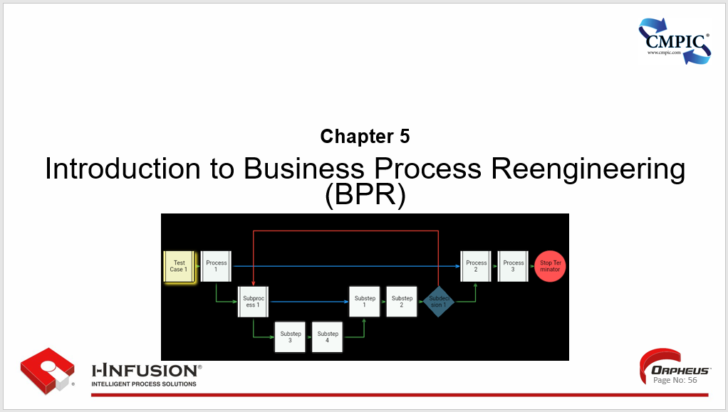

There are several process improvement initiatives being promoted out there today. For the purposes of this course, we will be focusing on two, Business Process Reengineering (BPR) and Continuous Process Improvement (CPI).

We are going to start with Business Process Reengineering.

Note of Caution: BPR, when radically applied is rarely successful.

We are going to look at BPR because many of you may be involved in, or, these kinds of activities are taking place in your enterprise environment. We will show you how and where to get involved and how you can provide leadership ensuring increased BPR success.

**Chapter5. Outline**

* Definition and History of BPR
* Key Principles and Objectives
* Benefits and Challenges of BPR
* Best Way to Get Started
* Key Points

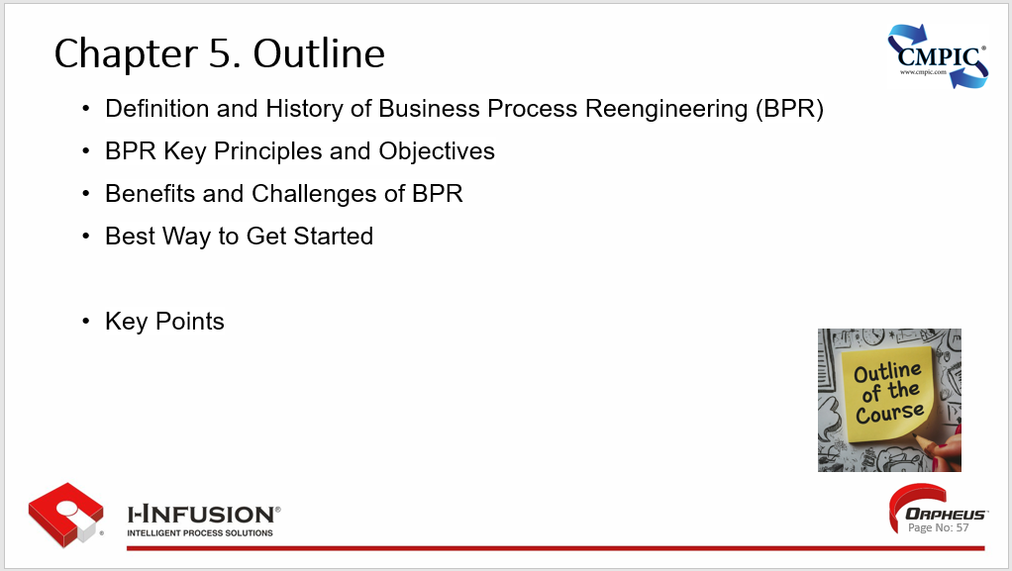

### Definition and History of Business Process Reengineering (BPR)

**Definition**

* Business Process Reengineering (BPR) is a **management** strategy that involves the “**radical” redesign of core business processes** to achieve **dramatic improvements in performance**, such as **cost, quality, service, and speed**.
* It focuses on **rethinking** and **reimagining existing processes** from the ground up, rather than making incremental improvements.
* BPR often **involves leveraging technology** to automate tasks, eliminate redundancies, streamline workflows, and provide visibility.

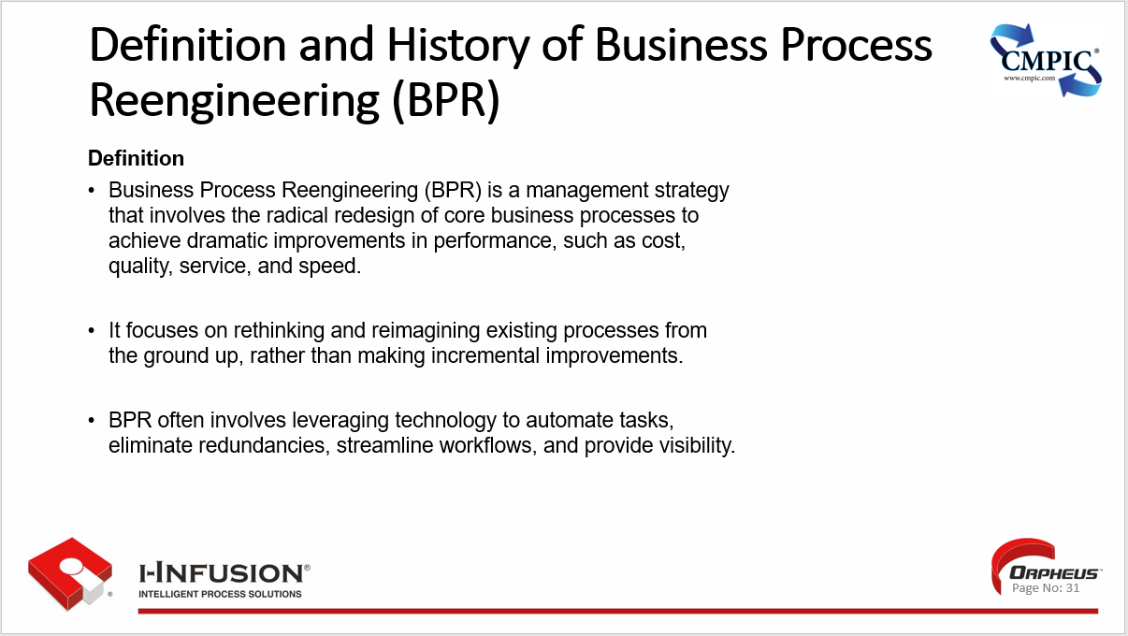

**History**

* The concept of BPR gained widespread recognition in the early 1990s, largely due to the influential book 'Reengineering the Corporation' by Michael Hammer and James Champy (1993). This book played a significant role in popularizing the concept of BPR.
* The book advocated for a complete overhaul of business processes, arguing that traditional methods were no longer adequate in the face of rapid technological advancements and increasing global competition.
* The rise of information technology played a significant role in the emergence of BPR, as it provided new opportunities to automate tasks, integrate systems, and facilitate information sharing.
* BPR initiatives often involve implementing enterprise resource planning (ERP) systems, product lifecycle management (PLM) systems, and other software solutions to streamline operations and improve efficiency.

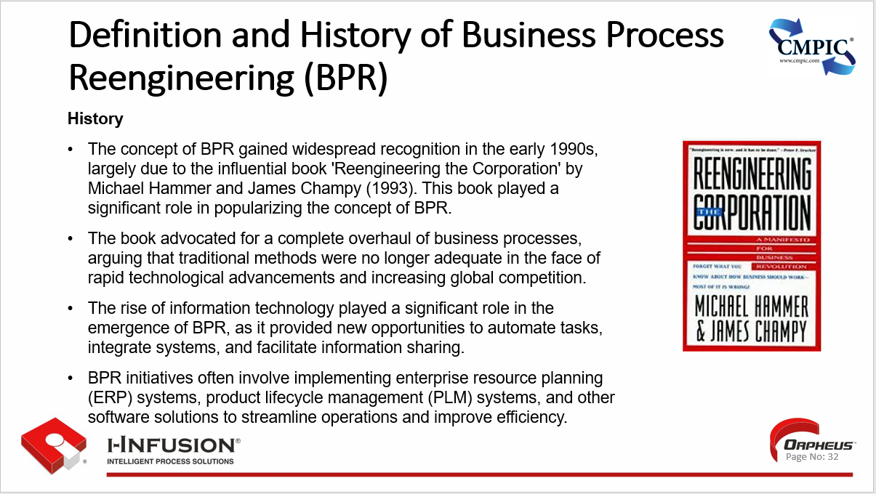

### BPR Key Principles and Objectives

**Key Principles**

**Fundamental Rethinking:** BPR challenges existing assumptions and encourages a fresh perspective on work. It involves questioning traditional methods and seeking innovative solutions.

*i-infusion Note: But remember, before you can think outside the box you must know what is in the box. Otherwise, you are increasing risk.*

**Radical Redesign:** BPR advocates for significant and transformative changes, not just incremental improvements. It aims to break down existing processes and rebuild them from scratch to achieve optimal efficiency.

*i-infusion Note: Depending on your definition of what “break down existing processes” means, whether it means destroy the old (no value), or to fully understand them, choices must be made.*

**Process Orientation:** BPR focuses on end-to-end processes rather than individual tasks or departments. It emphasizes the flow of work across the organization and seeks to eliminate bottlenecks and redundancies.

**Customer Focus:** BPR prioritizes meeting or exceeding customer expectations. It aims to design processes that deliver value to customers and enhance their experience.

**Technology Enablement:** BPR leverages technology to automate tasks, streamline workflows, improve efficiency, and make available, real-time, task activity. It recognizes the potential of technology to transform the way work is done.

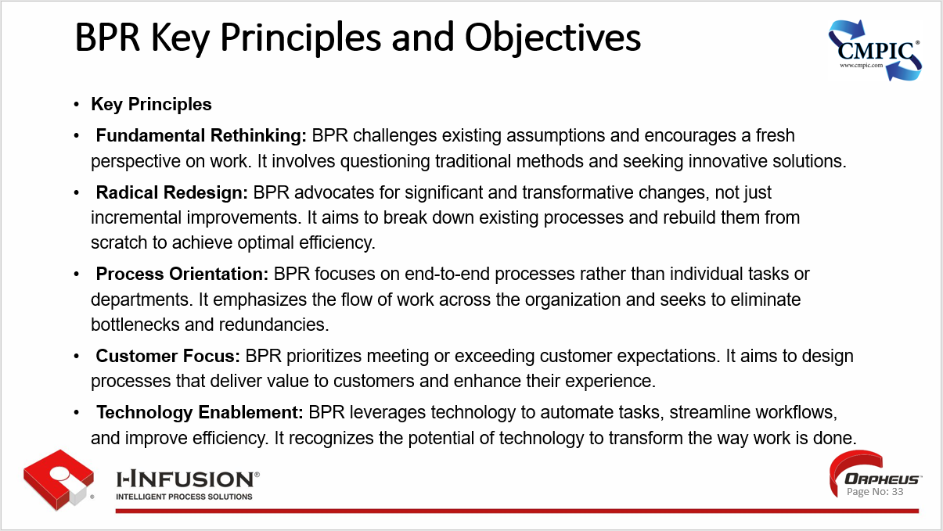

**BPR Key Objectives**

**Dramatic Improvement:** The primary objective of BPR is to achieve breakthrough performance improvements, not just incremental gains.

This may include significant reductions in cost, time, or defects or dramatic improvements in quality, service, or customer satisfaction.

*i-infusion Note: It has been our experience that the ROI in BPR activities can easily be 10x1, if the project is properly managed.*

**Enhanced Efficiency:** BPR seeks to eliminate waste, streamline processes, and optimize resource utilization, improving efficiency and productivity. Lean.

*i-infusion Note: “Brilliant process management is our strategy.*

*We get brilliant results from average people managing brilliant processes.*

*We observe that our competitors often get average (or worse) results from brilliant people managing broken processes.”   Mr. Cho – President of Toyota*

**Improved Quality:** By focusing on reducing errors and defects, BPR aims to enhance the quality of products and services, leading to increased customer satisfaction and loyalty.

**Increased Agility:** BPR helps organizations become more agile and responsive to change. By redesigning processes to be more flexible and adaptable, organizations can quickly respond to market trends, customer demands, and technological advancements.

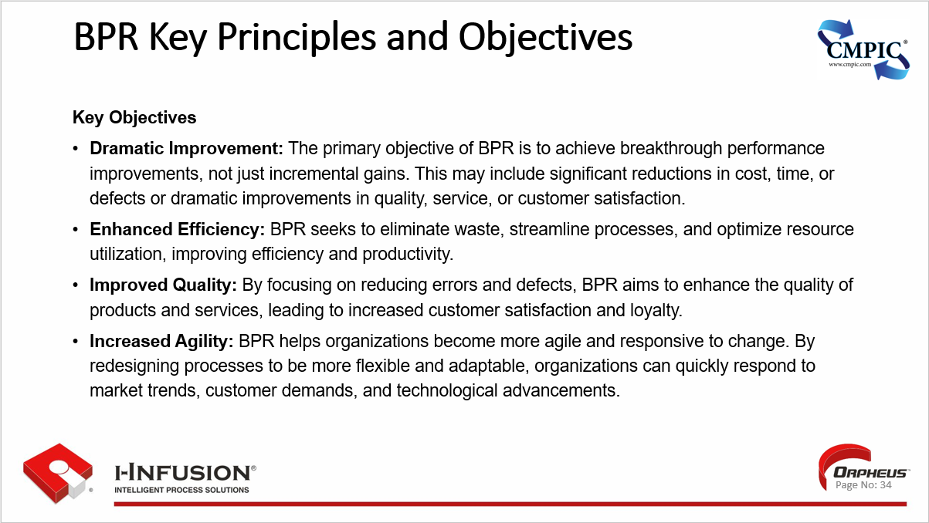

### Benefits and Challenges of BPR

BPR, when executed effectively, can offer several substantial advantages to organizations.

#### Benefits of BPR include:

1. **Improved Efficiency & Productivity:**

* By eliminating redundant tasks, automating manual processes, and streamlining workflows, BPR can significantly enhance operational efficiency, leading to faster turnaround times, increased output, and improved resource utilization.

1. **Cost Reduction:**

* Eliminating waste and inefficiencies can directly lead to cost savings. BPR helps organizations identify and remove non-value-adding activities, optimize resource allocation, and minimize operational expenses.

1. **Enhanced Customer Satisfaction:**

* BPR often focuses on aligning processes with customer needs and expectations. By streamlining processes and improving service delivery, organizations can enhance customer satisfaction, loyalty, and retention.

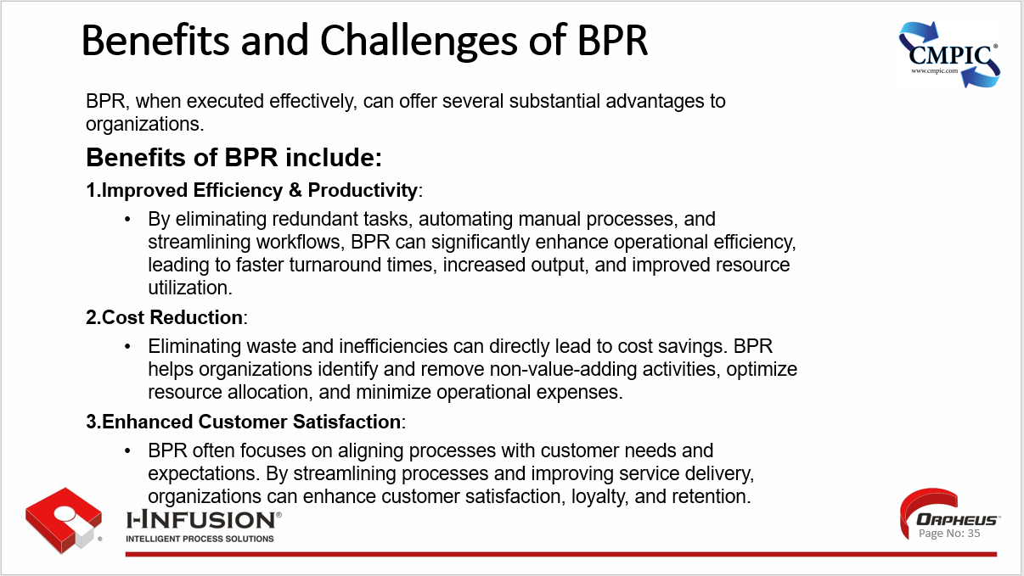

**Benefits of BPR cont.:**

1. **Increased Agility & Adaptability:**

* BPR helps organizations become more flexible and responsive to change.
* By redesigning processes to be more adaptable, and quantifying their implementation and execution, organizations can quickly react to market shifts, technological advancements, and customer demands.

1. **Quality Improvement:**

* BPR focuses on eliminating errors and reducing defects by redesigning processes to be more robust and reliable.
* This leads to improved product and service quality, which further enhances customer satisfaction.

1. **Employee Empowerment:**

* BPR often involves employees in the redesign process, empowering them to take ownership of their work and contribute to improvement initiatives.
* This can lead to increased motivation, engagement, and job satisfaction positively affecting morale and productivity.

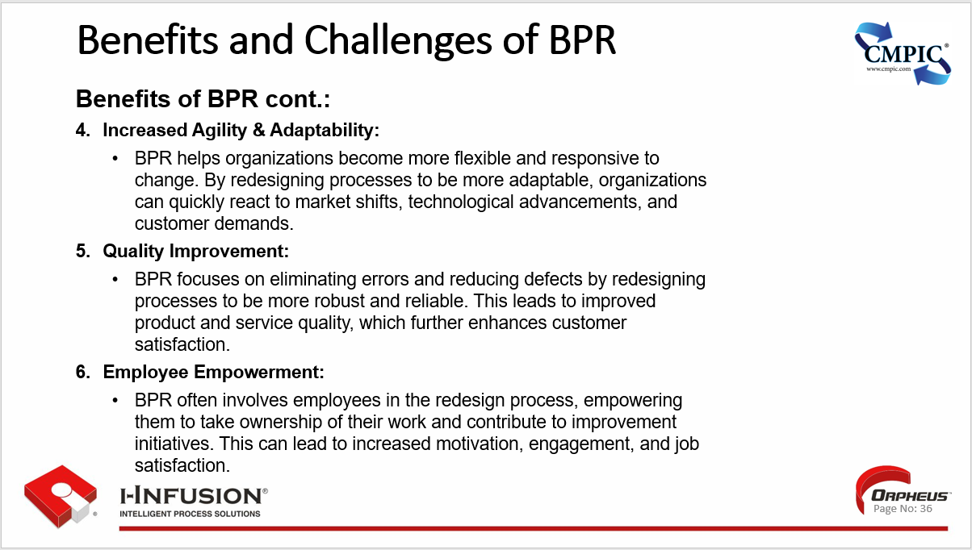

#### Challenges of BPR

While BPR led to some notable success stories, it also faced criticism and challenges. Some organizations experienced significant improvements in performance, while others struggled to implement BPR effectively or achieve the desired outcomes.

While BPR offers significant potential benefits, it also comes with its fair share of challenges. Common challenges included:

1. **Resistance to Change:**

* People are naturally resistant to change, and BPR often involves significant disruptions to established routines and ways of working. Employees may resist major changes to their work processes, leading to low morale and decreased productivity. Overcoming this resistance and ensuring employee buy-in is a crucial challenge.

1. **High Cost & Resource Intensive:**

* BPR initiatives can be expensive and time-consuming, requiring substantial investments in technology, training, and consulting services. Organizations need to carefully weigh the potential benefits against the costs involved.

1. **Risk of Failure:**

* BPR is a complex undertaking, and there is always a risk of failure if not properly planned and executed. Organizations need to have a clear vision, strong leadership, and effective change management strategies in place to ensure success.

1. **Lack of Top Management Support:**

* Successful BPR requires strong leadership and commitment from top management.
* Attitude reflects leadership; we must make leadership care and see the value of making the changes necessary.

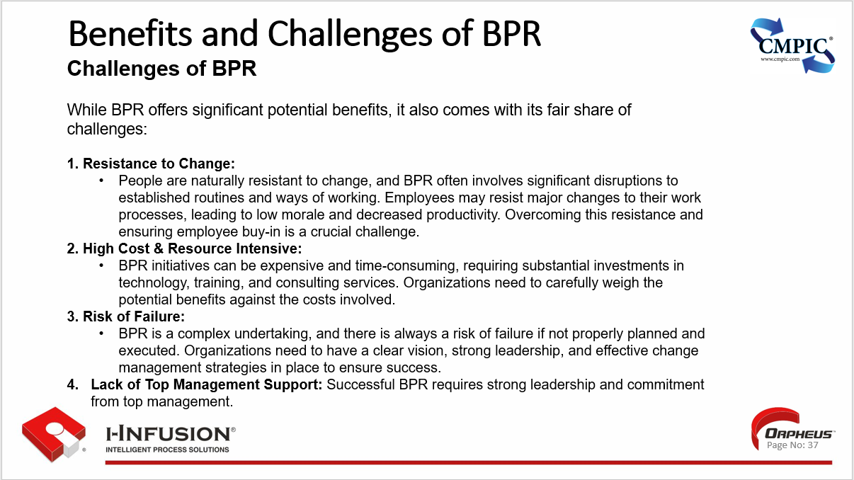

**Challenges of BPR cont.**

1. **Potential for Job Losses:**

* BPR can lead to job losses as processes are streamlined and automated. This can create anxiety and uncertainty among employees, negatively affecting morale and productivity.

1. **Difficulty in Measuring Success:**

* Measuring the success of BPR initiatives can be challenging, as the benefits may not always be immediately quantifiable. Organizations need to establish clear metrics and track progress to ensure that BPR is delivering the desired results.

*i-infusion Note: This is why we must model our As-Is processes first. Understanding the As-Is and having performance and status measurements in place will give us the data we need to build our business case for process improvement, as well as to demonstrate the delta (the change/improvement) of the activity once underway and executing.*

1. **Inadequate Planning and Execution:**

* BPR initiatives can be complex and require careful planning and execution to succeed.

1. **Overemphasis on Technology:**

* BPR should not focus solely on technology; it should also consider people and organizational culture.

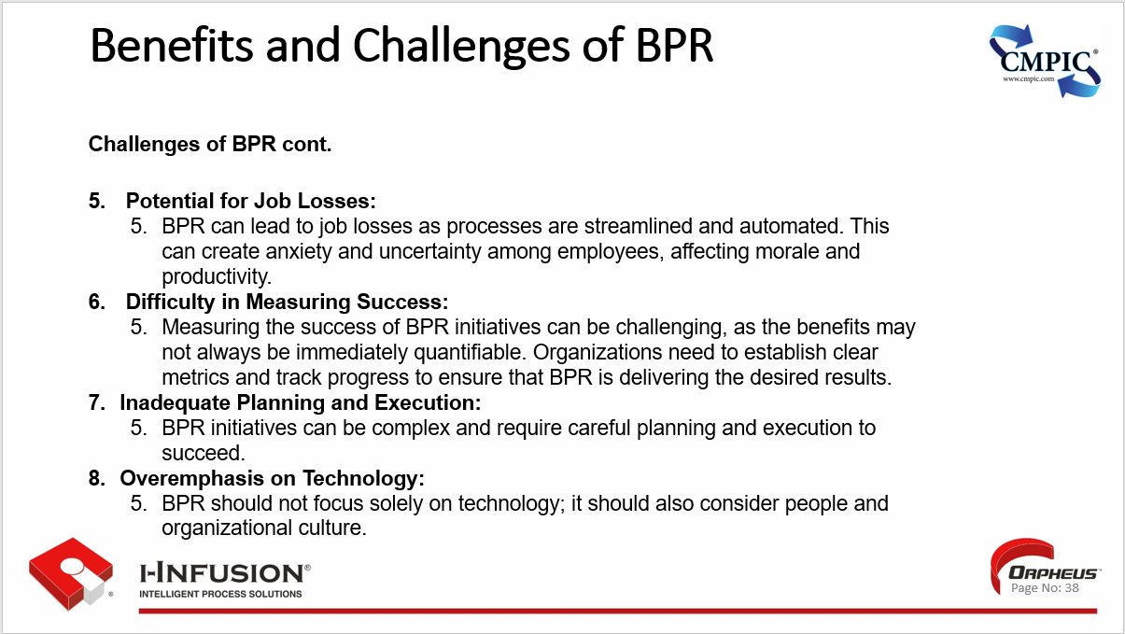

#### Conclusion

* Despite the challenges, BPR can be a powerful tool for organizations seeking to transform their operations and achieve significant performance improvements. However, it requires careful planning, strong leadership, and effective CM (including robust change management) to overcome the obstacles and realize the full potential of BPR.

### Best Way to Get Started

1. **Secure Top Management Commitment:**

* BPR requires significant organizational change and investment.
  + Obtain explicit support and buy-in from top leadership to ensure the necessary resources, authority, and momentum for success.

1. **Define Clear Objectives and Scope:**

* Establish a compelling vision for the desired future state.
  + Clearly define the specific problems BPR aims to address and the measurable outcomes you want to achieve.
  + Outline the scope of the initiative, including the processes and areas to be targeted.

1. **Assemble a Cross-Functional Team:**

* Form a dedicated BPR team comprising individuals from different departments and levels within the organization and/or your team of CM business anthropologists.
  + Ensure the team possesses a mix of skills and expertise, including process knowledge, analytical abilities, and CM knowledge and capabilities.

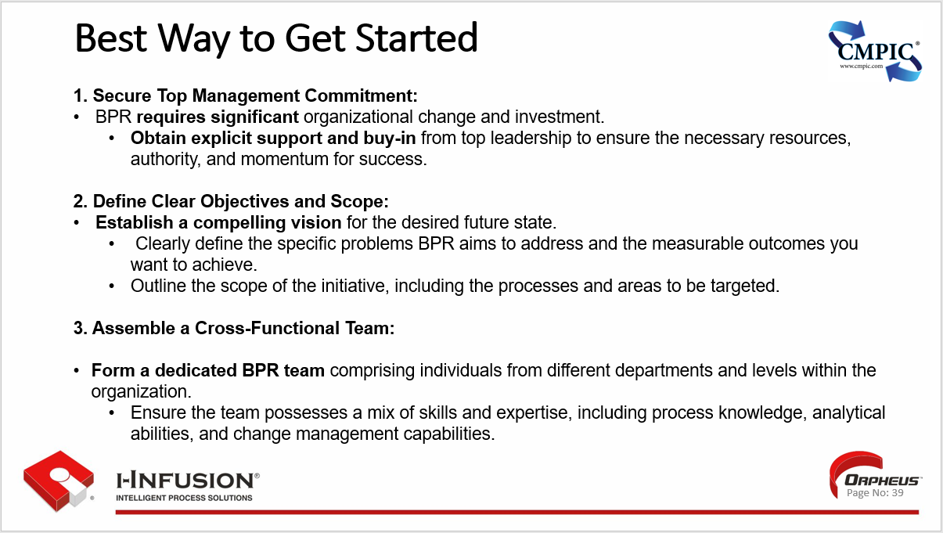

1. **Conduct a Thorough Process Analysis:**

* Map and analyze existing processes to deeply understand their current state, including their strengths, weaknesses, issues/bottlenecks, and inefficiencies.
  + Use tools like process mapping/modeling, data analysis, and stakeholder interviews to gather insights.

1. **Identify and Prioritize Improvement Opportunities:**

* Based on the process analysis, identify areas for improvement and prioritize them based on their potential impact on the organization's objectives.
  + Consider factors such as cost savings, quality enhancement, and customer satisfaction.

1. **Design and Model the New Process:**

* Develop a detailed redesigned process blueprint incorporating best practices, technology enablement, and innovative approaches.
  + Utilize process modeling tools to visualize the new process and simulate its operation and performance.

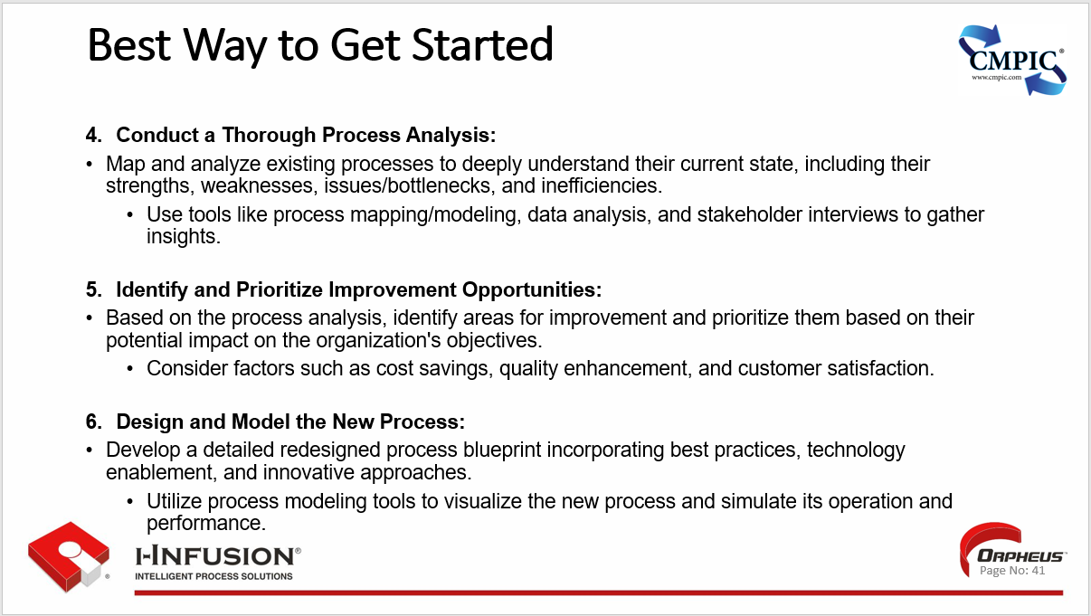

1. **Implement the New Process in a Controlled Environment:**

* Pilot the redesigned process in a controlled environment to test its effectiveness, identify potential issues, and gather stakeholder feedback. Based on the pilot results, make necessary adjustments.

1. **Roll Out and Monitor the New Process:**

* Implement the new process across the organization, ensuring that employees are adequately trained and supported. Establish clear communication channels to address any concerns or resistance to change.

1. **Monitor the process performance regularly**:

* Track progress and identify any further improvement opportunities.

*i-infusion Note:*

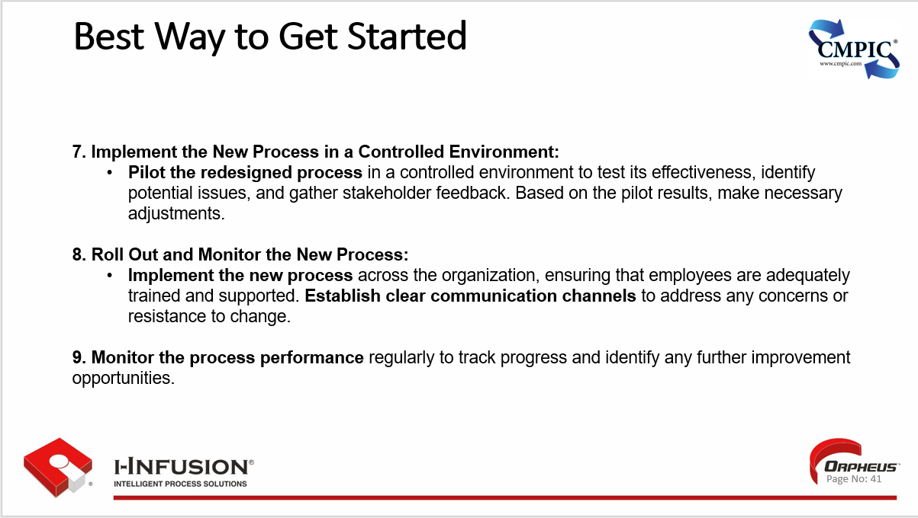

**Additional Considerations:**

* **Change Management:** BPR involves significant change, so effective **change management strategies** are critical for success.

This includes clear communication, stakeholder engagement, and addressing employee concerns.

* **Technology:** BPR often leverages technology to enable and streamline processes. Selecting the right technology solutions that align with the redesigned processes and support the desired outcomes is essential.
* **Continuous Improvement:** BPR is not a one-time event. It should be viewed as an **ongoing continuous improvement process**, with regular reviews and adjustments to ensure the organization remains agile and responsive to change.

By following these steps and embracing a strategic approach, organizations can maximize the benefits of Business Process engineering and achieve lasting improvements in their operations, performance, customer satisfaction, and achieving desired outcomes.

### Key Points

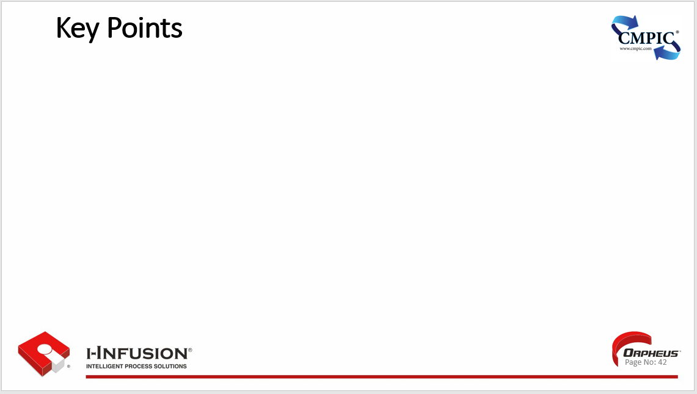

## Chapter 6: Identifying and Mapping Business Processes

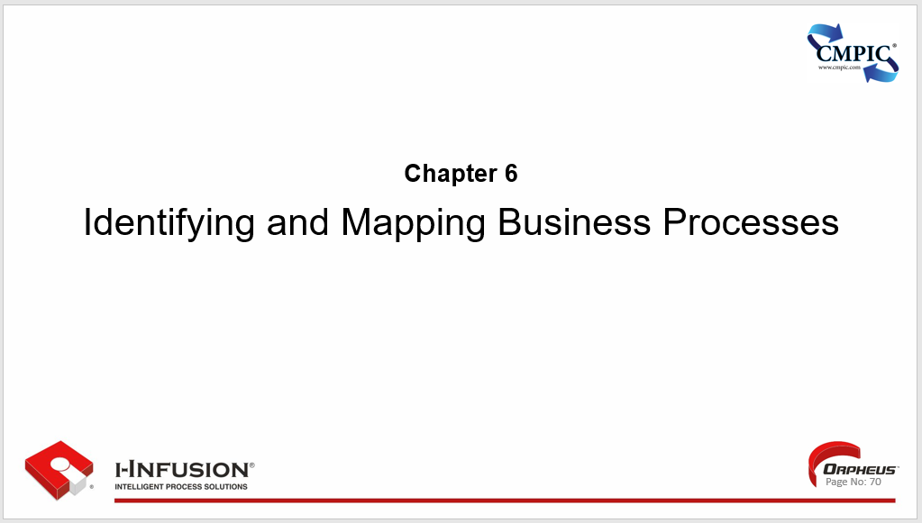

**Chapter 6. Outline**

* Identifying critical business processes
* Techniques for mapping processes (e.g., flowcharts, SIPOC diagrams)
* Tools for process mapping (e.g., Microsoft Visio, Orpheus)
* Key Points

**Workshop**

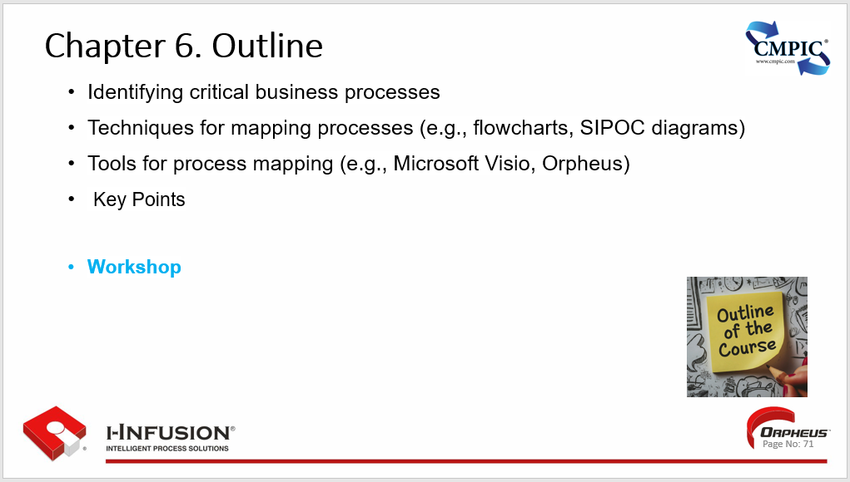

### Identifying Critical Business and Technical Processes

* Identifying critical CM business processes is crucial for ensuring the effectiveness and efficiency of configuration management practices within an organization.
* These processes directly influence the ability to maintain control, consistency, and traceability of enterprise artifacts and communication throughout their lifecycle.

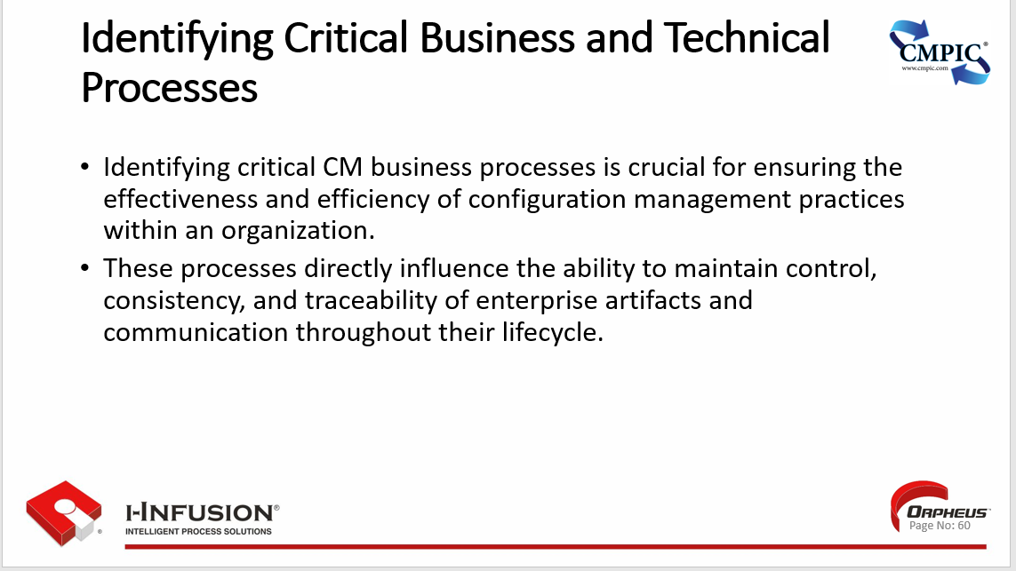

### Techniques for mapping processes (e.g., flowcharts, SIPOC diagrams)

Techniques for Mapping Processes:

1. **Flowcharts:** A visual representation of the sequence of steps and decisions in a process, using standardized symbols and arrows to depict flow and connections. Flowcharts are great for illustrating linear processes and highlighting decision points.
2. **SIPOC Diagrams:** (Suppliers, Inputs, Process, Outputs, Customers) A high-level process map that provides a quick overview of a process by identifying its key elements: suppliers, inputs, process steps, outputs, and customers. SIPOC diagrams are useful for understanding the big picture and stakeholder relationships.
3. **Swimlane Diagrams:** Similar to flowcharts, but with lanes representing different roles or departments involved in the process. This visualization helps clarify who is responsible for each step and how activities flow across functional areas.
4. **Value Stream Mapping:** A lean manufacturing tool used to visualize the flow of materials and information through a process, identifying value-adding and non-value-adding activities. Value stream mapping identifies and eliminates waste, improving efficiency and flow.
5. **Business Process Model and Notation (BPMN):** A standardized graphical notation for modeling business processes. BPMN provides a rich set of symbols and rules to represent complex process flows, decision points, and participant interactions.
6. **Data Flow Diagrams (DFDs):** Focus on the flow of data through a system, highlighting data sources, transformations, storage, and destinations. DFDs are useful for understanding how information is processed and used within a system or process.

Remember, the best technique for mapping processes depends on the specific context, complexity, and objectives of the process being analyzed.

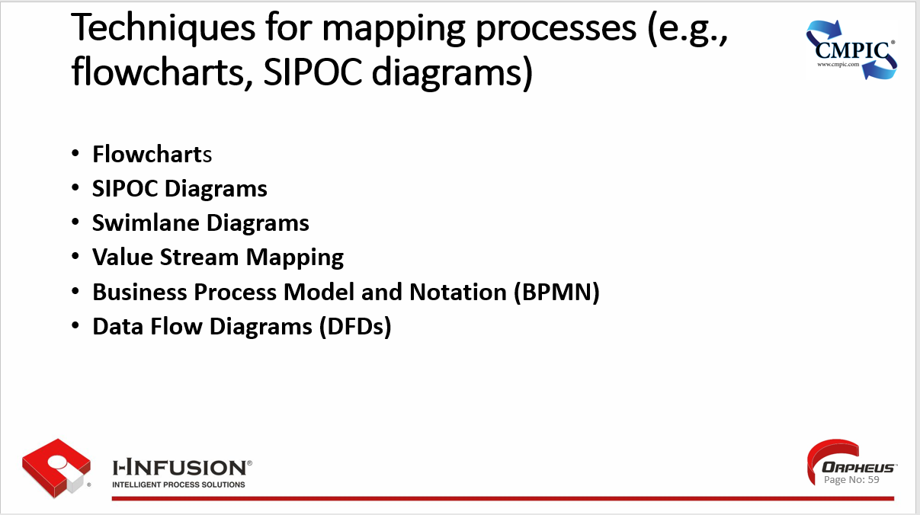

### Tools for process mapping (e.g., Microsoft Visio, Orpheus)

Techniques for Mapping Processes:

1. **Flowcharts:** A visual representation of the sequence of steps and decisions in a process, using standardized symbols and arrows to depict flow and connections. Flowcharts are great for illustrating linear processes and highlighting decision points.
2. **SIPOC Diagrams:** (Suppliers, Inputs, Process, Outputs, Customers) A high-level process map that provides a quick overview of a process by identifying its key elements: suppliers, inputs, process steps, outputs, and customers. SIPOC diagrams are useful for understanding the big picture and stakeholder relationships.
3. **Swimlane Diagrams:** Similar to flowcharts, but with lanes representing different roles or departments involved in the process. This visualization helps clarify who is responsible for each step and how activities flow across functional areas.
4. **Value Stream Mapping:** A lean manufacturing tool used to visualize the flow of materials and information through a process, identifying value-adding and non-value-adding activities. Value stream mapping identifies and eliminates waste, improving efficiency and flow.
5. **Business Process Model and Notation (BPMN):** A standardized graphical notation for modeling business processes. BPMN provides a rich set of symbols and rules to represent complex process flows, decision points, and participant interactions.
6. **Data Flow Diagrams (DFDs):** Focus on the flow of data through a system, highlighting data sources, transformations, storage, and destinations. DFDs are useful for understanding how information is processed and used within a system or process.

Remember, the best technique for mapping processes depends on the specific context, complexity, and objectives of the process being analyzed.

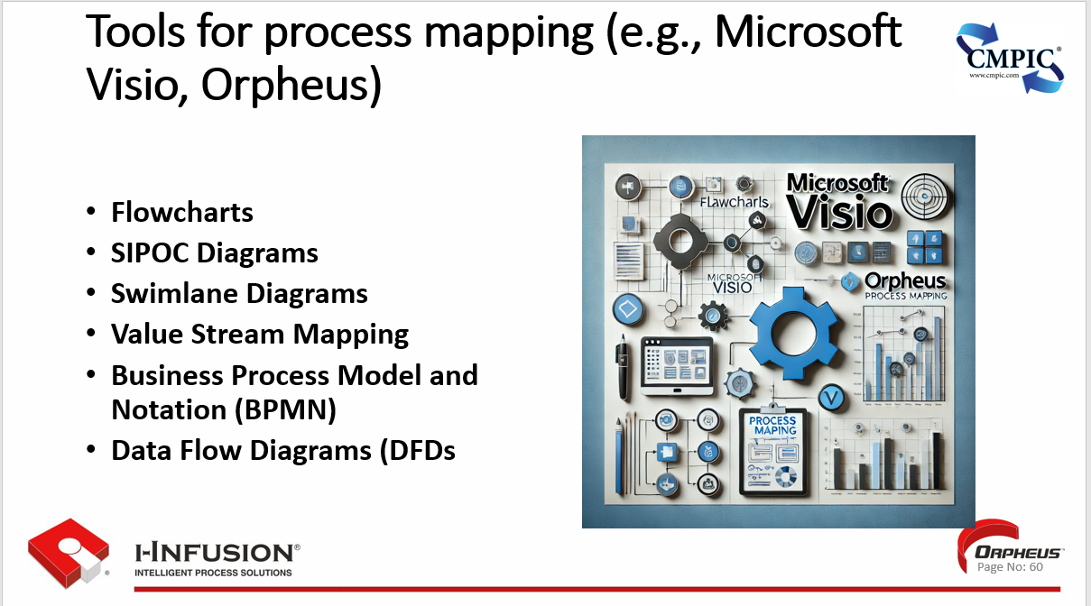

### Key Points

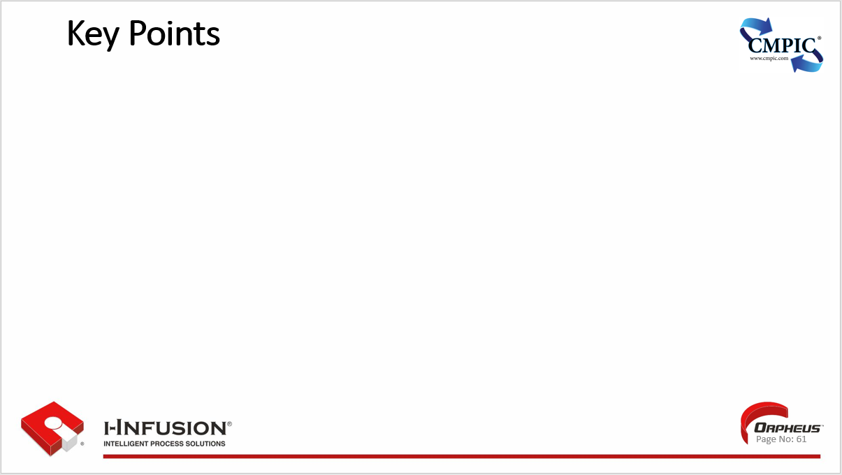

## Workshop

* ***OrpheusTM* Account Setup**
* **Modeling a Process**

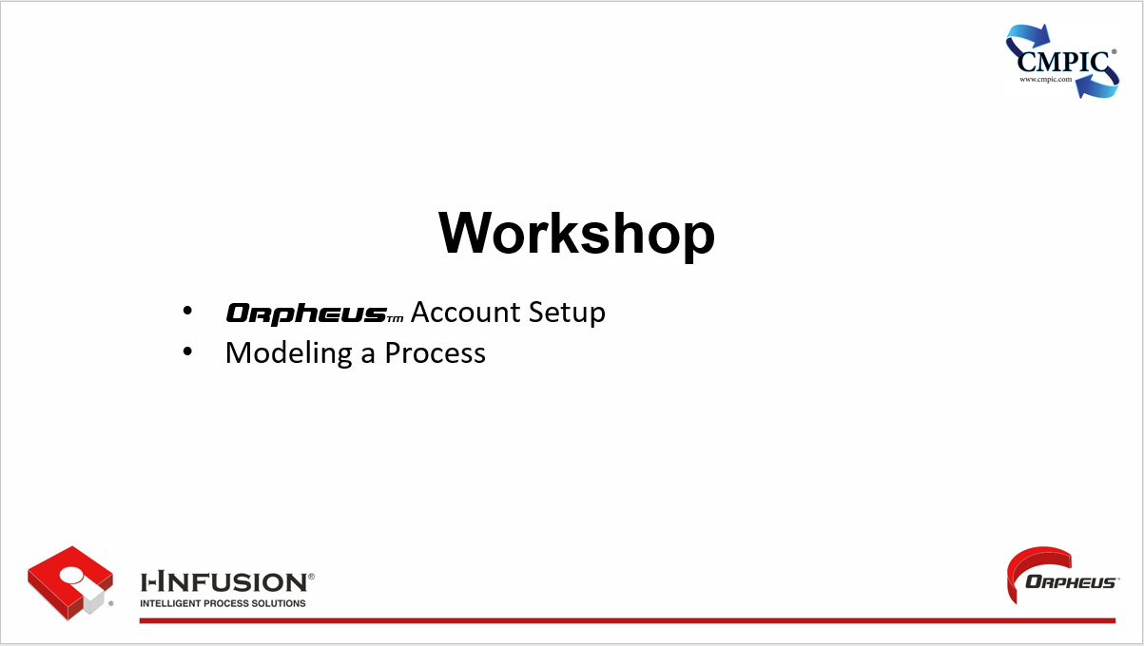

## Chapter 7: Understanding the Fundamentals of Continuous Process Improvement (CPI)

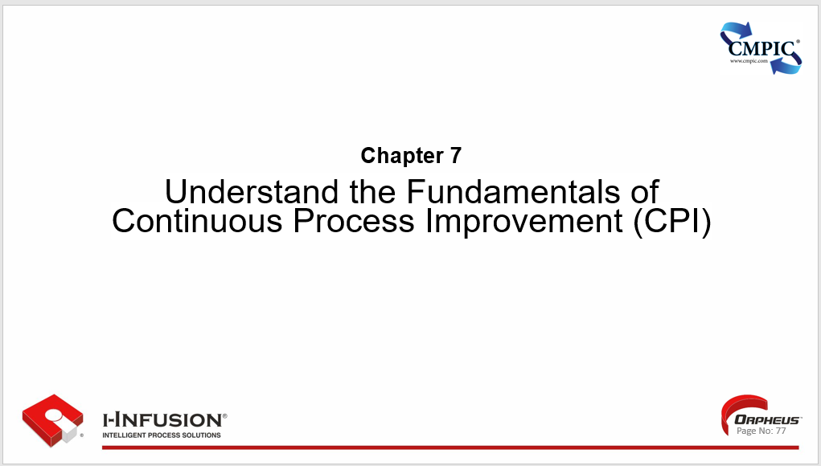

Chapter 7. Outline

* What is Continuous Process Improvement (CPI)?
* Why is Continuous Process Improvement Important
* What are the benefits of Continuous Process Improvement
* Identifying Improvement Opportunities
* Brainstorming techniques
* Process Mapping
* Data collection and analysis
* Key Points

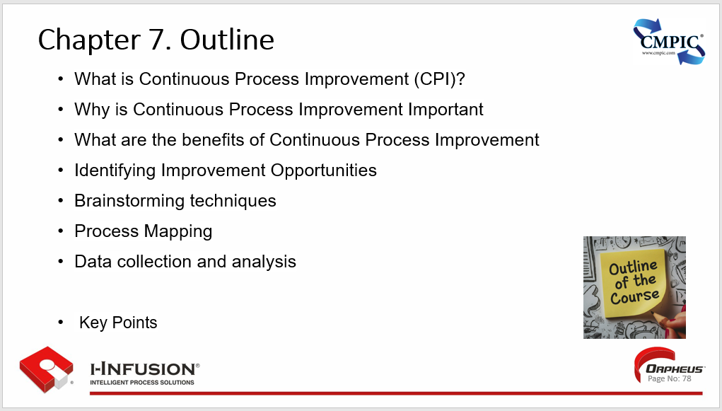

### What is Continuous Process Improvement (CPI)?

**Ongoing Effort:** CPI is an ongoing, systematic approach to improving processes, products, or services within an organization. It's a mindset of constantly seeking ways to do things better, faster, and more efficiently.

**Incremental and Breakthrough Changes:** CPI involves both small, incremental improvements and larger, breakthrough innovations. It recognizes that progress can be achieved through a combination of both approaches.

**Data-Driven Decision Making:** CPI relies on data collection and analysis to identify areas for improvement and measure the impact of changes. This ensures that decisions are based on evidence rather than assumptions.

**Employee Engagement:** CPI encourages employee participation and empowerment, recognizing that those closest to the work often have the best insights into how to improve it. This fosters a culture of ownership and continuous learning.

**Customer Focus:** CPI prioritizes meeting or exceeding customer expectations by aligning processes and products with their needs. This helps to enhance customer satisfaction and loyalty.

**Adaptability and Resilience:** CPI enables organizations to adapt to change and stay ahead of the competition by fostering a culture of innovation and continuous learning. This helps organizations remain agile and resilient in the face of evolving market conditions and customer demands.

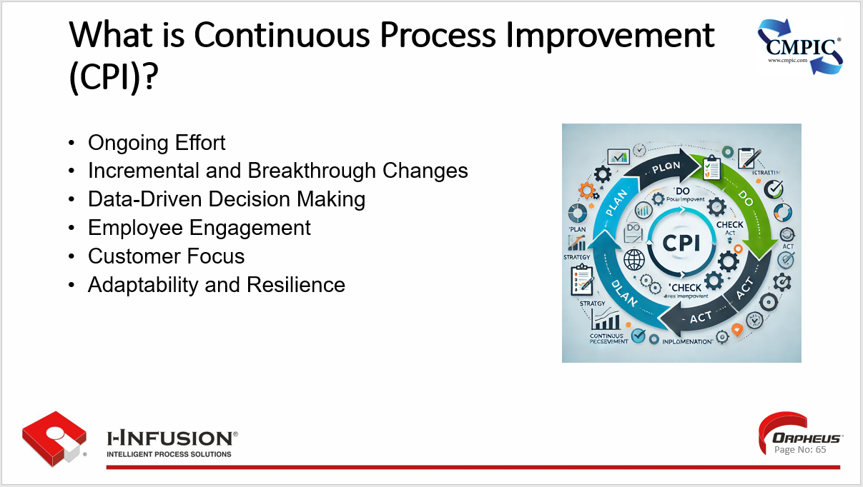

### Why is Continuous Process Improvement Important

* Ongoing Effort
* Incremental and Breakthrough Changes
* Data-Driven Decision Making
* Employee Engagement
* Customer Focus
* Adaptability and Resilience

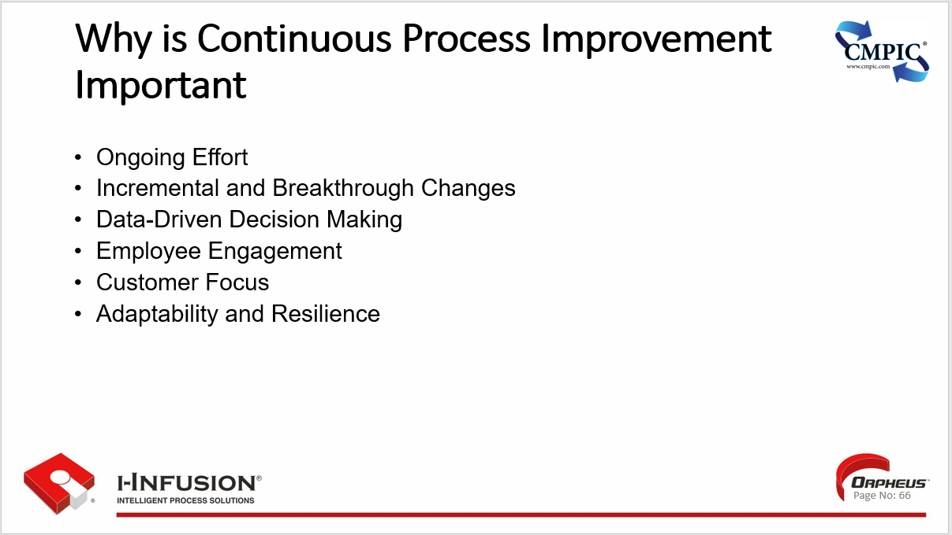

### What are the Benefits of Continuous Process Improvement

**Increased Efficiency**: Streamlining processes and eliminating waste results in faster turnaround times, increased productivity, and optimal resource utilization.

**Improved Quality:** CPI reduces errors, defects, and rework, leading to higher-quality products or services that better meet customer expectations.

**Enhanced Customer Satisfaction:** By focusing on customer needs and feedback, CPI helps organizations deliver better products and services, leading to increased customer loyalty.

**Cost Reduction:** Eliminating waste, optimizing processes, and improving efficiency can lead to significant cost savings for an organization.

**Employee Engagement:** Involving employees in the improvement process fosters a sense of ownership and empowerment, increasing their job satisfaction and motivation.

**Adaptability:** CPI creates an environment where organizations are constantly learning and adapting, enabling them to stay ahead of the curve and respond effectively to market changes and evolving customer needs.

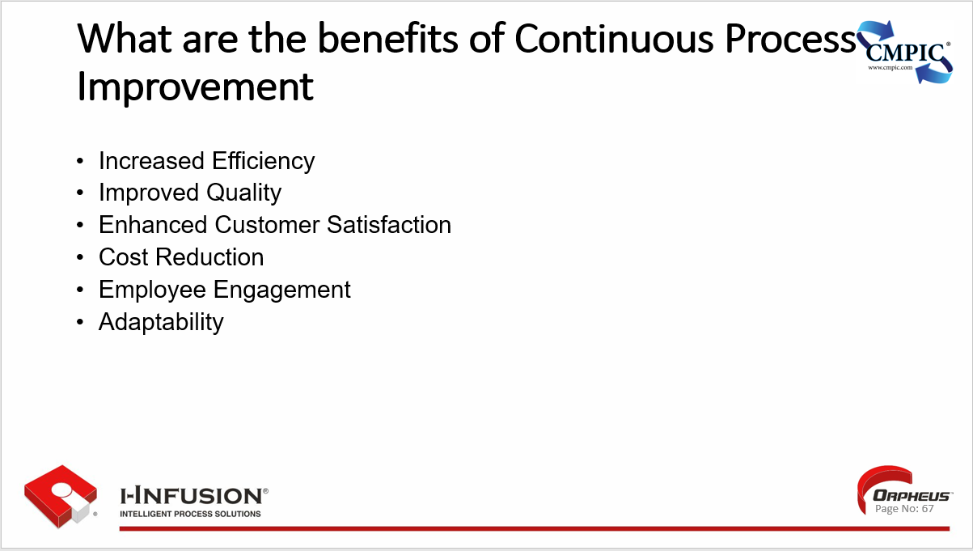

### Identifying Improvement Opportunities

?? Knowledge Elements

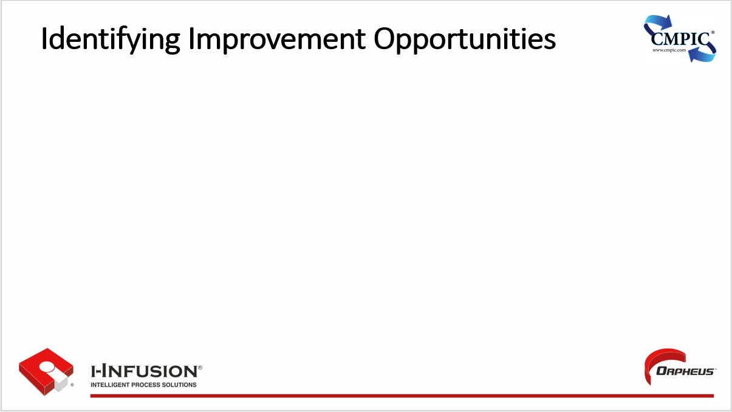

### Brainstorming Techniques

**Mind Mapping:** Start with a central idea and branch out with related concepts, creating a visual map of connections.

**Brainwriting:** Each participant writes ideas on a piece of paper, then passes it to the next person to add their own thoughts.

**Rapid Ideation:** Set a timer and generate as many ideas as possible without judgment.

**Reverse Brainstorming:** Instead of focusing on solutions, identify potential problems or obstacles.

**SCAMPER:** Use the acronym to trigger ideas: Substitute, Combine, Adapt, Modify, Put to another use, Eliminate, Reverse.

**Risk Management Framework: ??**

**Role-Playing:** Take on different perspectives or roles to spark new ideas.

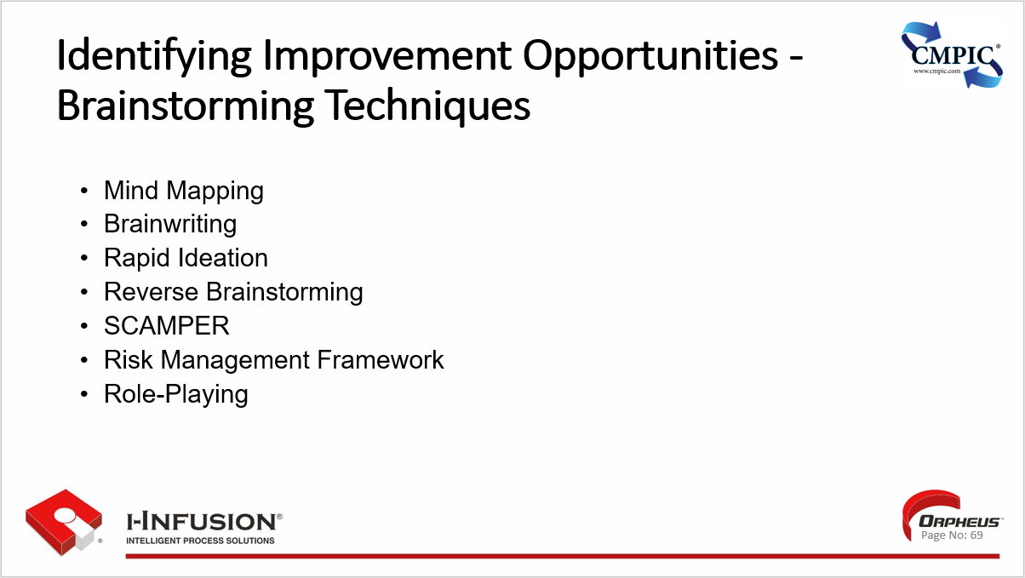

### Process Mapping

* Visual Representation
* Identifies Steps and Sequence
* Rapid Ideation
* Reverse Brainstorming
* SCAMPER
* Role-Playing

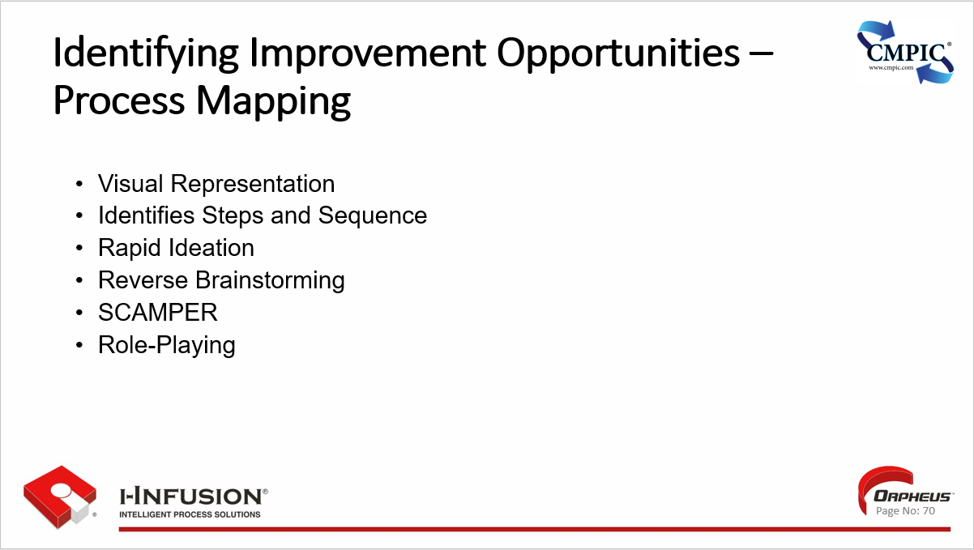

### Data Collection and Analysis

**Defines Objectives:** The first step in data collection and analysis is to clearly define the objectives and questions you want to answer with the data.

**Determines Data Sources:** Once objectives are defined, identify the appropriate data sources that will provide the necessary information. These could include surveys, experiments, observations, or existing databases.

**Collects Data:** Data collection involves gathering information from the identified sources using appropriate methods and tools. It is important to ensure data quality and accuracy during this process.

**Cleans and Prepares Data:** Raw data often requires cleaning and preparation before analysis. This involves handling missing values, outliers, and inconsistencies to ensure data integrity.

**Analyzes Data:** Data analysis involves applying various statistical and analytical techniques to extract insights, identify patterns, and test hypotheses.

**Interprets and Communicates Findings:** The final step is to interpret the analysis results and communicate the findings in a clear and concise manner, often using visualizations or reports.

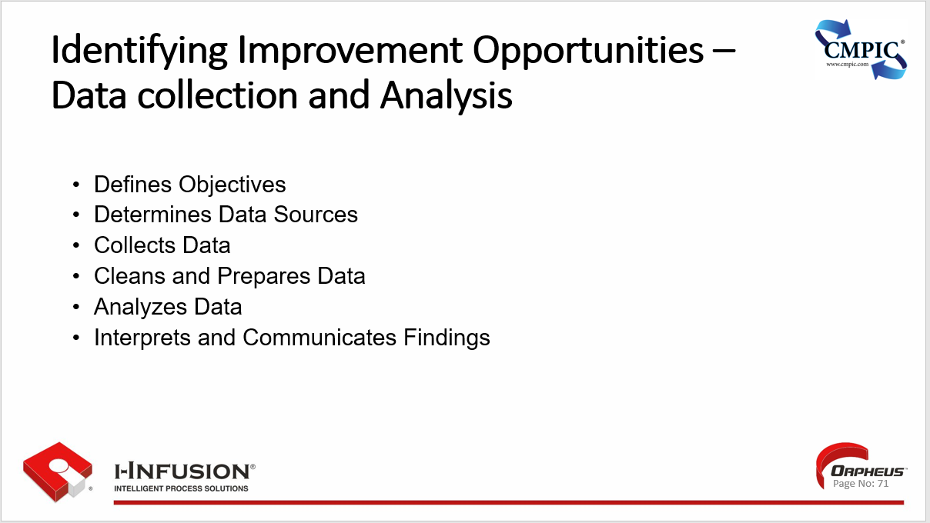

### Key Points

## Chapter 8: Practical Tools and Techniques

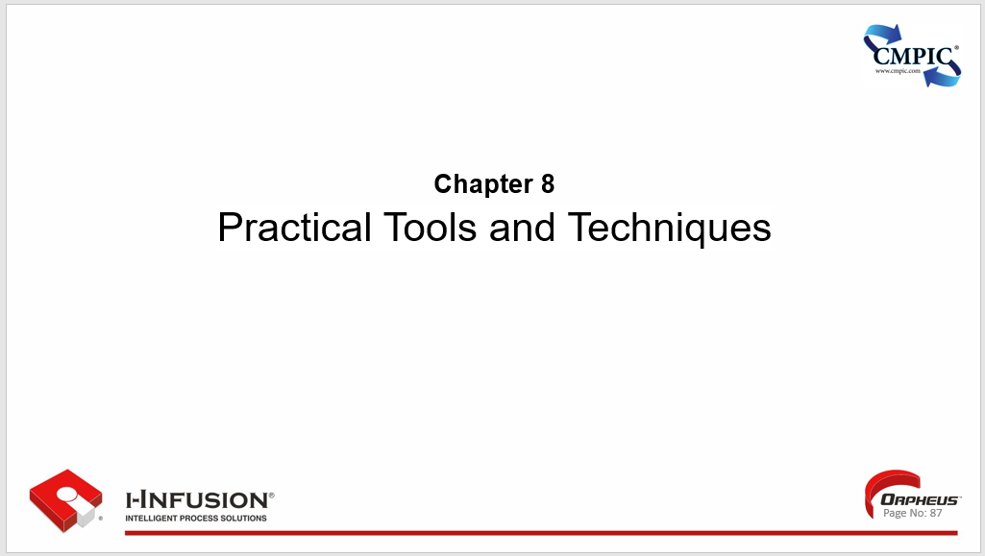

Chapter 8. Outline

* Lean: Value stream mapping, 5S, Kaizen events
* Six Sigma: DMAIC methodology, statistical process control
* Other tools: Pareto charts, Fishbone diagrams, Run charts
* Key Points
* **Workshop**

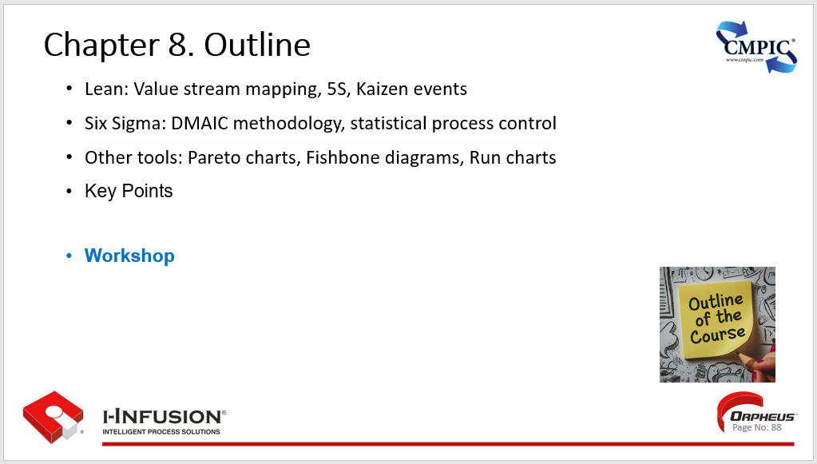

### Lean: Value Stream Mapping, 5S, Kaizen Events

**Lean Concepts**

* **Value Stream Mapping (VSM)**:
  + A visual tool to map the flow of materials and information required to bring a product or service to the customer.
  + Helps identify waste (non-value-added activities) and opportunities for improvement within the process.
* **5S**
  + A workplace organization methodology based on five Japanese words: Seiri (Sort), Seiton (Set in Order), Seiso (Shine), Seiketsu (Standardize), and Shitsuke (Sustain).
  + Aims to create a clean, organized, and efficient work environment, reducing waste and improving productivity.
* **Kaizen Events**
  + Short, focused improvement workshops where a cross-functional team tackles a specific problem or process.
  + Utilizes a structured approach to identify root causes, implement solutions, and measure results quickly.

**Benefits**

* + **Waste Reduction:** All three concepts focus on eliminating waste in processes, whether it's unnecessary steps, excess inventory, or inefficient movement.
  + **Improved Efficiency:** By streamlining processes and eliminating waste, Lean practices can lead to significant improvements in efficiency and productivity.

**Continuous Improvement:** Lean promotes a culture of continuous improvement, where employees are empowered to identify and implement improvements on an ongoing basis.

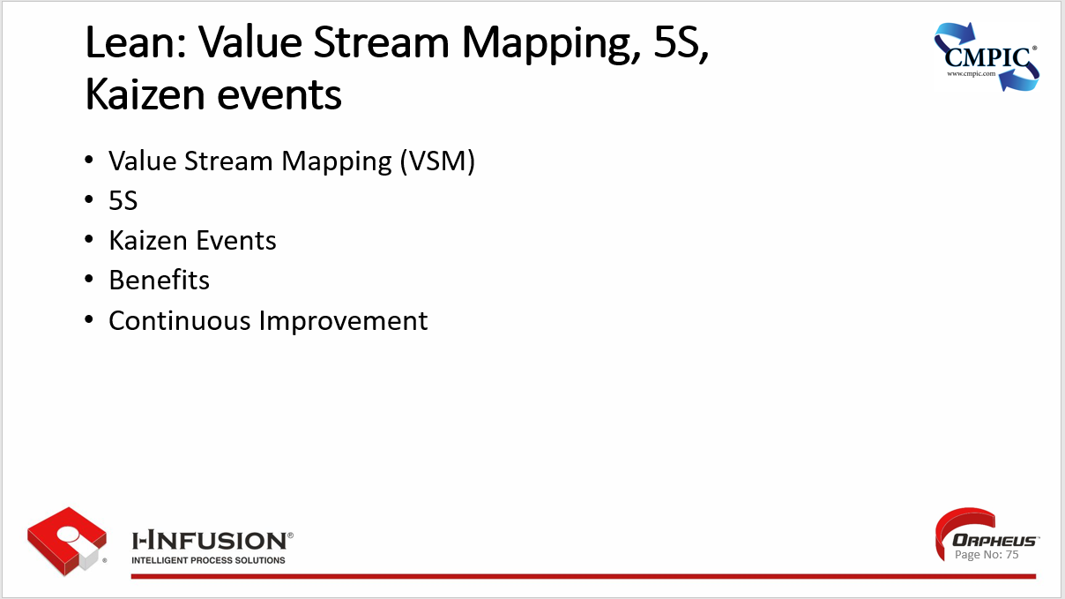

### Six Sigma: DMAIC Methodology, Statistical Process Control

**DMAIC**, A structured problem-solving approach used in Six Sigma projects. It stands for:

* + - **Define**: Clearly define the problem, goals, and customer requirements.
    - **Measure**: Collect data to understand the current process performance.
    - **Analyze**: Analyze the data to identify root causes of the problem.
    - **Improve**: Develop and implement solutions to address the root causes.
    - **Control**: Implement controls to sustain the improvements and prevent regression.

**Statistical Process Control (SPC)**:

* + A collection of statistical techniques used to monitor and control process performance.
  + Involves using control charts to track key process metrics and identify any deviations from the desired performance.
  + Helps detect and prevent defects, ensuring processes remain stable and predictable.

**Benefits**

* + **Reduced Defects:** Six Sigma aims to reduce defects to near zero, leading to higher quality products and services.
  + **Improved Process Efficiency:** By identifying and eliminating root causes of problems, Six Sigma can lead to significant improvements in process efficiency and productivity.
  + **Data-Driven Decision Making:** Six Sigma relies heavily on data analysis to guide decision-making, ensuring that improvements are based on facts and evidence.
  + **Customer Satisfaction:** By focusing on meeting customer requirements and reducing defects, Six Sigma can lead to increased customer and workplacesatisfaction.

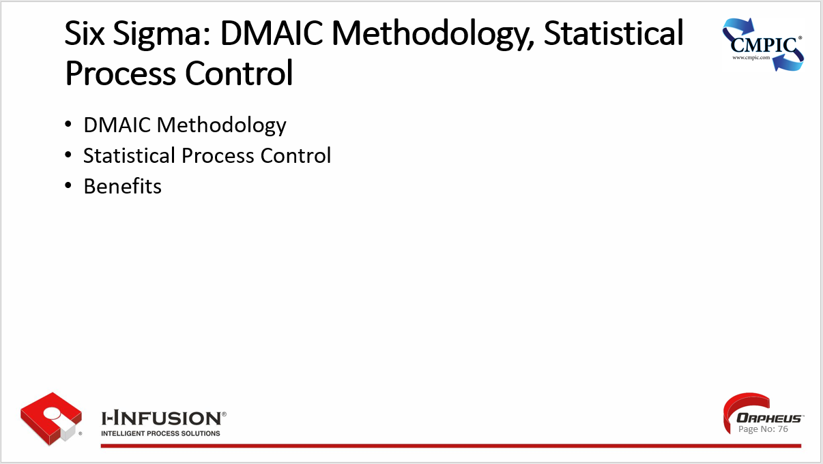

### Other tools: Pareto Charts, Fishbone Diagrams, Run Charts

**Pareto Charts**

* + **Visualizes Frequency**: Graphically represents the frequency or impact of different categories or causes, often highlighting the "vital few" that contribute to the majority of problems.
  + **Prioritizes Improvement Efforts**: Helps prioritize improvement efforts by focusing on the most significant factors first.

**Fishbone Diagrams**

* + **Identifies Root Causes:** Also known as Ishikawa or cause-and-effect diagrams, it systematically identifies and organizes potential root causes of a problem.
  + **Categorizes Causes:** Groups causes into major categories (e.g., Machine, Method, Material, Man, Measurement, Environment) to provide a structured analysis.

**Run Charts**

* + **Tracks Data Over Time:** Displays data points in chronological order to visualize trends, shifts, or patterns in a process.
  + **Monitors Process Stability:** Helps assess whether a process is stable or exhibits unusual variations.

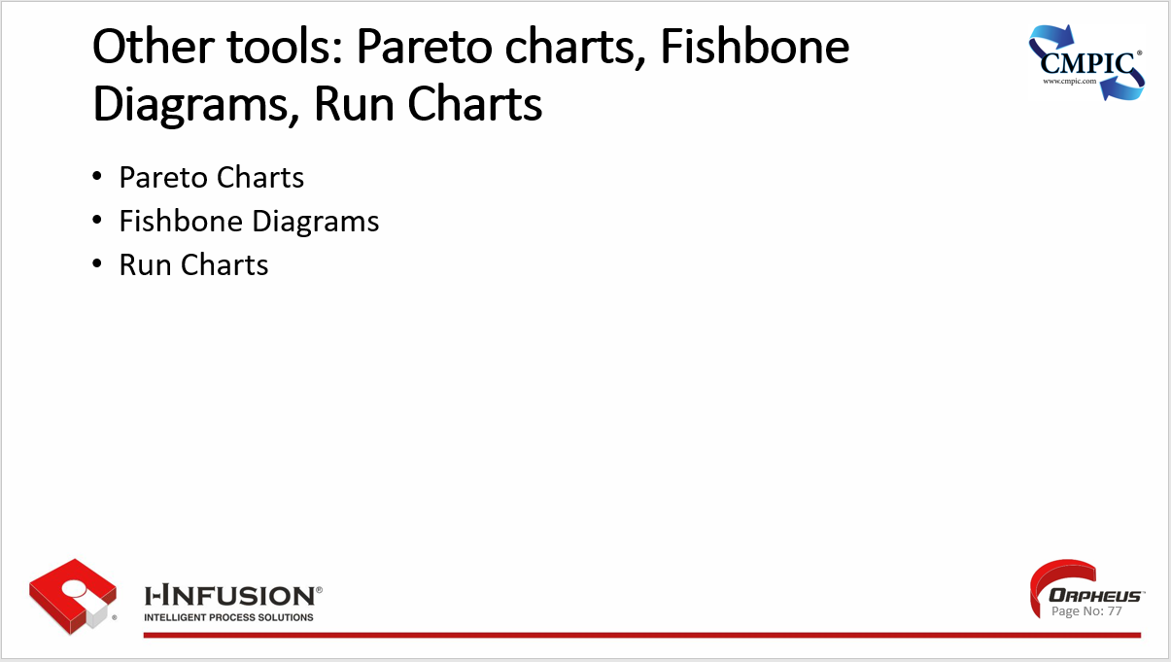

### Key Points

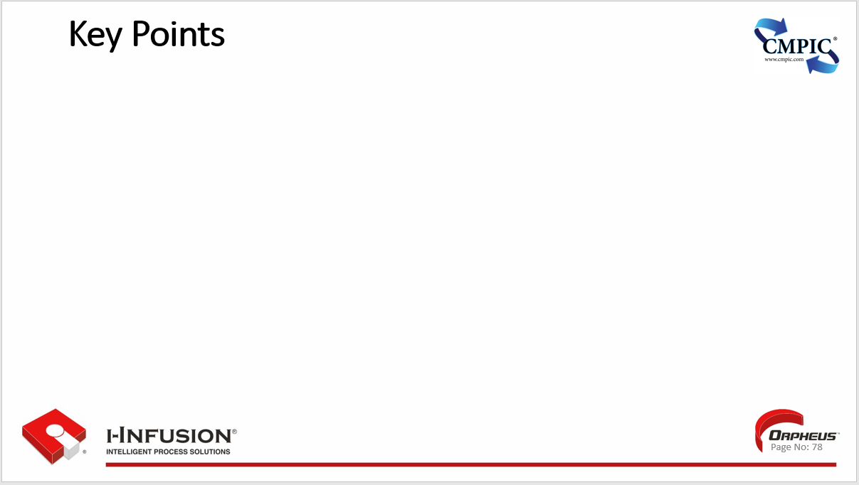

## Workshop

* *OrpheusTM*
* Modeling From a Document
  + Standards
  + Procedures/Work Instructions

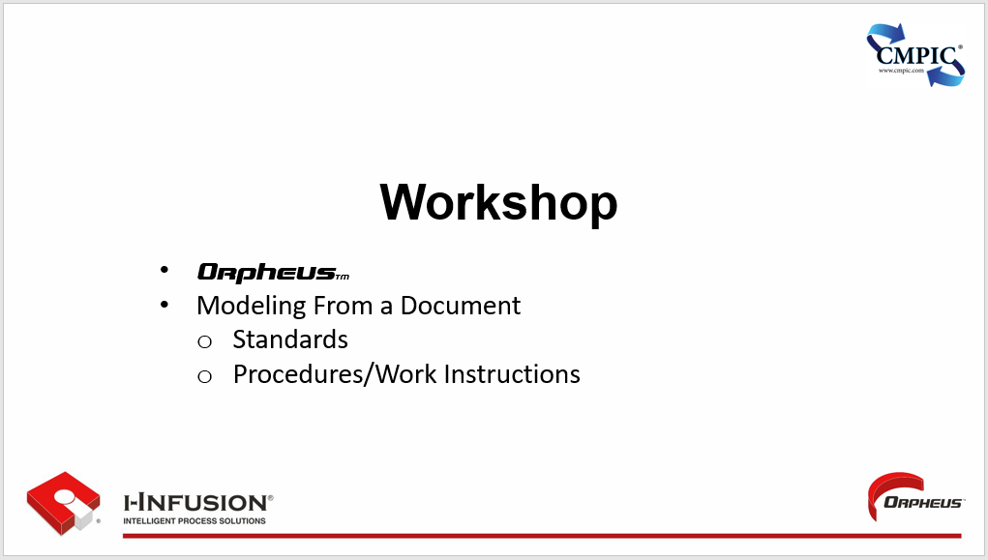

## Chapter 9: Analyzing Process Performance

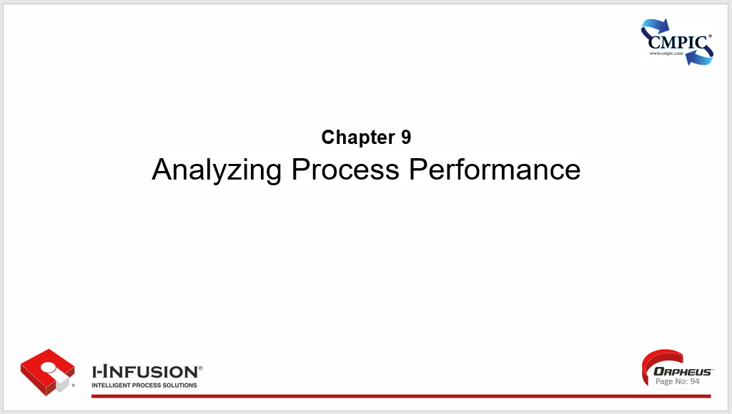

Chapter 9. Outline

* Status, Key Performance Indicators (KPIs) and Metrics
* Monitoring Progress and Measuring Results
* Analyzing Process Inefficiencies and Bottlenecks
* Techniques for Process Analysis (e.g., Root Cause Analysis, Pareto Analysis)
* Key Points

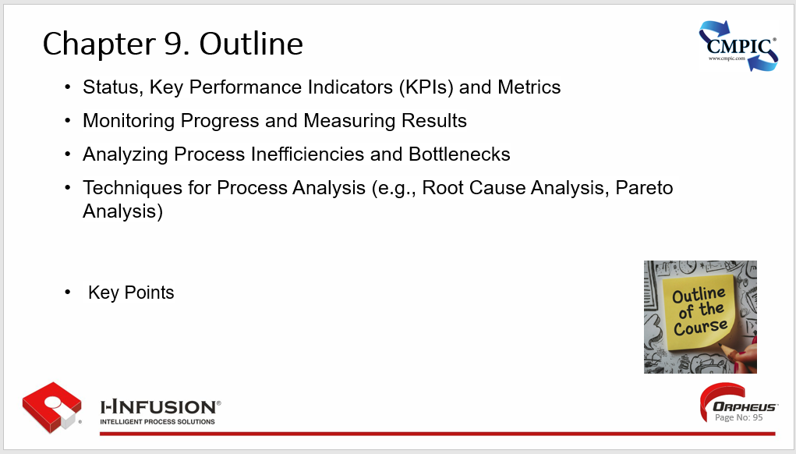

### Status, Key Performance Indicators (KPIs) and Metrics

**Status:** Provides a snapshot of the current state or condition of a project, process, or system. It typically indicates whether things are on track, delayed, or facing challenges.

**Key Performance Indicators (KPIs):** Specific, measurable values that demonstrate how effectively a company is achieving key business objectives. They are critical for tracking progress and making informed decisions.

**Metrics:** Quantifiable measures used to track and assess the performance of a particular process or activity. They provide valuable data for analysis and improvement.

**Alignment with Goals:** KPIs should be directly aligned with strategic goals and objectives, ensuring that everyone is working towards the same outcomes.

**Regular Monitoring:** KPIs and metrics should be monitored regularly to identify trends, potential issues, and opportunities for improvement.

**Actionable Insights:** Data from KPIs and metrics should provide actionable insights that enable informed decision-making and drive positive change.

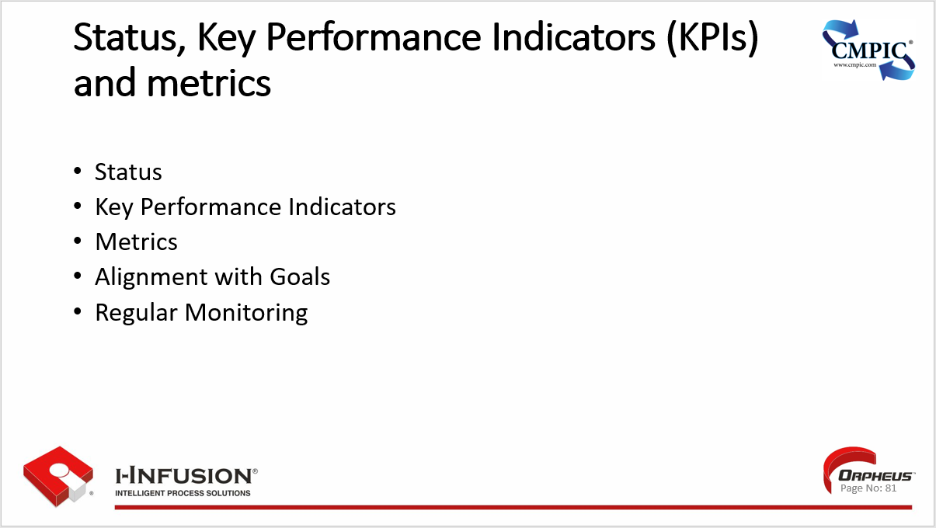

### Monitoring Progress and Measuring Results

**Establish clear goals and objectives**: Clearly define what you want to achieve and how you will measure success. This provides a framework for tracking progress and evaluating outcomes.

**Identify key performance indicators (KPIs)**: Select specific metrics that are directly aligned with your goals and objectives. These KPIs will help you track progress and identify areas for improvement.

**Collect and analyze data**: Regularly collect data related to your KPIs and analyze it to gain insights into performance trends and identify any potential issues.

**Track progress against targets**: Compare your actual performance against your established targets to see if you are on track to achieve your goals.

**Communicate results**: Share progress updates and results with relevant stakeholders. This helps ensure everyone is informed and aligned.

**Make adjustments as needed**: If your monitoring reveals that you are not on track to achieve your goals, make necessary adjustments to your plans or strategies.

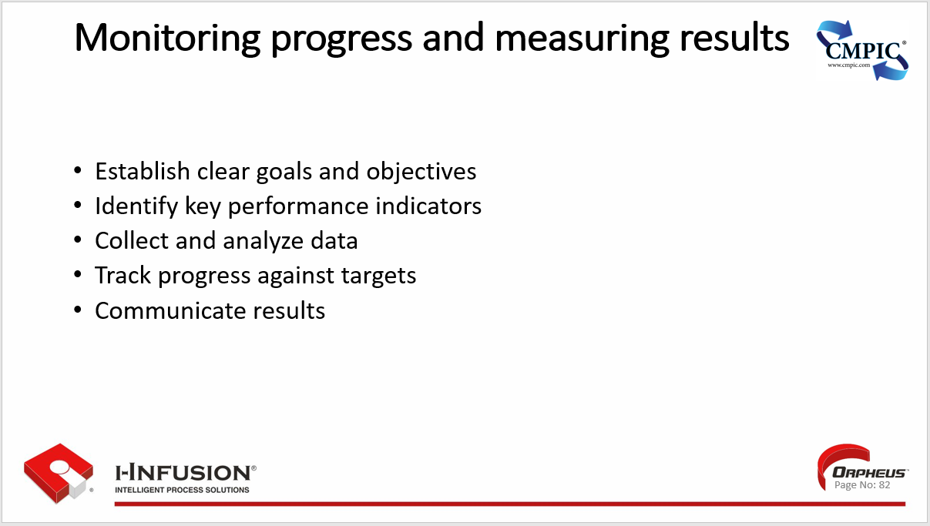

### Analyzing Process Inefficiencies and Bottlenecks

**Identify Process Steps:** Break down the process into its individual steps to gain a clear understanding of the workflow and sequence of activities.

**Map the Process:** Create a visual representation of the process, such as a flowchart or value stream map, to visualize the flow of work and identify potential areas of inefficiency.

**Collect Data:** Gather data on process performance, including cycle times, throughput, wait times, and error rates. This data will help pinpoint bottlenecks and areas for improvement.

**Analyze Data:** Analyze the collected data to identify patterns, trends, and areas where the process is slowing down or experiencing delays. Look for bottlenecks where work is piling up or resources are constrained.

**Identify Root Causes:** Use root cause analysis techniques (e.g., 5 Whys, Fishbone diagrams) to determine the underlying reasons for inefficiencies and bottlenecks.

**Develop and Implement Solutions:** Based on the analysis, develop and implement solutions to address the root causes of inefficiencies and bottlenecks. This may involve streamlining processes, reallocating resources, or adopting new technologies.

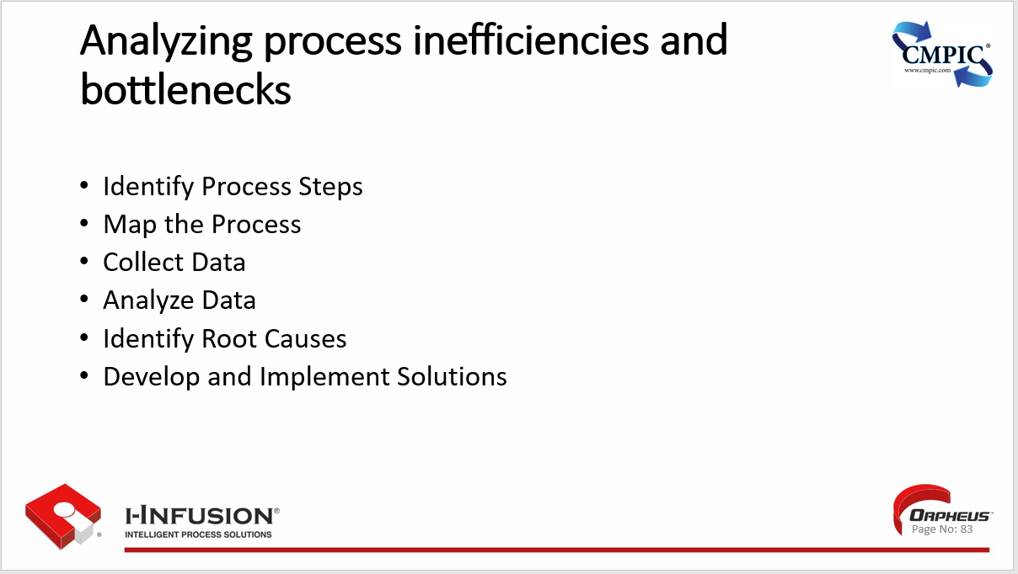

### Techniques for Process Analysis (e.g., Root Cause Analysis, Pareto Analysis)

**Process Analysis Techniques**

* **Root Cause Analysis (RCA)**
  + A systematic approach to identify the underlying causes of a problem or event.
  + Aims to prevent recurrence by addressing the root cause rather than just the symptoms.
  + Employs various tools like the 5 Whys, fishbone diagrams, and fault tree analysis.
* **Pareto Analysis**
  + Based on the Pareto principle (80/20 rule), which states that roughly 80% of effects come from 20% of causes.
  + Involves identifying and prioritizing the most significant factors contributing to a problem.
  + Uses a Pareto chart to visualize the relative impact of different causes.

**Additional Techniques**

* **Process Mapping:** Visually represents the steps and sequence of a process, helping to identify inefficiencies and areas for improvement.
* **Value Stream Mapping:** Focuses on identifying and eliminating waste (non-value-added activities) within a process.
* **Failure Mode and Effects Analysis (FMEA):** Proactively identifies potential failure modes in a process and assesses their impact and likelihood.
* **Statistical Process Control (SPC):** Uses statistical methods to monitor and control process performance, ensuring it remains stable and predictable.

These techniques help organizations understand their processes better, identify areas for improvement, and implement solutions to enhance efficiency, reduce costs, and improve overall performance.

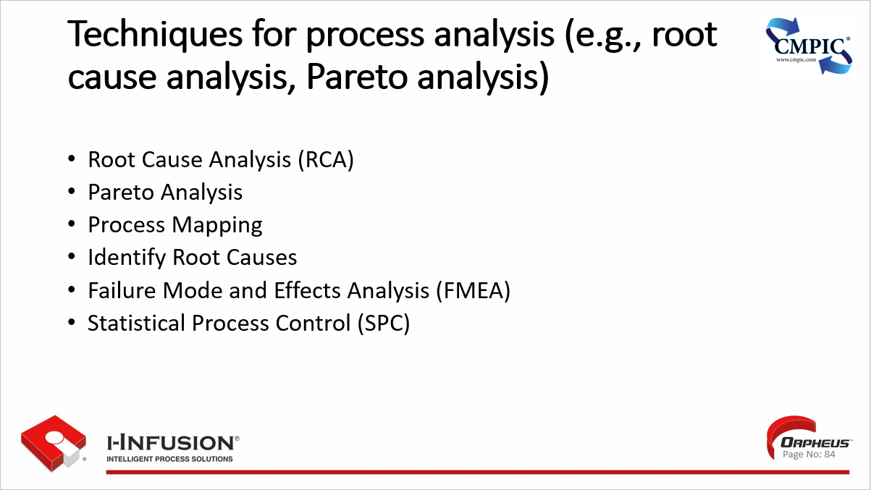

### Key Points

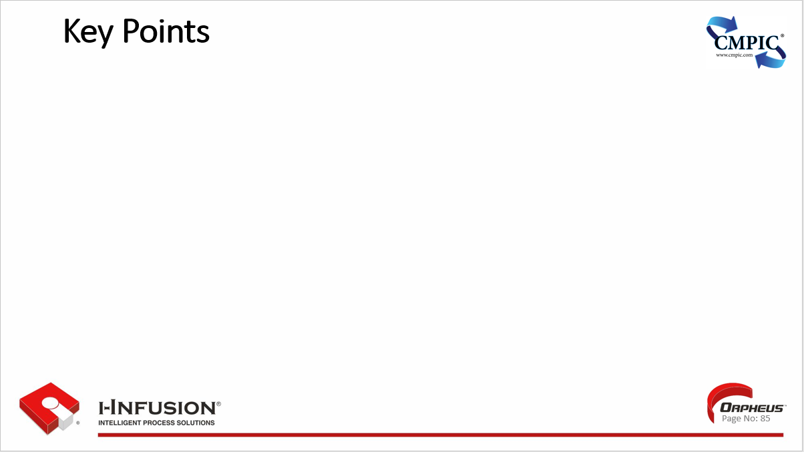

# Section 2: Redesigning and Implementing Processes

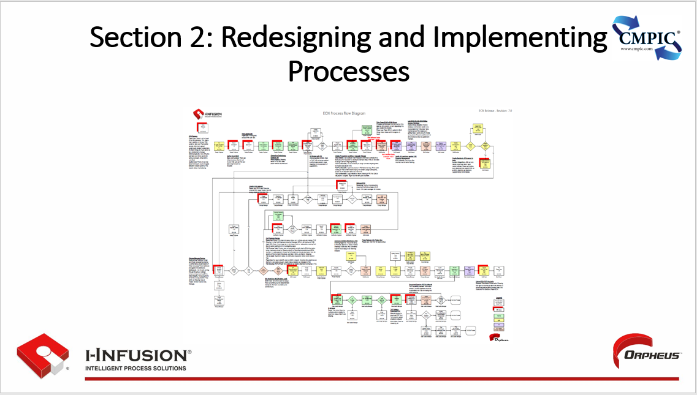

## Chapter 10: Preparing for Change

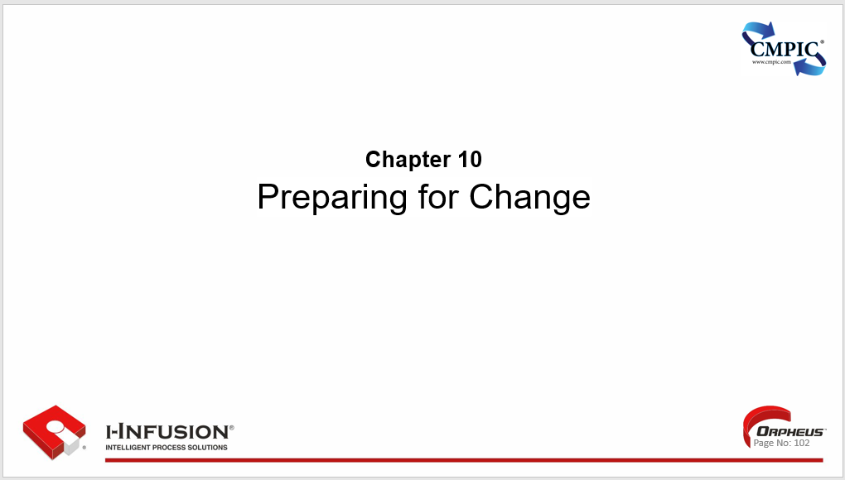

Chapter 10. Outline

* Change management principles
* Building a case for BPR within the organization
* Engaging stakeholders and managing resistance
* Key Points

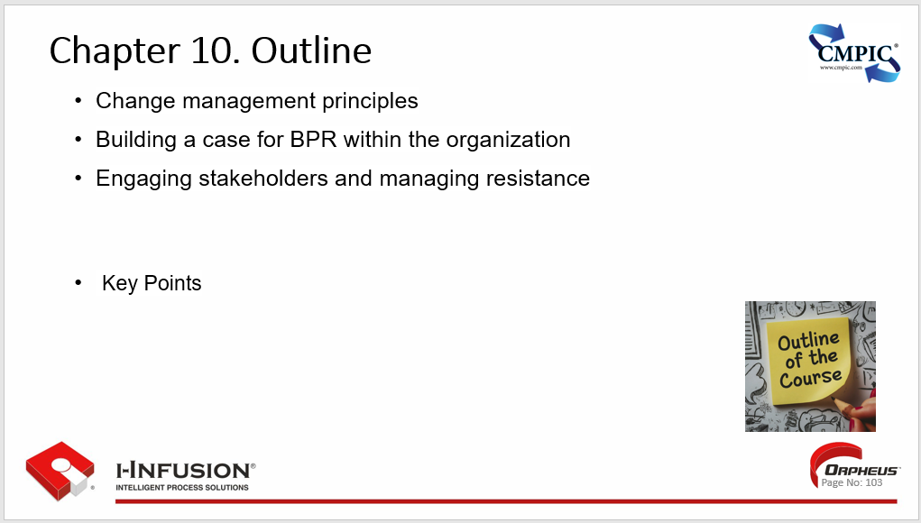

### Change management principles

* **Understanding the Need for Change:** Clearly articulate the reasons behind the change, highlighting the benefits and addressing any potential concerns or resistance.
* **Creating a Shared Vision:** Develop a compelling vision for the future that resonates with stakeholders, inspiring them to embrace the change and work towards its success.
* **Effective Communication:** Maintain open and transparent communication throughout the change process, providing regular updates, addressing questions, and managing expectations.
* **Stakeholder Engagement:** Identify and engage key stakeholders early on, ensuring their active participation and support throughout the change journey.
* **Managing Resistance:** Anticipate and address resistance to change through proactive communication, empathy, and support. Provide opportunities for feedback and address concerns constructively.
* **Celebrating Success:** Recognize and celebrate milestones and achievements throughout the change process to maintain momentum and motivation.

These principles, when implemented effectively, can contribute to successful change initiatives by fostering understanding, engagement, and commitment among stakeholders.

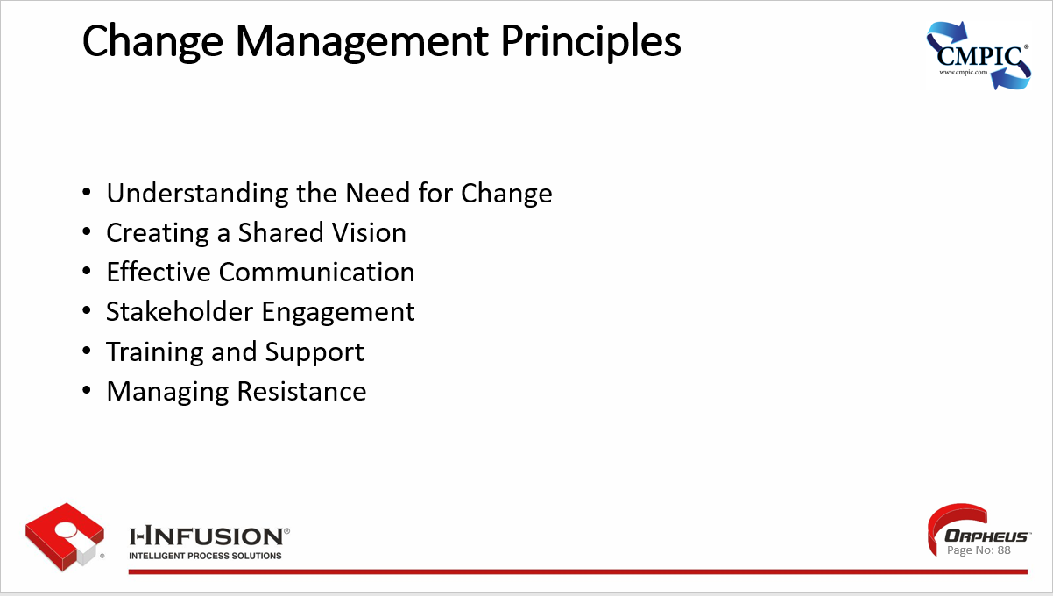

### Building a case for BPR within the organization

**Identify Pain Points and Inefficiencies:**

* Conduct a thorough analysis of existing processes to identify areas of inefficiency, bottlenecks, and unnecessary complexity.
* Gather data on process cycle times, error rates, customer complaints, and other relevant metrics to quantify the impact of these issues.

**2. Highlight Cost Savings and ROI:**

* Develop a business case that demonstrates the potential cost savings and return on investment (ROI) from BPR initiatives.
* Quantify the financial benefits of improved efficiency, reduced waste, and increased productivity.

**3. Emphasize Customer Satisfaction:**

* Show how BPR can lead to improved customer satisfaction through faster response times, better service quality, and streamlined interactions.
* Highlight the potential for increased customer loyalty and positive brand perception.

**4. Showcase Competitive Advantage:**

* Explain how BPR can help the organization gain a competitive edge by enabling faster innovation, greater agility, and improved responsiveness to market changes.
* Demonstrate how streamlined processes can lead to faster time-to-market for new products and services.

**5. Address Employee Concerns:**

* Acknowledge potential employee concerns about job security and changes to their roles.
* Emphasize the opportunities for skill development, career growth, and a more fulfilling work experience through streamlined processes and automation.

**6. Secure Executive Sponsorship:**

* Gain the support of key executives and decision-makers by clearly articulating the strategic benefits of BPR and its alignment with organizational goals.
* Obtain commitment for necessary resources, including budget, personnel, and technology, to ensure successful implementation.

By addressing these points, you can build a compelling case for BPR that resonates with stakeholders across the organization and paves the way for successful transformation initiatives.

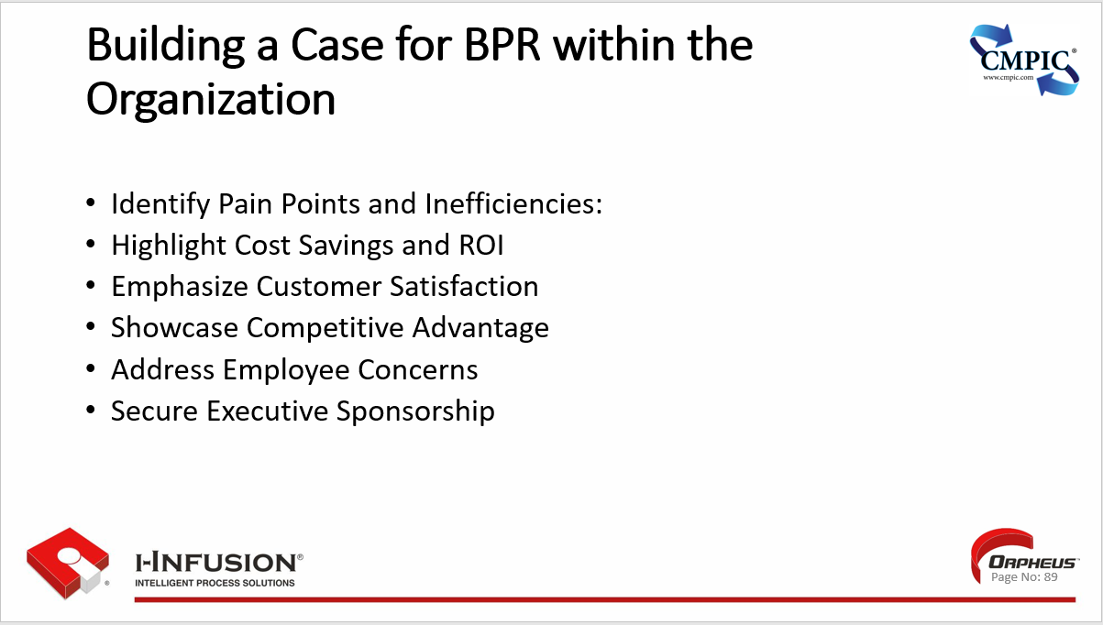

### Engaging Stakeholders and Managing Resistance

* **Identify Stakeholders:** Identify all individuals or groups who may be affected by or have an interest in the change. This includes employees, customers, suppliers, and other relevant parties.
* **Communicate Effectively:** Establish open and transparent communication channels to share information, address concerns, and gather feedback from stakeholders.
* **Build Relationships:** Foster positive relationships with stakeholders based on trust, respect, and collaboration.
* **Involve Stakeholders:** Actively involve stakeholders in the change process through participation in decision-making, providing opportunities for input, and recognizing their contributions.

**Managing Resistance**

* **Anticipate Resistance:** Recognize that resistance to change is natural and be prepared to address it proactively.
* **Address Concerns:** Listen empathetically to stakeholders' concerns and address them openly and honestly. Provide clear explanations and information to alleviate fears and uncertainties.

Remember that successful change initiatives require a proactive approach to engaging stakeholders and managing resistance. By actively involving stakeholders and addressing their concerns, organizations can increase the likelihood of successful change implementation and minimize disruptions.

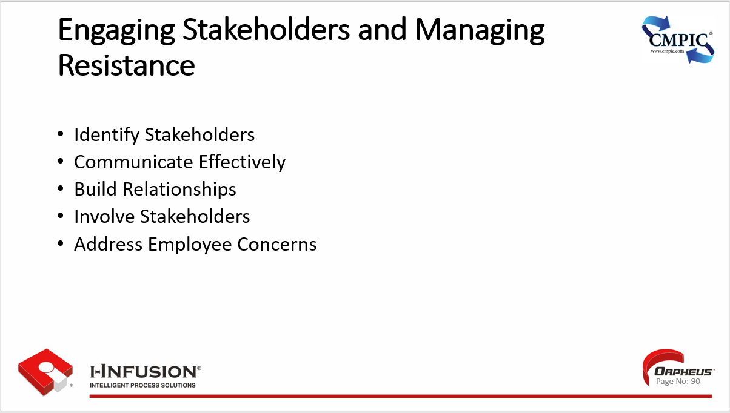

### Key Points



## Chapter 11: Redesigning Processes for Improvement

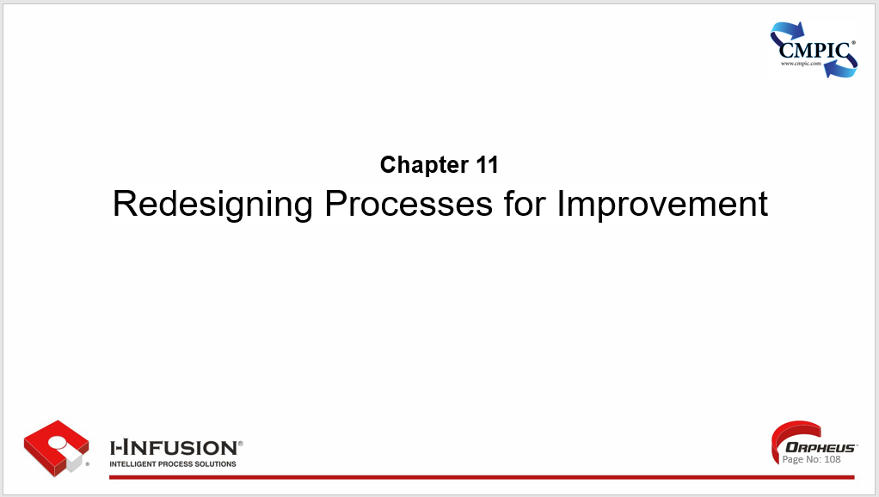

Chapter 11. Outline

* Principles of Effective Process Redesign
* Customer-Centricity
* Value Stream Focus
* Cross-Functional Collaboration
* Data-Driven Decision Making
* Continuous Improvement Mindset
* Technology Enablement
* Key Points
* Workshop

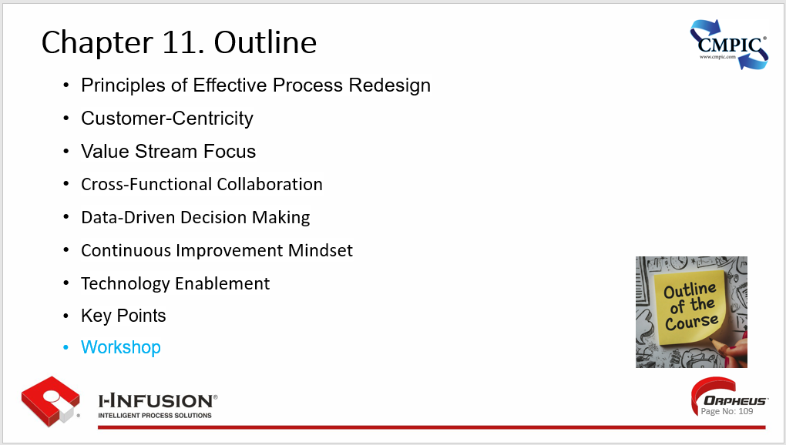

### Principles of Effective Process Redesign

* **Customer-Centricity:** Redesign processes with the customer's needs and expectations at the forefront. This ensures the process delivers value and enhances the overall customer experience.
* **Value Stream Focus:** Analyze the entire value stream to identify and eliminate non-value-adding activities (waste) and streamline the flow of work.
* **Cross-Functional Collaboration:** Involve stakeholders from different departments and functions throughout the redesign process to gain diverse perspectives and ensure alignment.
* **Data-Driven Decision Making:** Utilize data and analytics to understand current process performance, identify bottlenecks, and make informed decisions during the redesign.
* **Continuous Improvement Mindset:** View process redesign as an ongoing effort. Embrace a culture of continuous improvement where processes are regularly evaluated and optimized.
* **Technology Enablement:** Leverage technology solutions to automate tasks, improve efficiency, and enhance process visibility.

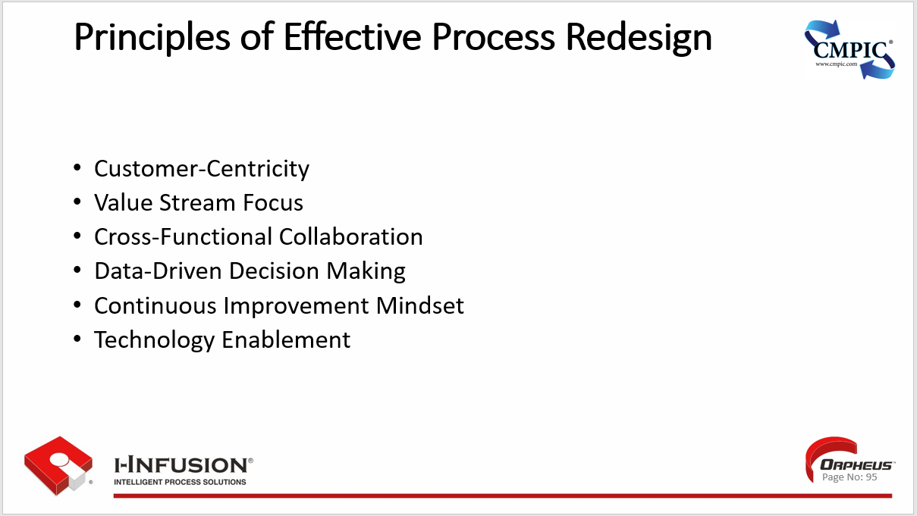

### Customer-Centricity

1. **Prioritize the Customer:** Customer-centricity places the customer at the heart of all business decisions and actions. It's about understanding their needs, preferences, and expectations, and consistently striving to exceed them.
2. **Focus on Customer Experience:** It goes beyond simply providing a product or service. It's about delivering a positive and memorable customer experience at every touchpoint, from initial contact to post-purchase support.
3. **Build Strong Relationships:** Cultivating strong, long-term relationships with customers fosters loyalty and advocacy. This involves proactive communication, personalized interactions, and going the extra mile to resolve issues and exceed expectations.
4. **Gather and Utilize Customer Feedback:** Actively solicit and collect customer feedback through various channels (surveys, reviews, social media). Analyze this feedback to gain insights into customer needs and preferences, and use it to drive continuous improvement.
5. **Empower Employees:** Empower frontline employees with the necessary information, tools, and authority to make decisions that benefit the customer. Create a culture where employees feel empowered to go above and beyond to meet customer needs.
6. **Measure and Track Customer Satisfaction:** Implement metrics to measure customer satisfaction, such as Net Promoter Score (NPS) or Customer Satisfaction Score (CSAT). Monitor these metrics regularly to identify areas for improvement and track progress over time.

By adopting a customer-centric approach, businesses can enhance customer loyalty, increase sales and revenue, and build a strong brand reputation.

* Automate tasks, improve efficiency, and enhance process visibility.

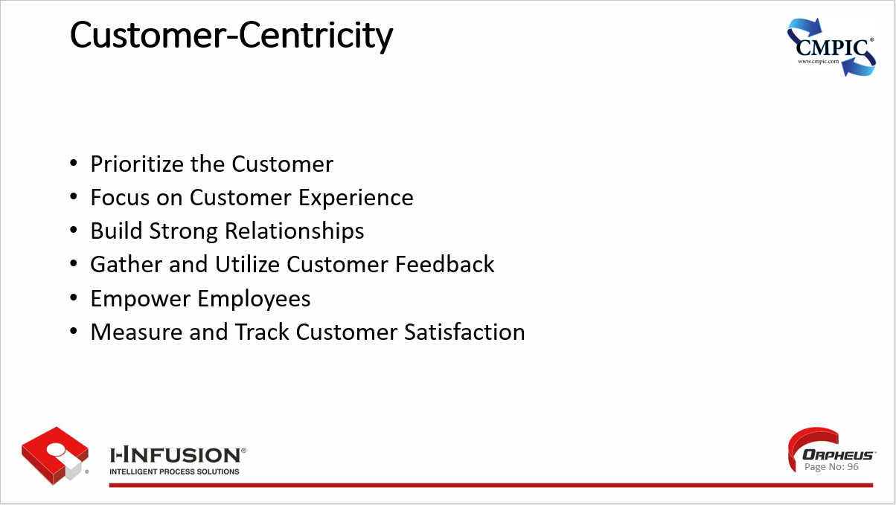

### Value Stream Focus

1. **Understanding the Value Stream:** A value stream encompasses all the activities, both value-adding and non-value-adding, required to bring a product or service from its raw material state to the customer. Value stream focus involves a deep understanding of this entire flow.
2. **Identifying Value-Adding Activities:** The core of value stream focus is to clearly distinguish between activities that directly add value to the product or service from the customer's perspective and those that do not.
3. **Eliminating Waste (Muda)**: Value stream focus relentlessly seeks to identify and eliminate any form of waste within the process. This includes activities that consume resources but do not create value, such as unnecessary movement, waiting, overproduction, defects, and excess inventory.
4. **Flow Optimization:** The goal is to create a smooth and continuous flow of work through the value stream. This involves reducing or eliminating bottlenecks, minimizing wait times, and ensuring a balanced workload across all steps.
5. **Customer-Centric Approach:** Value stream focus places the customer at the center, ensuring that the process is designed to meet their needs and expectations. This includes understanding the customer's definition of value and aligning the entire value stream accordingly.
6. **Continuous Improvement:** Value stream focus is not a one-time event but an ongoing pursuit of improvement. It involves constantly seeking ways to eliminate waste, improve flow, and increase value for the customer.

By maintaining a value stream focus, organizations can achieve significant improvements in efficiency, productivity, and customer satisfaction.

* Leading to efficiency, and enhance process visibility.

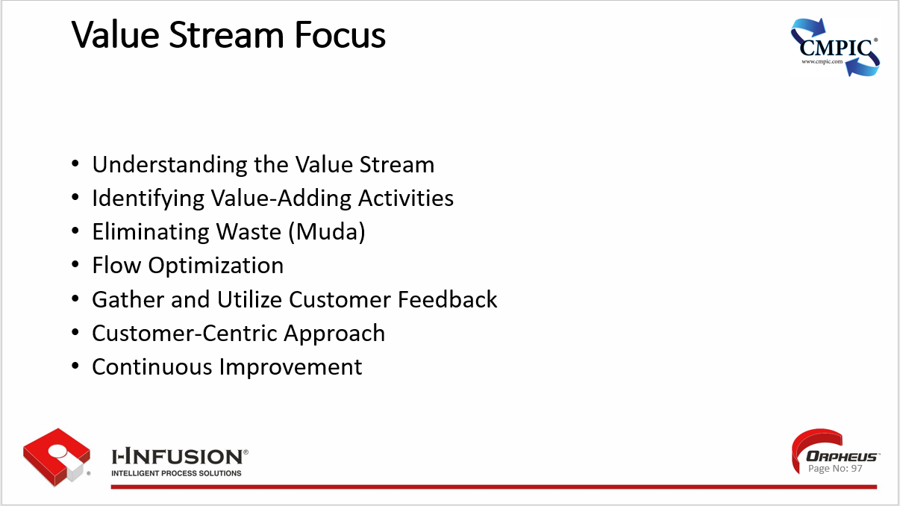

### Cross-Functional Collaboration

1. **Breaks down Silos:** It dismantles departmental barriers, enabling individuals from different areas of expertise to work together towards a shared goal.
2. **Fosters Innovation:** Brings together diverse perspectives and skillsets, sparking creativity and generating innovative solutions that may not arise within isolated teams.
3. **Enhances Communication and Understanding:** Promotes open communication and shared understanding across departments, improving overall coordination and efficiency.
4. **Increases Employee Engagement:** Provides opportunities for employees to learn from each other, develop new skills, and contribute to projects beyond their usual scope, leading to increased job satisfaction and engagement.
5. **Improves Problem-Solving:** Allows for a more comprehensive approach to problem-solving, leveraging the collective knowledge and experience of individuals from different disciplines.
6. **Accelerates Decision-Making:** Streamlines decision-making processes by bringing key stakeholders together, reducing delays and enabling faster action.

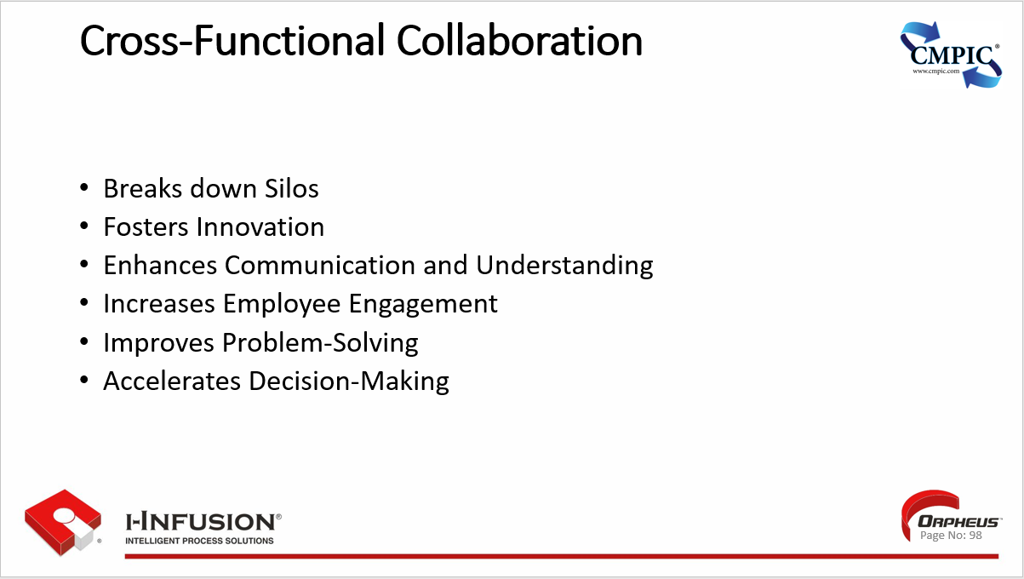

### Data-Driven Decision Making

* **Reliance on Data:** Data-driven decision making prioritizes objective data and evidence over intuition or gut feelings when making choices.
* **Improved Accuracy:** By utilizing data analysis and insights, the likelihood of making informed and accurate decisions increases, reducing the risk of errors or biases.
* **Enhanced Objectivity:** Data-driven approaches minimize the influence of personal opinions and subjective judgments, leading to more objective and rational decision-making.
* **Increased Efficiency:** Leveraging data analytics can help identify areas for improvement and streamline processes, leading to greater efficiency and productivity.
* **Better Resource Allocation:** Data-driven insights enable informed allocation of resources, ensuring they are utilized effectively and strategically to achieve optimal outcomes.
* **Competitive Advantage:** Organizations that embrace data-driven decision making gain a competitive edge by making faster, smarter, and more informed choices.

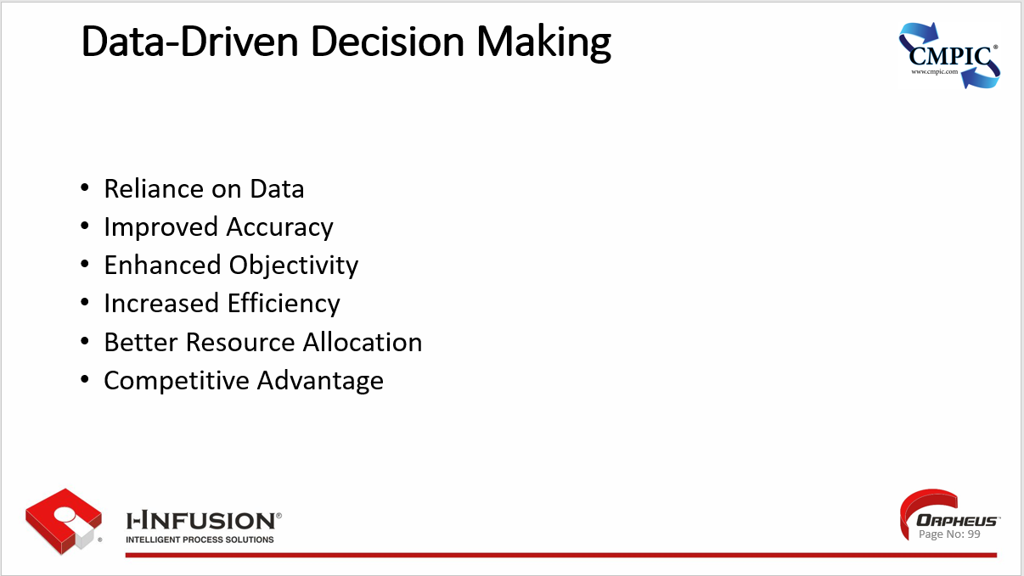

### Continuous Improvement Mindset

* **Embrace Change:** A continuous improvement mindset welcomes change as an opportunity for growth and development, rather than fearing or resisting it. It encourages individuals and organizations to adapt and evolve in response to new challenges and opportunities.
* **Focus on Process:** It emphasizes the importance of understanding and optimizing processes, rather than simply focusing on outcomes. It recognizes that small, incremental improvements to processes can lead to significant gains over time.
* **Empowerment and Collaboration:** A continuous improvement culture empowers individuals at all levels to identify and implement improvements. It fosters collaboration and teamwork, recognizing that everyone has a role to play in driving positive change.
* **Data-Driven Decision Making:** Decisions are based on facts and data rather than assumptions or opinions. Data is collected, analyzed, and used to identify areas for improvement and measure progress.
* **Learning from Failure:** Mistakes and failures are viewed as opportunities for learning and improvement. A continuous improvement mindset encourages experimentation and risk-taking, recognizing that not every attempt will be successful, but valuable lessons can be learned from each experience.
* **Long-Term Perspective:** Continuous improvement is a journey, not a destination. It requires a long-term commitment to constantly seeking ways to improve and evolve, even when things are going well.

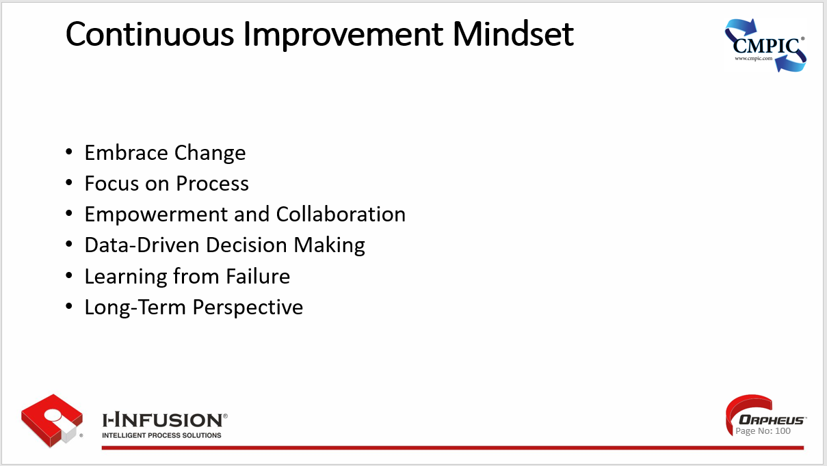

### Technology Enablement

* **Automation & Efficiency**: Technology can automate repetitive tasks, leading to increased efficiency and productivity by freeing up human resources for more strategic work
* **Improved Decision-Making**: Data analytics and business intelligence tools provide insights that enable more informed and effective decision-making.
* **Enhanced Collaboration & Communication:** Technology facilitates seamless communication and collaboration among teams, regardless of their location.
* **Innovation & New Opportunities**: New technologies can open up new business opportunities, create innovative products and services, and disrupt existing markets.
* **Customer Experience Enhancement:** Technology can be used to personalize customer interactions, improve service delivery, and enhance overall customer experience.
* **Cost Reduction**: By automating processes and optimizing operations, technology can contribute to cost savings and improved profitability.

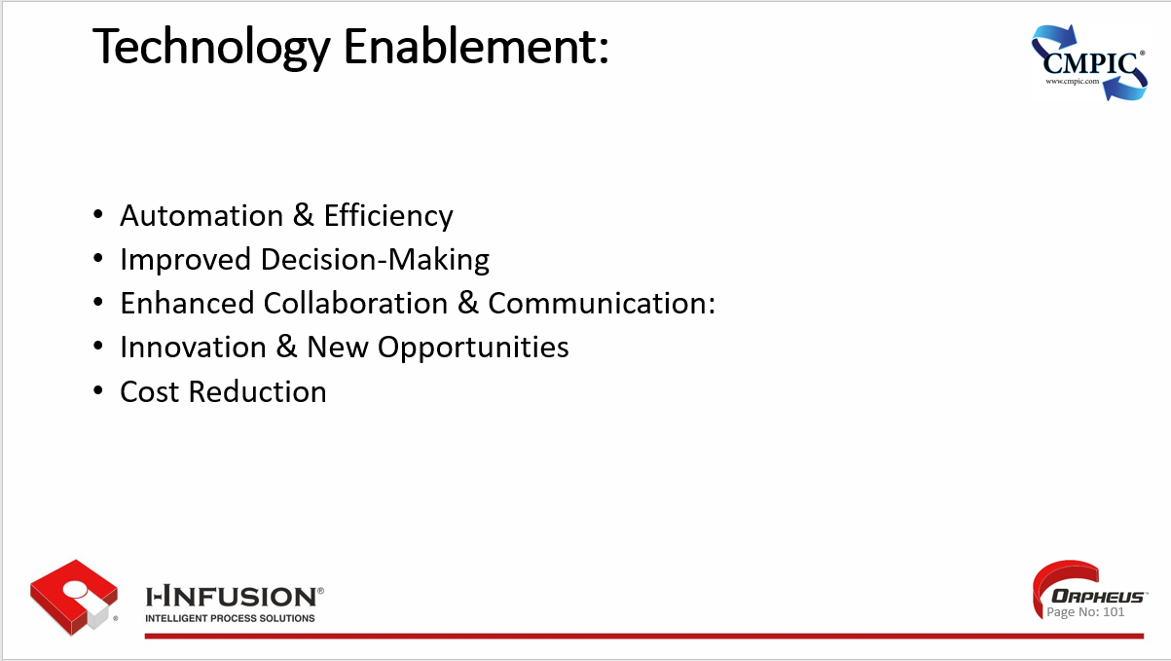

### Key Points

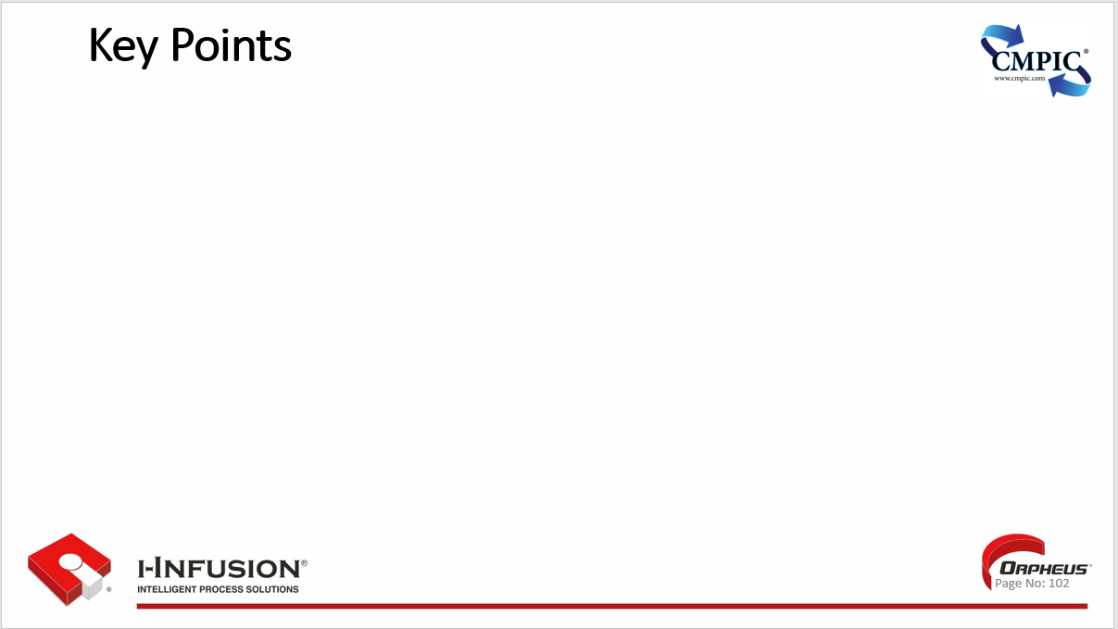

## Workshop

* *OrpheusTM*
* ???

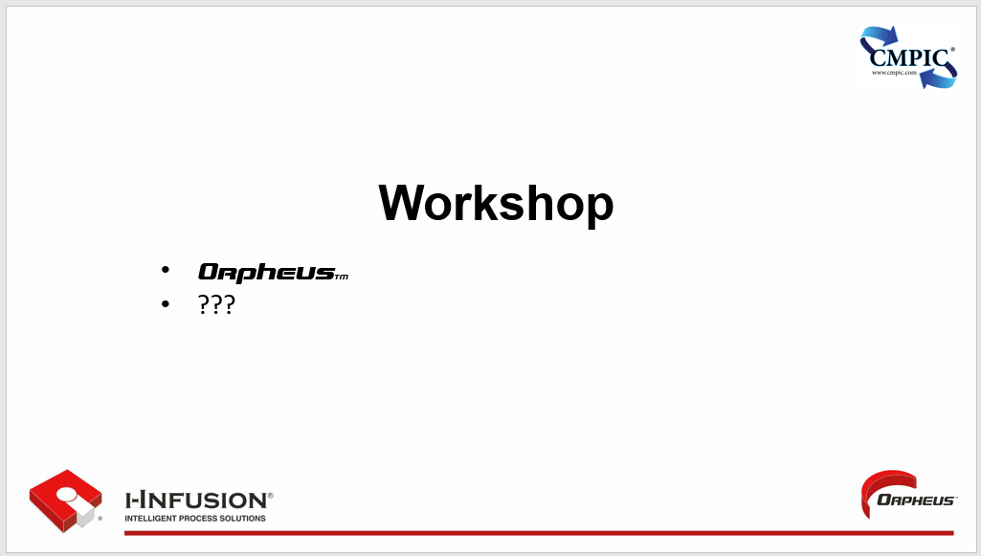

## Chapter12: Implementing the Redesigned Process

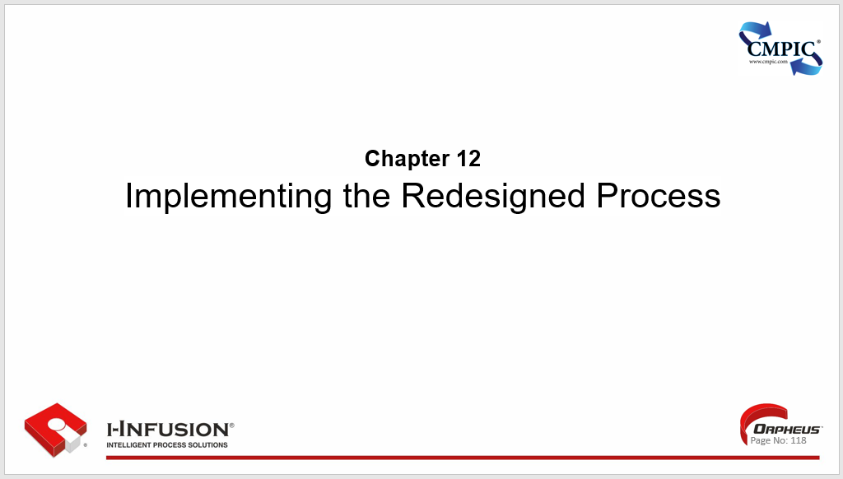

Chapter 12. Outline

* Developing an Implementation Plan
* Communicating Changes to the Organization
* Training and Development for New Processes
* Key Points

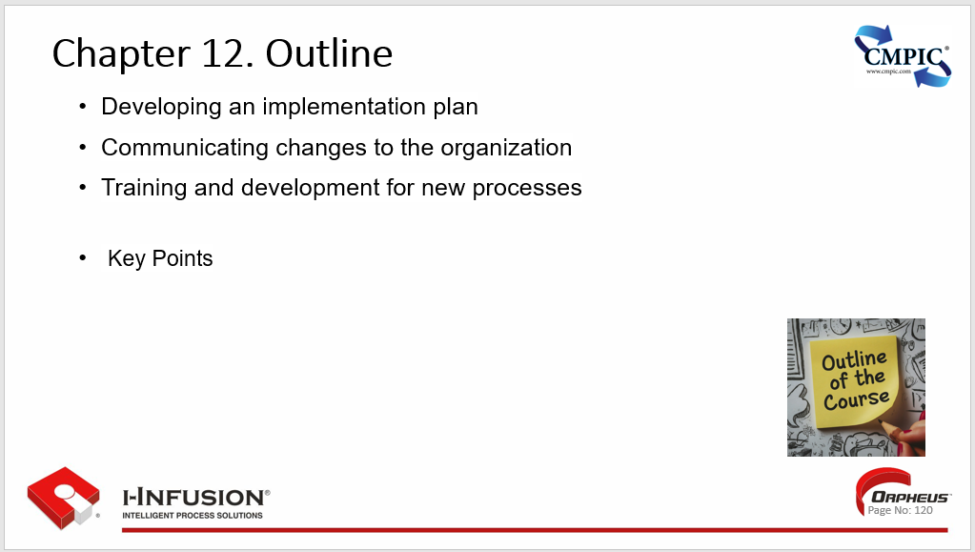

### Developing an Implementation Plan

**Define Objectives:** Clearly articulate the desired outcomes and goals of the implementation. What are you trying to achieve, and how will you measure success?

**Identify Tasks and Activities:** Break down the implementation into specific tasks and activities. This creates a comprehensive list of what needs to be done to achieve the objectives.

**Sequence and Dependencies:** Determine the order in which tasks need to be completed and identify any dependencies between them. This helps create a logical and efficient workflow.

**Assign Responsibilities:** Assign ownership for each task or activity to specific individuals or teams. Ensure everyone understands their roles and responsibilities.

**Set Deadlines:** Establish realistic deadlines for each task and the overall project. This helps keep the implementation on track and ensures timely completion.

**Develop a Communication Plan:** Create a plan for communicating progress, updates, and potential issues to stakeholders throughout the implementation process.

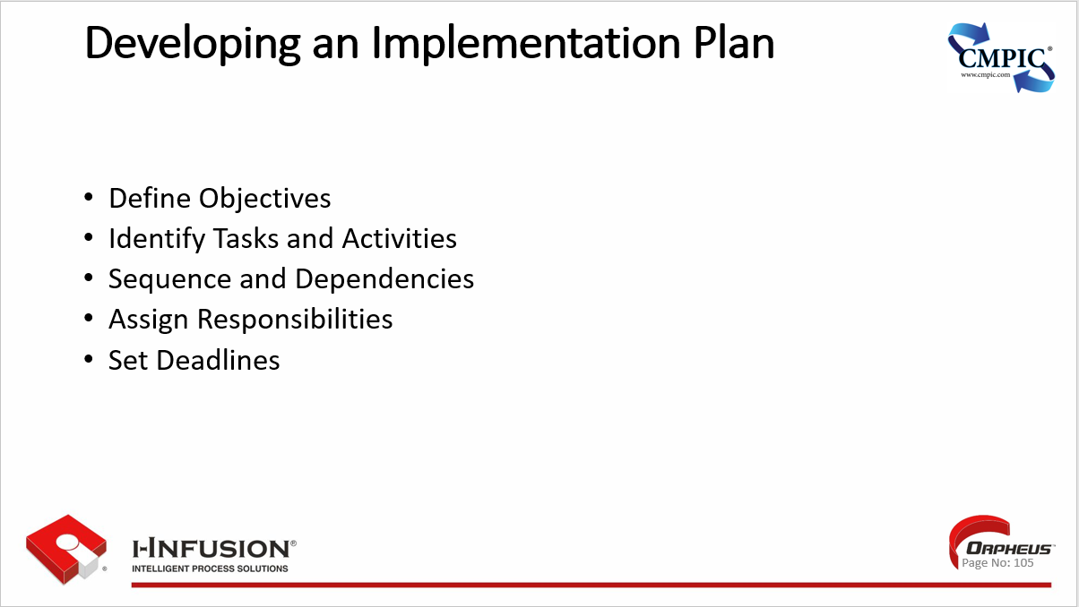

### Communicating Changes to the Organization

**Define Objectives:** Clearly articulate the desired outcomes and goals of the implementation. What are you trying to achieve, and how will you measure success?

**Identify Tasks and Activities:** Break down the implementation into specific tasks and activities. This creates a comprehensive list of what needs to be done to achieve the objectives.

**Sequence and Dependencies:** Determine the order in which tasks need to be completed and identify any dependencies between them. This helps create a logical and efficient workflow.

**Assign Responsibilities:** Assign ownership for each task or activity to specific individuals or teams. Ensure everyone understands their roles and responsibilities.

**Set Deadlines:** Establish realistic deadlines for each task and the overall project. This helps keep the implementation on track and ensures timely completion.

**Develop a Communication Plan:** Create a plan for communicating progress, updates, and potential issues to stakeholders throughout the implementation process.

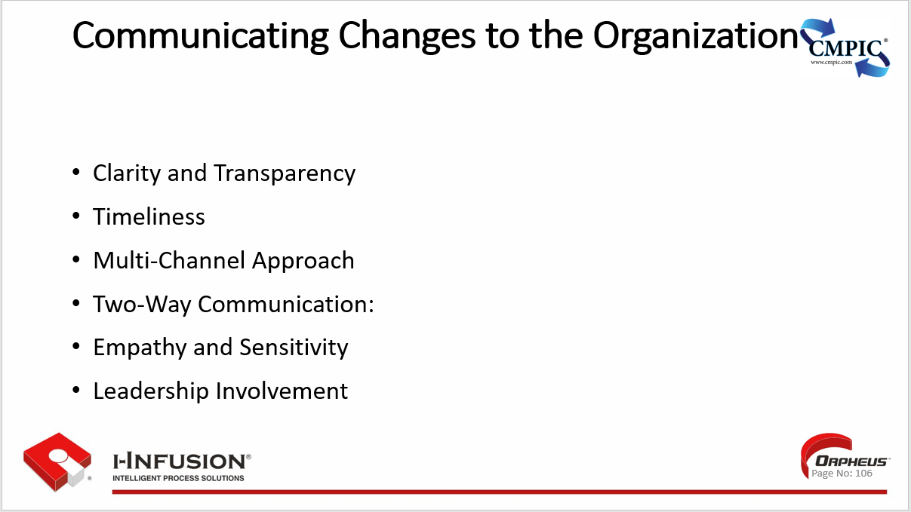

### Training and Development for New Processes

* Needs Assessment
* Customized Training Programs
* Hands-on Practice
* Ongoing Support and Reinforcement
* Performance Measurement
* Continuous Learning Culture

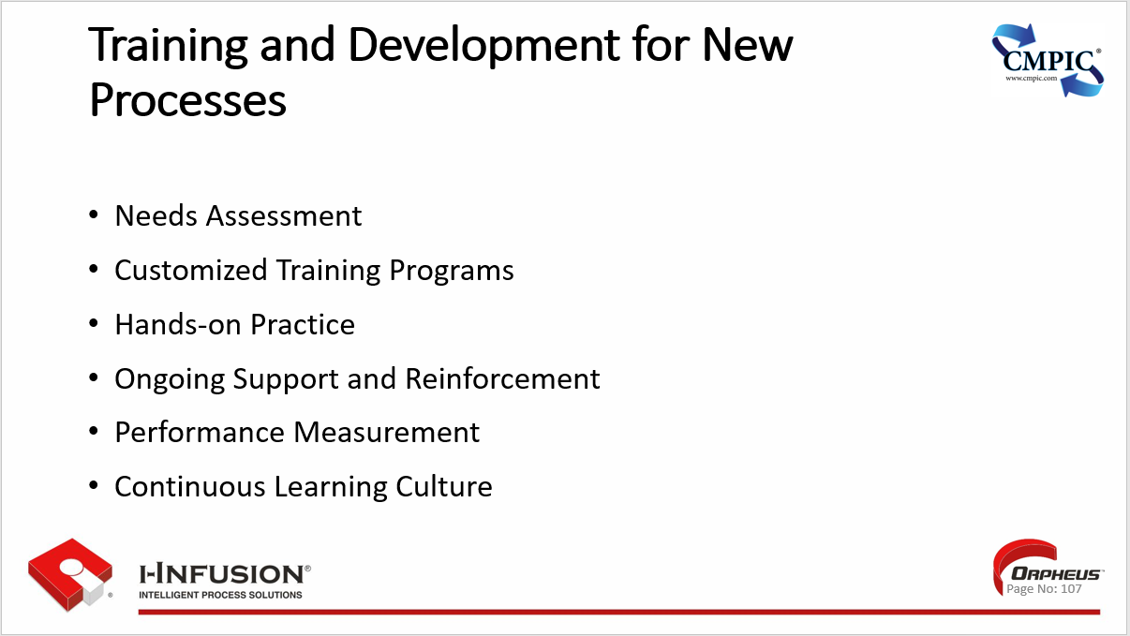

### Key Points



## Chapter 13: Monitoring and Continuous Improvement

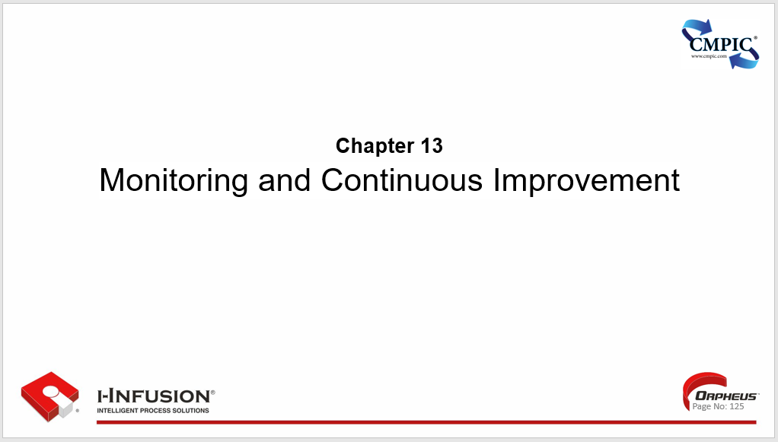

Chapter 13. Outline

* Establishing a Monitoring and Feedback System
* Techniques for Continuous Process Improvement (e.g., Kaizen, Six Sigma)
* Sustaining BPR Initiatives Over the Long Term
* Key Points

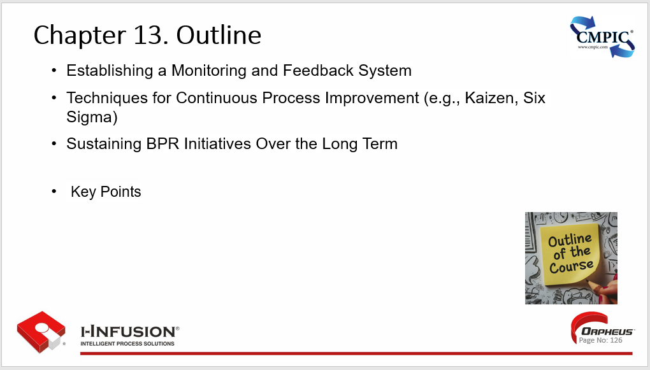

### Establishing a Monitoring and Feedback System

**Define Key Performance Indicators (KPIs):** Identify and define the specific metrics that will be used to measure the performance of the process. These KPIs should be aligned with the overall goals and objectives of the process improvement initiative.

**Establish Data Collection Methods:** Determine how data related to the KPIs will be collected. This may involve manual data entry, automated data capture through technology systems, or a combination of both.

**Implement Data Analysis Tools:** Utilize appropriate tools and techniques to analyze the collected data and generate meaningful insights. This may involve using spreadsheets, statistical software, or business intelligence platforms.

**Create Feedback Channels:** Establish channels for gathering feedback from employees, customers, and other stakeholders involved in or impacted by the process. This feedback can provide valuable insights into areas for improvement.

**Regular Reviews and Reporting:** Schedule regular reviews of the collected data and feedback to assess progress and identify any potential issues or opportunities for improvement. Communicate findings to relevant stakeholders through clear and concise reports.

**Actionable Insights and Adjustments:** Use the insights gained from monitoring and feedback to make informed decisions and implement necessary changes to the process. Continuously iterate and refine the process based on the feedback received.

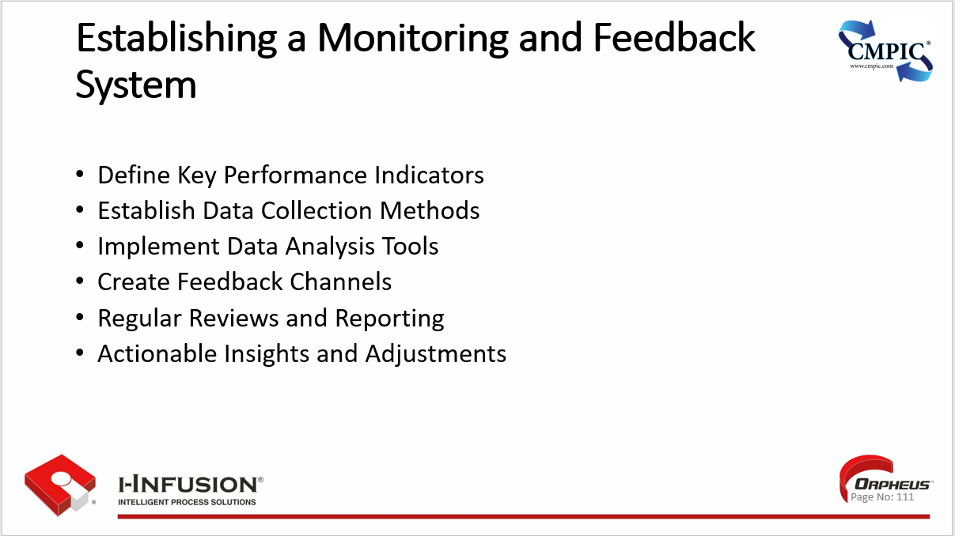

### Techniques for Continuous Process Improvement (e.g., Kaizen, Six Sigma)

* **PDCA Cycle (Plan-Do-Check-Act):** This foundational iterative method involves systematically planning improvements, implementing them, evaluating the results, and then acting on those learnings to make further adjustments.
* **Kaizen:** This philosophy emphasizes small, incremental improvements driven by employees at all levels. It fosters a culture of continuous learning and problem-solving.
* **Six Sigma:** A data-driven methodology focused on minimizing defects and variation in processes. Six Sigma projects often use the DMAIC framework (Define, Measure, Analyze, Improve, Control) to systematically address problems.
* **Lean Manufacturing:** This approach centers on eliminating waste (muda) in all its forms, from unnecessary motion to overproduction. Lean tools like value stream mapping help visualize and streamline processes.
* **Total Quality Management (TQM):** A management philosophy focused on customer satisfaction and continuous improvement through the involvement of all employees. TQM emphasizes quality in all aspects of an organization's operations.
* **Value Stream Mapping:** A visual tool that maps the flow of materials and information required to deliver a product or service. It helps identify waste and opportunities for process improvement.

Kaizen and Six Sigma are just two examples within a broader array of continuous improvement techniques available to organizations. The best approach will depend on the specific context and goals.

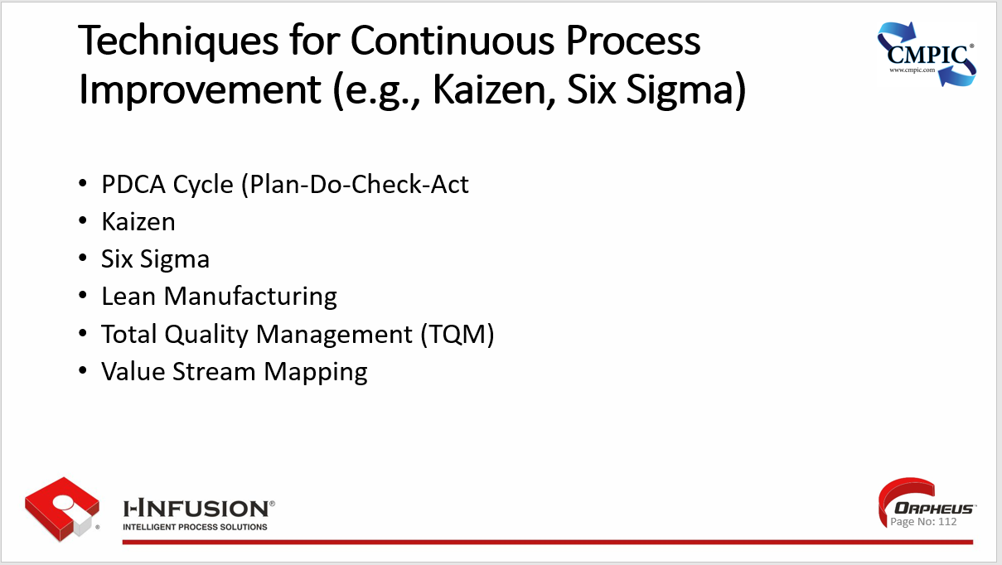

### Sustaining BPR Initiatives Over the Long Term

1. **Embed a Culture of Continuous Improvement:** Foster an organizational culture where continuous improvement is valued and encouraged. This empowers employees to identify areas for ongoing optimization and ensures that the gains from BPR are not lost over time.
2. **Establish Clear Metrics and Monitoring Systems:** Implement a system for tracking key performance indicators (KPIs) and regularly monitoring process performance. This allows you to identify any deviations or areas where improvements are slipping, enabling timely corrective action.
3. **Provide Ongoing Training and Development:** Ensure that employees receive ongoing training and development to keep their skills and knowledge up-to-date with evolving processes and technologies. This helps them remain engaged and effective in their roles.
4. **Encourage Employee Engagement and Ownership:** Foster a sense of ownership among employees for the redesigned processes. Empower them to suggest and implement improvements, and recognize and reward their contributions.
5. **Regularly Review and Adapt Processes:** Periodically review the redesigned processes to ensure they remain aligned with business goals and customer needs. Adapt and refine processes as necessary to respond to changing circumstances and maintain optimal performance.
6. **Celebrate Successes and Share Lessons Learned:** Recognize and celebrate successes achieved through BPR initiatives. Share lessons learned and best practices across the organization to promote a culture of continuous learning and improvement.

By implementing these strategies, organizations can increase the likelihood of sustaining the benefits of BPR initiatives and ensuring ongoing success in the long term.

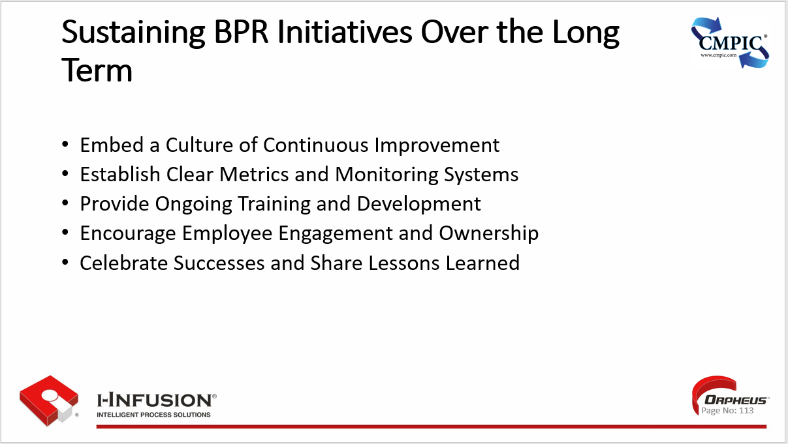

### Key Points



## Chapter 14: Real-World Applications and Case Studies

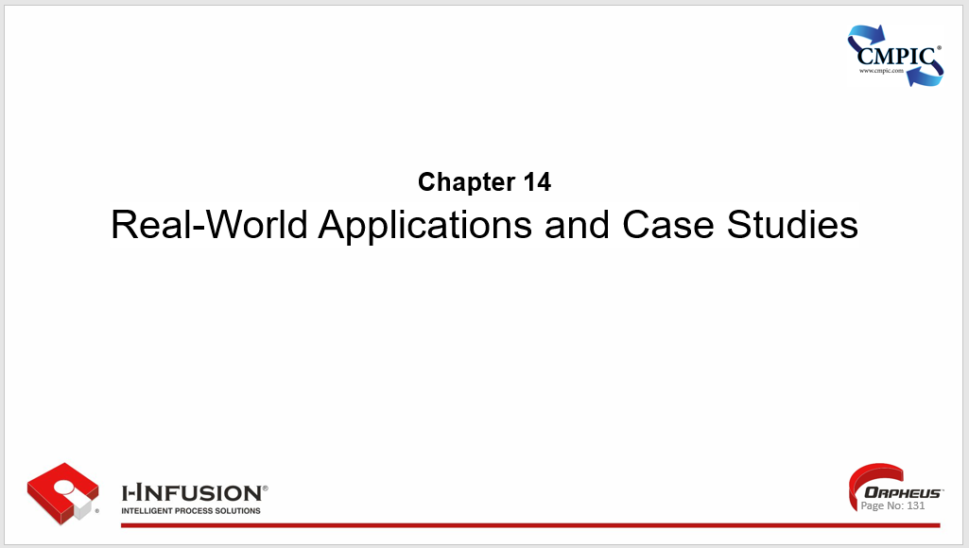

Chapter 14. Outline

* Case Studies of Successful BPR Implementations
* Lessons Learned and Best Practices in Business Process Reengineering
* Interactive Q&A with a BPR Expert (guest speaker)
* Key Points

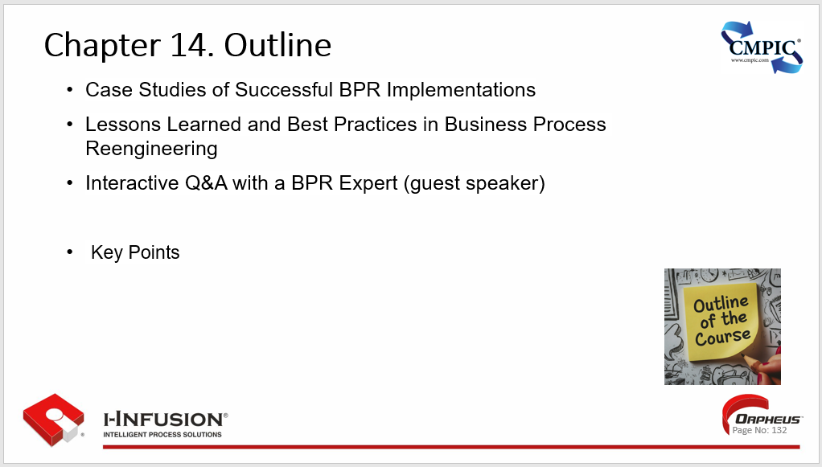

### Case Studies of Successful BPR Implementations

1. **Ford Motor Company (Accounts Payable):** In the 1980s, Ford famously reengineered its Accounts Payable process, reducing headcount from 500 to just 5 employees. This dramatic improvement was achieved by automating manual tasks, streamlining workflows, and eliminating unnecessary steps.
2. **Taco Bell:** The fast-food chain implemented BPR to redesign its restaurant operations, shifting food preparation to centralized commissaries. This change resulted in significant cost savings, improved food quality, and faster service.
3. **Procter & Gamble (Order Fulfillment):** P&G reengineered its order fulfillment process, reducing the time it took to get products from factories to shelves. This led to improved inventory management, reduced costs, and increased customer satisfaction.
4. **IBM (Credit Authorization):** IBM reengineered its credit authorization process, reducing the time it took to approve credit applications from several days to just a few hours. This improvement led to increased sales and improved customer service.
5. **Hallmark (Product Development):** Hallmark reengineered its product development process, reducing the time it took to bring new greeting cards to market. This change resulted in increased sales and market share.
6. **Kodak (Film Manufacturing):** Kodak reengineered its film manufacturing process, significantly reducing production costs and improving product quality. This enabled Kodak to maintain its competitive advantage in the face of growing digital photography.

These case studies illustrate the potential for BPR to achieve breakthrough improvements in various industries. By fundamentally rethinking and redesigning core processes, organizations can achieve significant gains in efficiency, cost reduction, quality, and customer satisfaction.

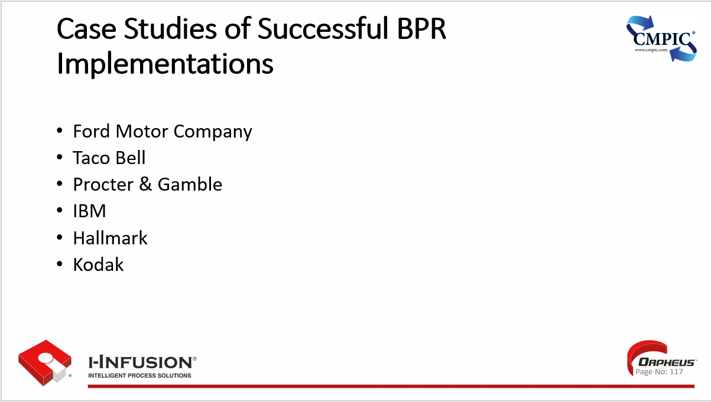

### Lessons Learned and Best Practices in Business Process Reengineering

* Strong Leadership and Vision
* Change Management
* Focus on Customer Value\
* Technology is an Enabler, not a Solution
* Measure and Monitor Progress
* Don't Underestimate the Complexity

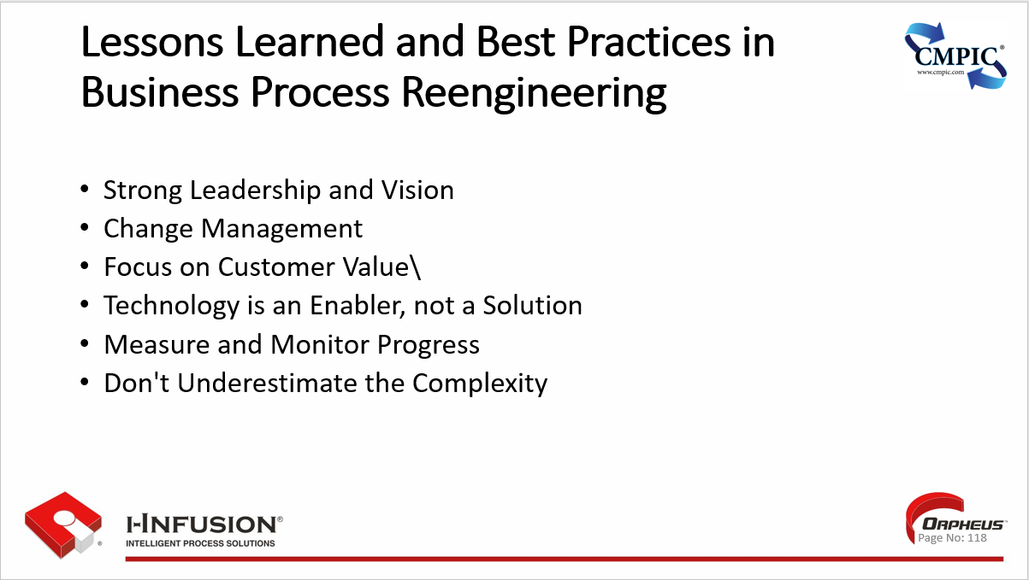

### Interactive Q&A with a BPR Expert (Guest Speaker)

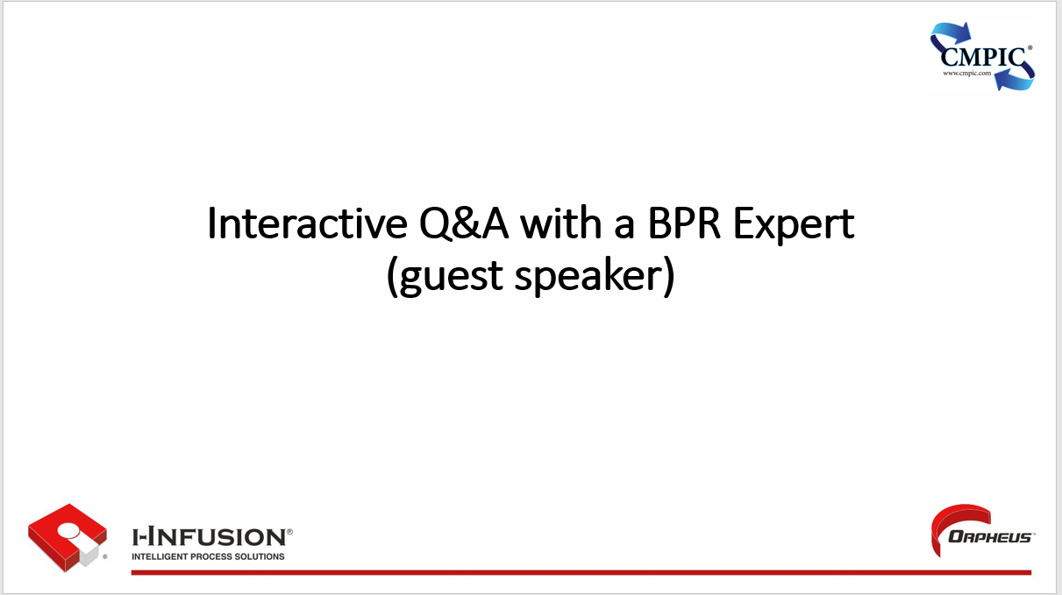

### Key Points



## Chapter 15: Training Recap

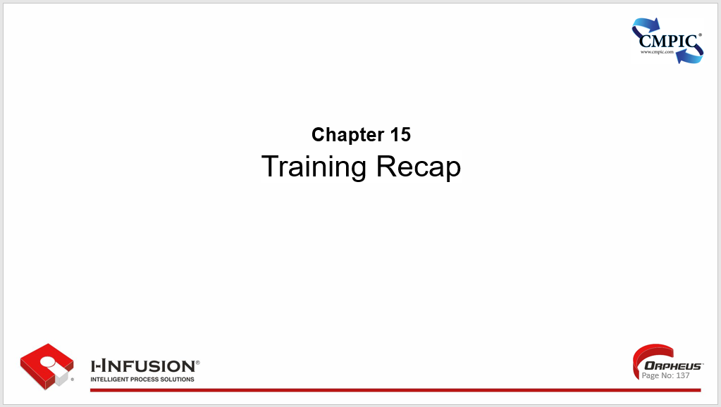

Chapter 15. Outline

* Recap of key learnings
* Post-workshop resources and support
* Key Points

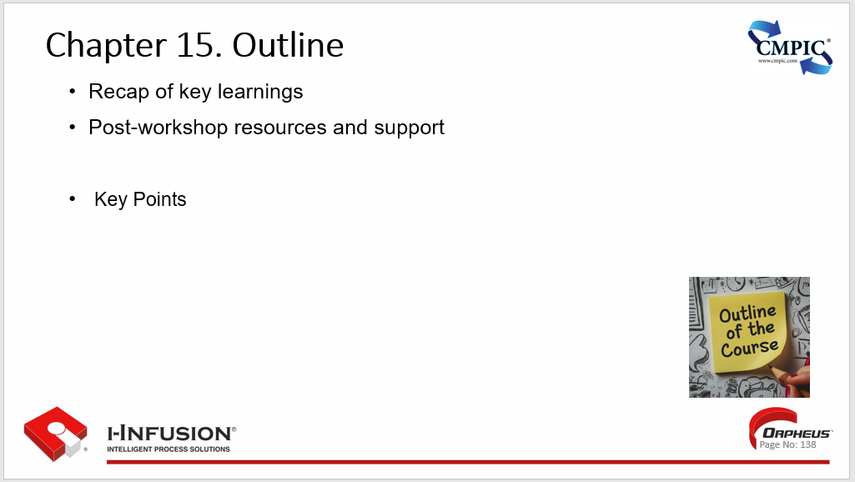

### Recap of key learnings

**Continuous Improvement Mindset:** CPI is an ongoing journey, not a one-time project. It emphasizes the importance of constantly seeking opportunities for improvement and fostering a culture of innovation and learning.

**Process-Centric Approach:** CPI focuses on understanding and optimizing processes, rather than simply addressing individual tasks or symptoms. By analyzing the entire process, organizations can identify root causes of problems and implement systemic solutions.

**Data-Driven Decision Making:** CPI relies on data and evidence to guide improvement efforts. By collecting and analyzing data, organizations can identify areas for improvement, measure the impact of changes, and make informed decisions.

**Employee Engagement:** CPI empowers employees to participate in the improvement process, recognizing their valuable insights and expertise. This fosters a sense of ownership and engagement, leading to better solutions and sustainable results.

**Customer Focus:** CPI prioritizes meeting or exceeding customer expectations. By understanding customer needs and feedback, organizations can design processes and products that deliver greater value and enhance customer satisfaction.

**Adaptability and Resilience:** CPI enables organizations to adapt to change and remain competitive in a dynamic environment. By continuously improving their processes and products, organizations can stay ahead of the curve and respond effectively to evolving market conditions and customer demands.

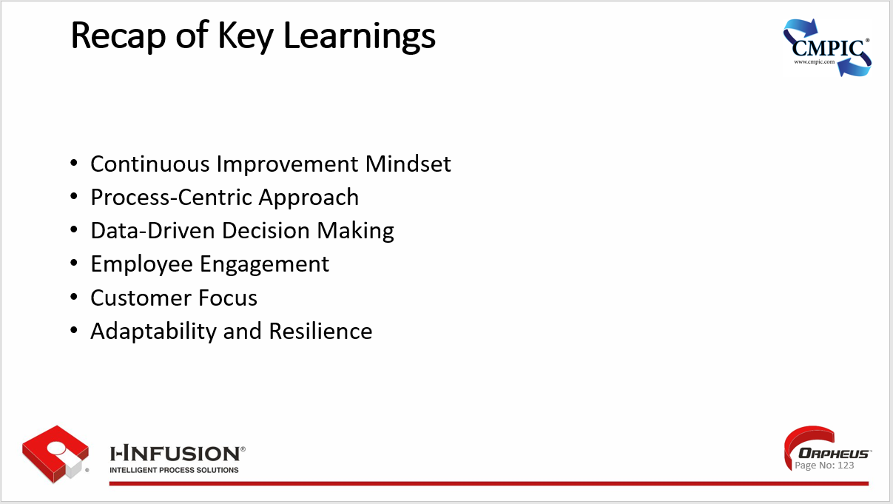

### Post-workshop resources and support

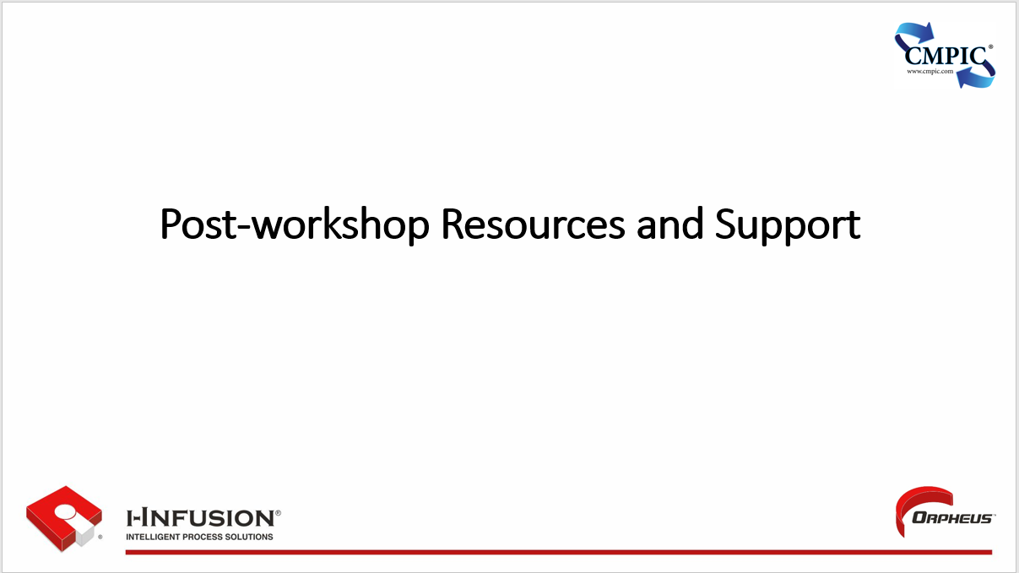

### Key Points



A user story is the processes. It has a beginning and it has an end or desired outcome. Like a process, user stories have activities and flow, they have inputs to accomplish activities with, it describes work products resulting from managed activities. Also, like process’, user stories contain detail regarding resources required, and influencing controls (e.g., governance). So why not capture and distill your user stories into an environment where they can be quantified and managed in a way that provides not only enduring truth, trust, and traceability, but also results in efficient, effective, lean, resilient, financially responsible, and profitable business and technical operations. Let your enterprises most valuable asset work for you, manage your processes brilliantly with Orpheus.